Leveling the Global Playing Field: Taxing Energy Use and Carbon Emissions
Scott McDonald (Oxford Brookes University)
&
Karen Thierfelder (US Naval Academy)
&
Sherman Robinson (University of Sussex)

WORK IN PROGRESS: PRELIMINARY DRAFT.

PLEASE DO NOT QUOTE WITHOUT PRIOR AGREEMENT WITH THE AUTHORS.

Address for correspondence:
Department of Economics & Strategy,
Oxford Brookes University,
Wheatley Campus, Wheatley,
Oxford, OX33 1HX, UK
Email: smcdonald@brookes.ac.uk
Tel: +44 1865 485948

1. Introduction
The global data on energy use and emissions produced by the Global Trade Analysis Project (GTAP) indicate substantial differences in tax rates on energy commodities, and hence implied tax rates on emissions, both between regions and between sectors within regions. These data indicate that energy tax rates on final demands are appreciably higher than those on intermediate inputs, which, combined with the substantial differences in tax rates on different energy sources by purchasing sector, implies that the incentives facing purchasers of energy commodities differ widely within regions. Furthermore, energy tax rates differ widely by regions, with producers and consumers in the EU paying much higher energy taxes than consumers in other developed countries, particularly the U.S. In such an economic environment, the implications of imposing carbon taxes without addressing distortions in the existing structure of incentives are vague.
The issue of the interaction of different tax instruments stimulated considerable debate during the 1990s. At the heart of these debates were issues relating to the replacement of tax instruments that distorted markets, especially factor markets, and the replacement of these taxes with carbon taxes (e.g., Pearce, 1991; Nordhaus, 1993; Oates, 1995). It was suggested that there was the possibility of realizing a ‘double dividend’ whereby emissions were reduced and existing tax distortions were reduced (Goulder et al., 1997; Goulder et al., 1999; Parry, 2003). The issue of interacting tax effects and carbon emissions seems more recently to have faded as economists and policy makers have become increasingly interested in carbon trading, grandfathered permits and carbon offsetting schemes. Yet given the evidence on widely differing tax regimes in on energy commodities in different countries it is surprising to find so little concern for how different tax instruments may interact.
This study uses a Social Accounting Matrix (SAM) representation of the GTAP database together with satellite accounts for the volumes of energy commodities used and volumes of emissions (primarily CO2) to derive estimates of the implied taxes on carbon emissions by region, energy commodity, and purchasing agent. Identifying existing differences in incentives represents an important first step in response to the threat of climate change. A series of experiments are conducted using the GLOBE_EN computable general equilibrium (CGE) model to estimate the impact of reducing the differences in tax structures within and across regions on implied CO2 emissions.
When the average EU energy tax rates – the highest rates - are applied to all developed countries the model indicates that there would be substantial reductions in global energy use and CO2 emissions. If these rates are extended to all regions there are further reductions in energy use and emissions but the welfare costs for developing countries are appreciable. Subsequent simulations consider the impact of replacing energy use taxes with taxes on CO2 emissions - initially as revenue neutral taxes within regions and then as common carbon tax rates across developed and all regions. By changing tax instruments, one eliminates a distortion for targeting CO2 emissions. Additional simulations consider the effect of using taxes on CO2 emissions to attain carbon emission targets.
The impacts of these scenarios are then compared with scenarios in which carbon (emission) taxes are applied in place of the existing energy use taxes to meet CO2 emission targets. The interpretation of these results is complicated by the fact that the emission tax incentives are distorted by the existing structure of energy use taxes. If energy use taxes are left constant and tax replacement (for an assumed revenue-neutral policy shock) is realised through changes in income taxes, the reductions in emissions are much less than if tax replacement is realised through reductions in energy use taxes. This suggests that there might be greater returns to adjustments to the existing tax structures than to the development of countervailing and ‘third best’ tax regimes.
The rest of this paper is organised as follows. In section 2 the energy use and tax data in the GTAP global database are reviewed. This is followed by a description of the data set and model used in this study, section 3, and details of the reported policy simulation, section 4. The results are discussed in section 5 and the paper ends with some concluding comments.

2. Energy Use and Taxes in GTAP

2.1 Transactions Data
A SAM is a transactions matrix; hence each cell in a SAM records the value (price * quantity) of the transactions between the two agents identified by the row and column accounts. The selling agents are identified by the rows, i.e., the row entries record the incomes received by the identified agent, while the purchasing agents are identified by the columns, i.e., the column entries record the expenditures made by agents. As such a SAM is a relatively compact form of double entry bookkeeping that can be used to present the National Accounts of a country in a single two-dimensional matrix (see UN, 1993, for a detailed explanation of the relationship between conventional and SAM presentations of National Accounts). A SAM is complete in the sense that the SAM should record ALL the transactions within the production boundary of the National Accounts, and consistent in the sense that income transactions by each and every agent are exactly matched by expenditure transactions of other agents. A fundamental consequence of these conditions is that the row and column totals of the SAM for each region must be identical, and hence the SAM provides a complete characterisation of current account transactions of an economy as a circular (flow) system.
Hence a Global SAM can be conceived of as a series of single region SAMs that are linked through the trade accounts. In the context of a global SAM the complete and consistent conditions need extending to encompass transactions between regions. Thus for trade in commodities/products (goods and services) the value of exports, valued free on board (fob), from source s to destination d must be exactly equal to the value of imports valued fob to destination d from source s; and since this holds for all commodity trade transactions the sum across all regions of the differences in the values of imports and exports must equal zero. Similarly other current account transactions between regions can be recorded, and since ex post the balance of payments must balance the net capital account transfers between regions must equal zero if the system is to be complete and consistent. A representative SAM for a region is provided in Table 2.1.
The analyses reported in this study are derived using a model calibrated with a SAM representation of the GTAP database (see McDonald and Thierfelder, 2004). In the context of the GTAP database the ONLY way in which the regions are linked directly in the database is through commodity trade transactions although there are some indirect links through the demand and supply of trade and transport services. Hence the resultant trade balances do not fully accord with national accounting conventions because other inter regional transactions are not recorded in the database (see McDonald and Sonmez, 2004). A description of the transactions recorded in a representative SAM for a typical region in the GTAP database is provided in Table 2.1.

Table 2.1 Social Accounting Matrix for a Region in the Global Social Accounting Matrix
 | Commodities | Activities | Factors | Households | Government | Capital | Margins | Rest of World | Totals
Commodities | 0 | Combined Intermediate Use Matrix | 0 | Private Consumption | Government Consumption | Investment Consumption | Exports of Margins (fob) | Exports of Commodities (fob) | Total Demand for Commodities
Activities | Domestic Supply Matrix | 0 | 0 | 0 | 0 | 0 | 0 | 0 | Total Domestic Supply by Activity
Factors | 0 | Expenditure on Primary Inputs | 0 | 0 | 0 | 0 | 0 | 0 | Total Factor Income
Households | 0 | 0 | Distribution of Factor Incomes | 0 | 0 | 0 | 0 | 0 | Total Household Income
Government | Taxes on Commodities | Taxes on Production  Taxes on Factor Use | Direct/Income Taxes | Direct/Income Taxes | 0 | 0 | 0 | 0 | Total Government Income
Capital | 0 | 0 | Depreciation Allowances | Household Savings | Government Savings | 0 | Balance on Margins Trade | Foreign Savings | Total Savings
Margins | Imports of Trade and Transport Margins | 0 | 0 | 0 | 0 | 0 | 0 | 0 | Total Income from Margin Imports
Rest of World | Imports of Commodities (fob) | 0 | 0 | 0 | 0 | 0 | 0 | 0 | Total Income from Imports
Totals | Total Supply of Commodities | Total Expenditure on Inputs by Activities | Total Factor Expenditure | Total Household Expenditure | Total Government Expenditure | Total Investment | Total Expenditure on Margin Exports | Total Expenditure on Exports

2.2 Energy Use & Emissions
The GTAP energy database records both quantities of energy commodities used, in millions of tonnes of oil equivalent (MTOE) and CO2 emissions. In the context of a SAM these data can be recorded as satellite accounts for each source of demand, although government and investment demands are virtually zero in all regions of the database. The underlying structure of the database with satellite accounts for a single region with a single energy commodity is illustrated in Table 2.2.
Thus the GTAP database has the great advantage of providing data on both the transactions values for energy commodities and quantifying CO2 emissions by reference to both the energy commodity and the agent that utilises the energy commodity, i.e., it encompasses differences in the technologies employed by the purchasing agents when they use the energy commodity.

Table 2.2 Transaction and Satellite Accounts for Energy
 | Commodities | Activities |  | Households | Government | Capital
Commodities | 0 | Energy Commodity Intermediate Use Matrix |  | Energy Consumption | Energy Consumption | Energy Consumption
Factors | 0 | Expenditure on Primary Inputs |  | 0 | 0 | 0
Government | Taxes on Energy Commodities | Taxes/Subsidies on Energy Use in Production |  | 0 | 0 | 0
Totals | Total Supply of Commodities | Total Expenditure on Inputs by Activities |  | Total Household Expenditure | Total Government Expenditure | Total Investment
 | Quantity of Energy Input | Quantities of Intermediate Energy Input |  | Quantities of Final Demand Energy Input | Quantities of Final Demand Energy Input | Quantities of Final Demand Energy Input
 | CO2 by Energy Input | Quantities CO2 Emissions from Energy Input |  | Quantities CO2 Emissions from Energy Input | Quantities CO2 Emissions from Energy Input | Quantities CO2 Emissions from Energy Input

2.3 Tax Rates
The GTAP database records sales taxes that are both commodity and purchasing agent specific – as such the GTAP database appears to contradict the ‘law of one price’ that underpins the concept of a SAM. In fact closer inspection of the data (see McDonald and Thierfelder, 2004; and McDonald, 2007) demonstrates that the differences in the sales tax rates for non energy commodities for intermediate inputs by purchasing agent within a region are minimal. But for energy commodities this is not the case. To allow for this the underlying data are adjusted so that the energy intermediate inputs are valued inclusive of the sales tax rate charged on final demands by households – the highest sales tax rate on every energy commodity in every region – and then a ‘rebate’ is computed for each energy commodity according to the purchasing agent. This creates the seemingly odd situation that activities purchase energy commodities at prices inclusive of the region specific sales taxes and then receive a rebate from the government. In practice this is how a VAT tax system works.
However the actual ‘rebate’ rates differ appreciably across purchasing agents. Some variation in implied rebate rates is to be expected because of variations in the proportions of activities that fall within VAT thresholds, but many of the differences are so large that they are unlikely to be explained solely by differences in thresholds. Whether these differences reflect real differences in applied tax rates or are ‘errors’ in the GTAP database is unknown and considerable effort is being expended by GTAP to reduce any ‘errors’ in the energy and emissions data (McDougall, 2007).
Nevertheless the tax rate capture an important economic dimension; differences in the energy input use rebates by purchasing agent need to enter into the first-order conditions that determine demand for energy products by economic agents.

3. Data and Model

3.1 GTAP Transactions and Energy Data: aggregation and descriptive statistics
The data used for the global computable general equilibrium (CGE) model are drawn from the Global Trade Analysis Project (GTAP) database version 6. The database for this study is derived from the GTAP database version 6.0, which is benchmarked to the year 2001 (see Dimanaran, 2006). The form of the database used for this study is a Social Accounting Matrix (SAM) representation of the Global Trade Analysis Project (GTAP) database version 6 (see McDonald and Thierfelder, 2004, for a detailed description of the core database). The GTAP project produces the most complete and widely available database for use in global computable general equilibrium (CGE) modelling; and the database has become generally accepted for global trade policy analysis. It is used by nearly all the major international institutions and many national governments. Hertel (1997) provides an introduction to both the GTAP database and its companion CGE model. The precise version of the database used as the starting point for this study is a reduced form global SAM representation of the energy augmented GTAP database (see McDonald, 2006).
In addition to the standard GTAP transactions data this study, and the model GLOBE_EN, make use of the satellite account data produced by GTAP. This consists of 6 (three dimensional) matrices that record the volumes of energy inputs used by activities and purchased by domestic institutions in terms of million tonnes of oil equivalent (MTOE) and 6 (three dimensional) matrices that record the CO2 emissions associated with each energy commodity and using agent, i.e., the emissions data allow for the quantities of energy inputs used, inherent differences between energy commodities and variations in the technologies that are used by the agents in different regions.

Table 3.1 SAM and Model Accounts
Sectors | Factors | Regions
Agriculture | Land & Natural Resources | USA and Canada
Coal | Unskilled labour | Brazil
Oil | Skilled labour | Rest of Americas
Gas | Capital | European Union
Minerals |  | China and Hong Kong
Food products |  | Japan and Korea
Basic manufacturing |  | Rest of East Asia
Light manufacturing |  | India
Petroleum coal products | Energy ‘Factors’ | Rest of South Asia
Heavy manufacturing | Coal | Southern African Customs Union
Electricity | Oil | Rest of sub Saharan Africa
Gas manufacture distribution | Gas | Russian Federation and Rest of FSU
Construction | Petroleum coal products | North Africa and Middle East
Transport | Electricity | Rest of the world
Services | Gas manufacture distribution

The aggregation used for this application of the model includes 15 sectors (commodities and activities), 14 regions, and 4 factors of production. The accounts in the SAM, which are detailed in Table 3.1, and the aggregation mapping from the GTAP data were designed to provided a balanced set of regions and activities. Details of the mappings used are reported in Appendix 1. Given the size of the database and the layered production system aggregation is necessary to render the model practical.

Figure 3.1 Shares of Global GDP
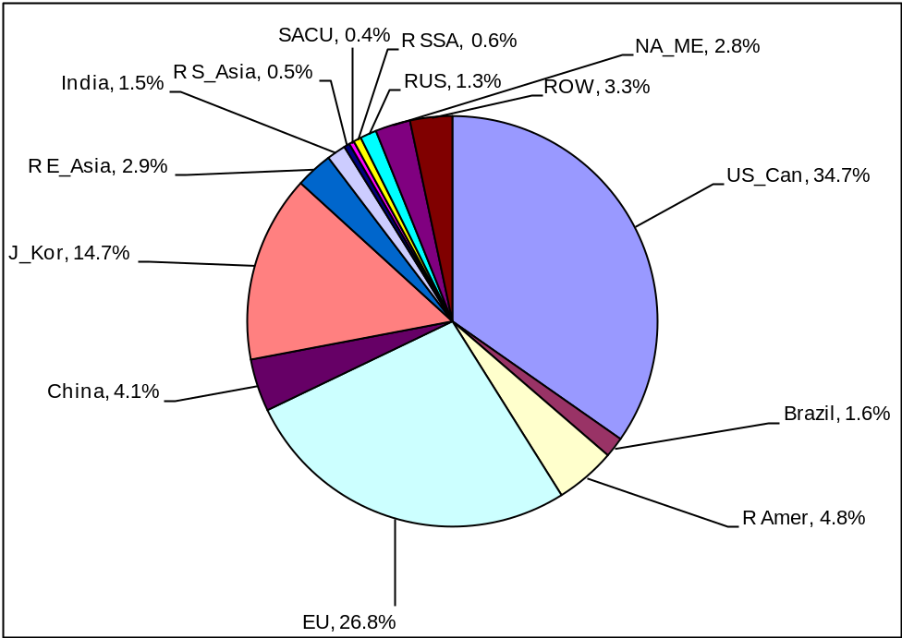
Source: GTAP database aggregation
The aggregation reflects the global distribution of GDP (Figure 3.1): the USA and Canada (US_Can), European Union (EU) and Japan and Korea (J_Kor) account for some 76 percent of global GDP, with no other region in the aggregation accounting for more than 5 percent. In particular China, with 4 percent, and India, with 1.5 percent, are small contributors despite their very large populations. However the global shares of CO2 emissions – Figure 3.2 - present a very different distribution: the large developed economies ‘only’ produce some 52 percent of CO2 emissions while China, with 12.5 percent, and India, with 4 percent, are much more prominent. Indeed many of the lesser developed regions account for shares of CO2 emissions that are multiples– 2 or more times- of their shares of GDP, with Russia standing out with a share of emissions that is nearly 7 times it share of GDP.
This pattern of greater emissions intensity at lower levels of income has been commented on frequently in the literature (see for instance Ang (1995), Ang and Lee (1996), Chen and Rose (1990), and Park et al., (1993)). This is well illustrated in Figure 3.3 where the ratios of the shares of CO2 emissions to shares of GDP are reported; thus while the developed regions produce over half the global emissions of CO2, the rate of CO2 emissions per unit of GDP is appreciably lower. But the expectation is that ceteris paribus the absolute demand for energy use with growth will increase appreciably even if the proportionate increases in energy use are less than the proportionate increases in income and hence CO2 emissions will also grow strongly.

Figure 3.2 Shares of Global Emissions
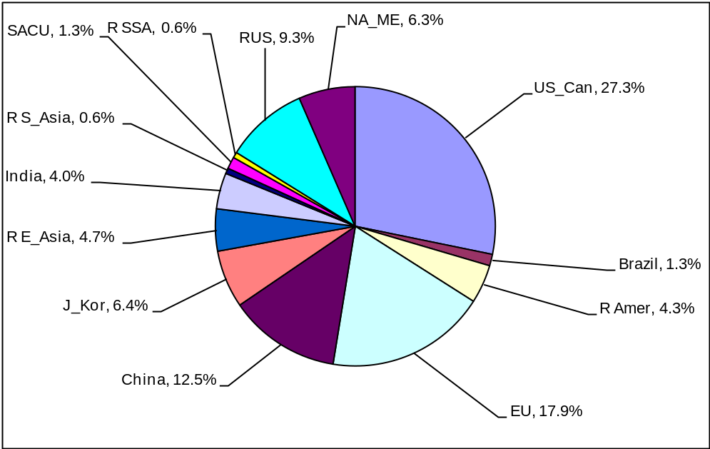
Source: GTAP database aggregation
The ratios in Figures 3.3 and 3.4 are indicative of aspects of the debates over emissions and the distribution of responsibilities for reducing global CO2 emissions. Clearly the lesser developed regions are emitting more CO2 per unit of GDP and therefore controlling the extent to which CO2 emissions increase with growth is important, BUT equalling clearly the majority of emissions are produced by a smallish minority of the world’s population. This is made explicit in Figure 3.4 where no region of the world produces more than 40 percent of the emissions per capita of those produced in the USA and Canada, and the least developed countries all produce appreciably less than 5 percent although China, at 10 percent, is clearly a potentially important contributor to future CO2 emissions.
These data indicate the extent to which different regions have different incentives in the negotiations. Clearly the USA and Canada have reasons to support grandfathered permits since these will provide them with considerable potential for the acquisition of rents, while developing countries have obvious reasons for opposing such schemes since they place serious limits upon their ability to develop/grow. Similarly any trading scheme based on the existing volumes and patterns of emissions is likely to founder on the issue of the distribution of ‘rights’.

Figure 3.3 Ratios of Shares of CO2 Emissions to Shares of GDP
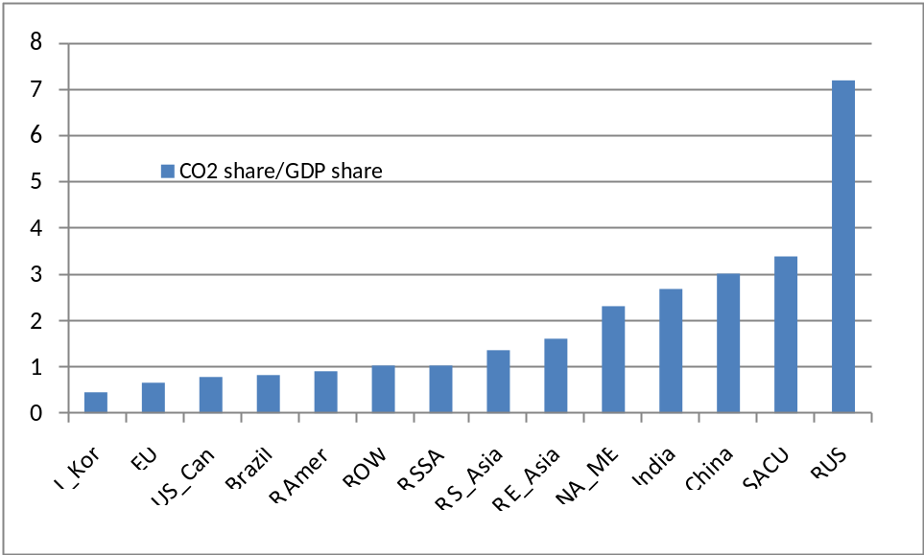
Source: GTAP database aggregation

Figure 3.4 Emissions Per Capita Relative to USA and Canada
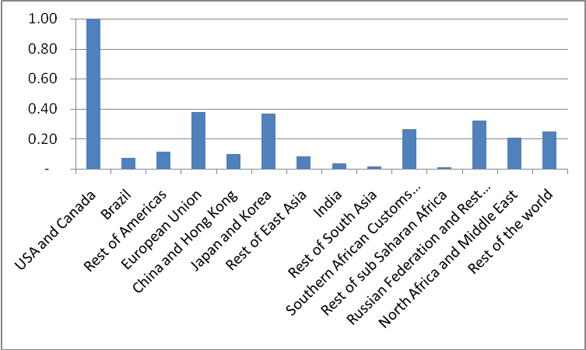
Source: GTAP database aggregation
Given the wide differences in emissions, and energy use, even between regions with relatively similar levels of economic development it is worth questioning the extent to which these differences reflect the current structures of incentive. Table 3.1 reports the sales taxes on energy commodities paid by households in each region; the differences are major with the EU reporting by far the highest rates and the USA and Canada standing out among developed regions for the relatively low rates. Perhaps even more notable than the differences in the rates is the range of rates both across and within regions. These rates alone are enough to suggest that there is some scope for mitigating CO2 emissions by simply revising the structure of taxes rather than engaging in complex carbon offset and trading schemes, which may be necessary but will be difficult subject around which to achieve consensus.

Table 3.1 Sales Tax Rates on Energy Commodities
 | Coal | Oil | Gas | Petroleum coal products | Electricity | Gas/ manufacture distribution
USA and Canada | 0.5 | 0.0 | 1.8 | 73.6 | -0.3 | 2.7
Brazil | 0.0 | 0.0 | 0.0 | 123.3 | 39.9 | 12.4
Rest of Americas | 0.2 | -2.1 | 2.0 | 105.2 | 23.5 | 21.9
European Union | 65.6 | 1.4 | 87.6 | 396.4 | 38.1 | 63.2
China and Hong Kong | 0.0 | 0.0 | 0.0 | 0.0 | -0.5 | 1.2
Japan and Korea | 0.1 | 0.0 | 22.7 | 197.9 | 3.6 | 26.1
Rest of East Asia | -0.2 | -0.4 | 1.8 | 52.9 | -2.4 | 26.4
India | 2.4 | 0.0 | 0.0 | 95.9 | 0.0 | 0.0
Rest of South Asia | 0.0 | 8.2 | 0.0 | 3.1 | -1.6 | 2.6
Southern African Customs Union | 5.9 | 5.9 | 6.0 | 91.2 | 0.0 | 0.0
Rest of sub Saharan Africa | -0.2 | -0.7 | -1.1 | 4.2 | 0.8 | -1.0
Russian Federation & Rest of FSU | 17.3 | 1.0 | 28.5 | 45.4 | -23.2 | 11.2
North Africa and Middle East | 18.7 | 0.4 | 3.1 | 25.2 | 2.7 | -1.3
Rest of the world | 3.9 | -0.6 | 7.5 | 169.3 | 13.5 | 14.8
Source: GTAP database aggregation

3.2 GLOBE_EN CGE Model
The GLOBE_EN CGE model (McDonald and Thierfelder, 2008) is a development of the GLOBE model (McDonald et al., 2007) where the major changes relate to the modelling of production relationships and the recording of taxes on energy use.
The GLOBE model is a member of the class of multi-country, computable general equilibrium (CGE) models that are descendants of the approach to CGE modeling described by Dervis et al. (1982). The model is a SAM-based CGE model, wherein the SAM serves to identify the agents in the economy and provides the database with which the model is calibrated. The SAM also serves an important organizational role since the groups of agents identified in the SAM structure are also used to define sub-matrices of the SAM for which behavioural relationships need to be defined. The implementation of this model, using the GAMS (General Algebraic Modelling System) software, is a direct descendant and extension of the single-country and multi-country CGE models developed in the late 1980s and early 1990s.
The modelling of trade employs the Armington insight in the form of two-level nests of constant elasticity of substitution (CES) functions for imports and two-level nests of constant elasticity of transformation (CET) functions for exports. Appendix 2 briefly describes the modelling of international trade.

Demand
Final demand by the government and for investment is modelled under the assumption that the relative quantities of each commodity demand by these two institutions is fixed—this treatment reflects the absence of a clear theory that defines an appropriate behavioural response by these agents to changes in relative prices. For the household there is a well developed behavioural theory; and the model contains the assumption that households are utility maximisers who respond to changes in relative prices and incomes. In this version of the model, the utility functions for private households are assumed to be Stone Geary functions; for the OECD countries they are parameterised as Cobb Douglas functions, i.e., there are no subsistence expenditures. The utility functions have been altered so that carbon emission taxes can enter into the first-order conditions determining the use of energy commodities by households.

Production System
Production relationships by activities are defined as nested Constant Elasticity of Substitution (CES) production functions. Activity output is a CES aggregate of the quantities of aggregate intermediate inputs and aggregate value added, while aggregate intermediate inputs are a Leontief aggregate of the (individual) intermediate inputs and aggregate value added is a CES aggregate of the quantities of primary inputs demanded by each activity. Producers are assumed to maximize profits, which determines product supply and factor demand. Product markets are assumed to be competitive, and the model solves for equilibrium prices that clear the markets. Factor markets in developed countries are also assumed to have fixed labour supplies, and the model solves for equilibrium wages that clear the markets. In developing countries, however, we assume that the real wage of unskilled labour is fixed and that the supply of unskilled labour is infinitely elastic at that wage. So, labour supply clears the market, and aggregate unskilled employment is endogenous rather than the real wage. In this specification, any shock that would otherwise increase the equilibrium wage will instead lead to increased employment.
The production system is set up as a five-stage nest of CES production functions, where the components at each level are either ‘natural’ inputs, e.g., labour and electricity, or constructs that represent aggregates of both ‘natural’ and/or other aggregate inputs. The tree diagram illustrations in Figures 4 and 5 are drawn with explicit reference to the structure of the data available in the GTAP database; as such the description of the model presented here refers to applications of the model that utilise only the transactions data provided in the basic GTAP database. In addition to simplify exposition several simplifying assumptions are imposed. First there are only three primary inputs (labour (l), land (n) and capital (k)), two non-energy intermediate inputs (cegn1 and cegn2) and three energy intermediate inputs (electricity (el) and two non-electricity energy intermediates (ceg1 and ceg2)). Second, the description of the nesting structure is restrictive in the sense that variations in the components of the sub aggregates that can be governed by set membership are ignored. And third, other nesting structures that can be imposed are not explored (see McDonald and Tlhalefang, 2001, for a review of nesting structures found in the literature).

Figure 4 Production Quantity System for a Typical Region with Energy Nests
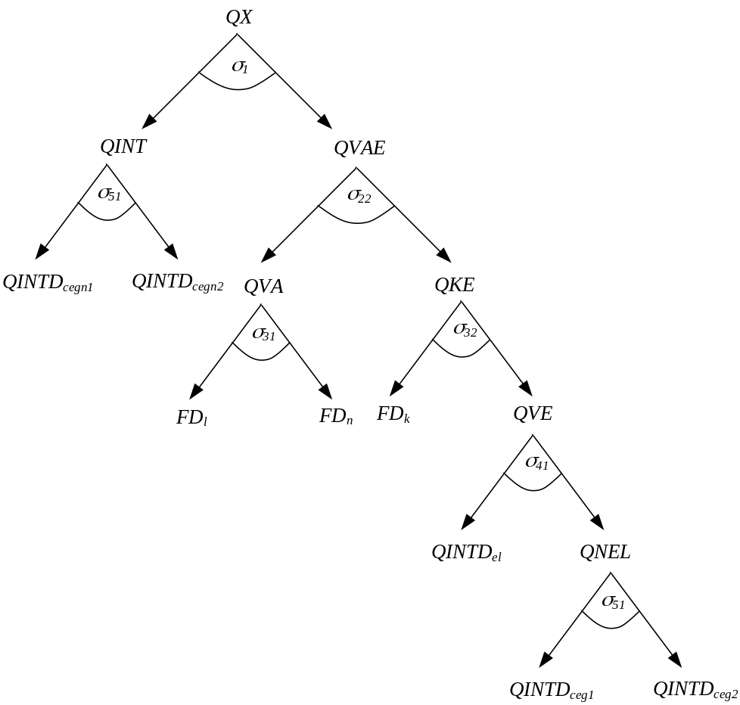
At the top level aggregate non-energy intermediate inputs (QINT) are combined with aggregate of primary and energy inputs (QVAE) to produce the output of an activity (QX) using a standard two argument CES function. At all levels the production functions can take either CES or Leontief forms, with CES being the default and the elasticities being activity and region specific. The model allows the user to specify the share of cost in total cost for each aggregate below which the Leontief alternatives are automatically selected.
The second level aggregate of non-energy intermediate inputs is a Leontief aggregation of the individual non-energy intermediate inputs where the input-output coefficients (ioqint) are defined in terms of non-energy input quantities relative to the non-energy aggregate intermediate input and non-energy intermediate inputs are a subset (cegn) of all intermediate inputs. The value added-energy aggregate (QVAE) is standard two argument CES function of aggregates of capital-energy (QKE) and other (non-capital) primary inputs (QVA).
The value added (QVA) production function is a standard CES function over all non-capital primary inputs, with the elasticities being activity and region specific. Note how the inputs to aggregate value added include ‘natural’ inputs (labour (FD_{l}) and land (FD_{n})) and hence the operation of this aggregator function can, of course, be influenced by choices over the market clearing rules for factor accounts, e.g., it may be the case that there is unemployed labour or a short-run case is being examined where the supply of land to an activity is fixed. The capital-energy aggregate (QKE) is a standard two argument CES function of aggregate of energy (QVE) and capital (FD_{k}), and because one of the arguments is a ‘natural’ inputs the issue of the conditions for factor market clearing become relevant.
The fourth and fifth levels of the production nest distinguish between electricity and other energy inputs where the other energy inputs are directly based on fossil fuels; an important reason for this distinction is the use of fossil fuels in the generation of electricity. At the fourth level aggregate energy (QVE) is defined by a standard CES function over two arguments – electricity (QINTD_{el}) and an aggregate of other energy inputs (QNEL) - with the elasticities being activity and region specific. And finally at the fifth level the aggregate of non-electricity inputs (QNEL) is defined by a multi argument CES function over non-electivity energy inputs (QINTD_{ceg}).
At all levels the optimum combinations of inputs, be they ‘natural’ or constructed aggregates, are determined by relative prices. Hence the price system and associated taxes are important, while in addition to the prices for ‘natural’ inputs it is necessary for there to be prices for each constructed aggregate. These are illustrated in Figure 4.
The price system contains a series of constructed prices for the aggregates, i.e., PINT, the price of aggregate non-energy intermediates, PVAE, the price of the value added-energy aggregate, PVA, the price of the non-capital primary input aggregate, PKE, the price of the capital-energy aggregate, PVE, the price of aggregate energy, and PNEL, the price of the non-electricity energy aggregate, and prices for ‘natural’ inputs. Ignoring for the moment the issue of taxes, the factor prices (WF) for the primary inputs are allowed to be both factor and activity specific (see below in section 4 where a formal description of the equations is provided), while for the energy inputs the prices are only input specific, i.e., the standard ‘law’ of one price conditions hold.

Figure 5 Production Price System for a Typical Region with Energy Nests
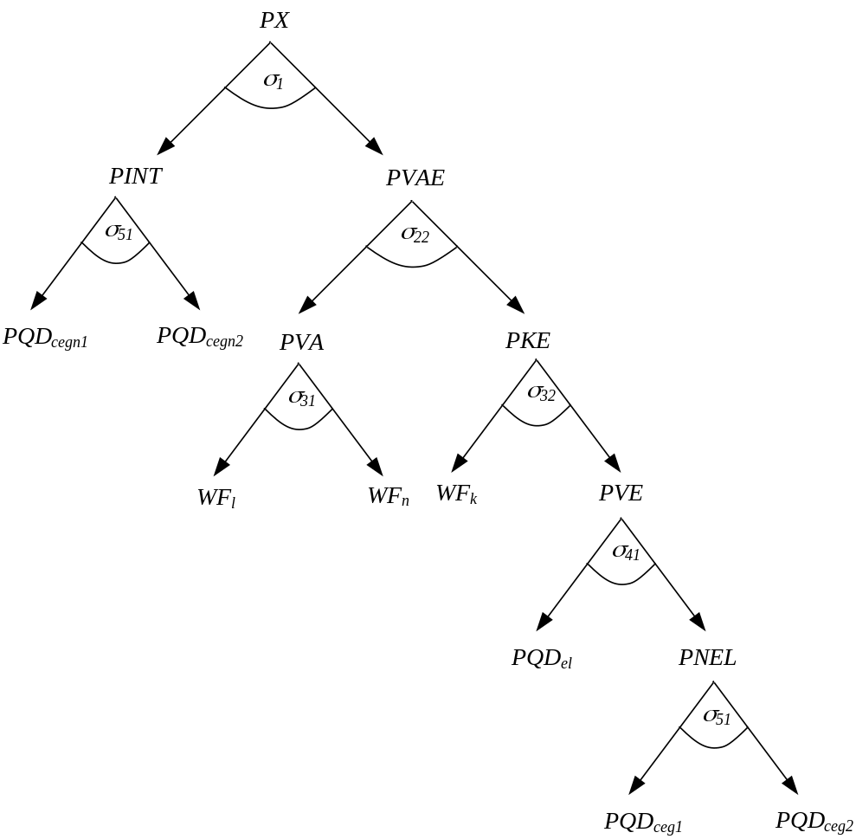
Taxes are however a critical consideration and one of the main instruments available to influence the use energy inputs. In this model no taxes are levied on the constructed aggregates and all taxes are levied solely on the ‘natural’ inputs. For factor use taxes the model follows the approach in the GLOBE model wherein factor use taxes are both factor and activity specific and therefore the taxes enter into the first order conditions for optimum factor use. This approach allows the government to adjust taxes not only on the basis of the factor but also on the basis of the activity that uses the factor, which creates policy space in the model. For exactly the same reason the model allows taxes on energy intermediate inputs to be both input and activity specific, which ensures that the taxes enter into the decision processes that determined the optimum use of each energy input by each activity.

4. Policy Experiments and Model Closure

4.1. Policy Experiments
The first series of policy experiments are concerned with the implications the widely differing tax rates on energy commodities. The experiments shed light on the extent to which differences in tax rates on energy commodities contribute (indirectly) to CO2 emissions. For each simulation tax replacement constraints are imposed to ensure that all adjustments are constrained to take place with the transition between states of the world.
- Uniform global tax rates on energy commodities equal to the average rates applied by all regions across all purchasing agents – this involves removing all intermediate input energy tax rebates.
- Uniform global energy tax rates on energy commodities equal to the rates applied by the EU, with intermediate input energy tax rebate set at EU rates.
- Uniform energy tax rates on energy commodities for all OECD regions equal to the rates applied by the EU, with intermediate input energy tax rebate set at EU rates.
- Implementation of a VAT system for taxation of energy products
The second series of policy experiments concentrate on the impact of emissions tax on CO2 emissions both in addition to the existing energy taxes and as replacements for energy taxes; taxes on emissions involve not just taxes on the quantities of an input used but also on the inherent nature of energy inputs, e.g., ‘dirty’ vs ‘clean’ coal, and the technologies with which the inputs are used.
The second set of policy experiments focus on replacing energy taxes with emissions taxes and with determining the emissions tax rates required to achieve reductions in emissions.
- Removal of ALL energy taxes and rebates by ALL regions, with emissions tax rates on CO2 endogenously determined to produce identical tax revenues.
- Removal of ALL energy taxes and rebates by ALL regions, with emissions tax rates on CO2 endogenously determined to produce a 10% reduction in emissions of CO2 by ALL regions.

4.2 Model Closure & Sensitivity Analysis
All CGE models are sensitive to the selection of macroeconomic closure and market clearing conditions. For this model the basic closure and market clearing conditions are:
- Foreign Exchange Closure: All external (trade) balances are assumed fixed in real terms (relative to the global numéraire) and exchange rates are assumed to be flexible so that changes in the exchanges rates clear the foreign exchange market.
- Investment-Savings Closure: the volumes of investment are fixed and household savings rates are (additively) variable so that the capital accounts are cleared by changes in household savings.
- Government Account Closure: the government is assumed to spend a fixed share of domestic absorption (part of a so-called balanced macroeconomic closure) and to maintain a fixed internal (government) deficit; given changes in taxes and the general level of economic activities the government accounts are cleared by changes in the direct tax rates levied on households.
- Numéraire: the region numéraire are the region specific consumer price indices – hence changes in value variables are all real – and the global numéraire is an index of the exchange rates for the OECD regions – USA & Canada, EU and Japan.
The factor market clearing presumption is that for all regions skilled labour, capital and land are fully employed and mobile between sector; the same applies to skilled labour in developed and middle income countries but for the least developed regions it is assumed that there is a perfectly elastic supply of labour at a fixed real wager rate. In all cases technology is assumed to the constant, i.e., the shift ‘parameters’ in the production/aggregator functions are constant.

5. Results

Energy Tax Experiments
The simple experiments whereby energy tax rates are equalised across regions have straightforward consequences on overall economic activity. The increases in energy taxes in most regions produce reductions in real GDP (Figure 5.1); for some regions the decline in real GDP is substantial and typically in the order of 2 percent or more. The only exceptions are the EU and Rest of World regions, for whom the world average rates mean a reduction in current energy tax rates, and the least developed regions when they are not required to change applied rates. Although the changes in tax rates are tax revenue neutral within regions the impacts on real GDP are negative because, in large part, the energy tax revenues are offset by reductions in income taxes, which are less distortionary. This is an expected result given the choice of tax replacement instrument and indeed when other indirect tax instruments, e.g., taxes on production and or sales taxes on non energy commodities, are chosen as tax replacement instruments it is possible to substantially reduce the reductions in real GDP and with some configurations to reduce them to almost zero.

Figure 5.1 Real GDP (% change)
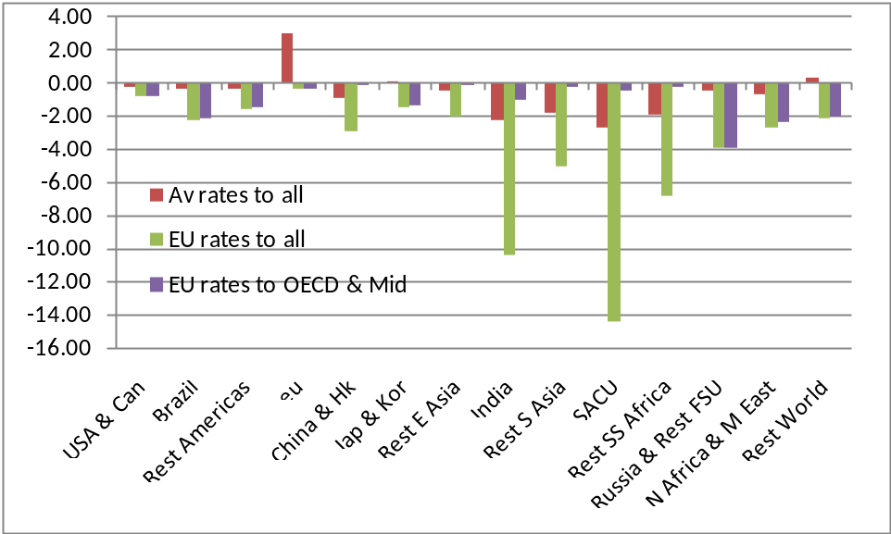
Source: Model simulations.
However the main concern is with the extent to which CO2 emissions might change simply through changes that broadly equalise energy tax rates. Estimates of changes in CO2 emissions are reported in Figure 5.2; these suggest that the simple harmonisation of energy tax rates could make a substantial difference to the level of global CO2 emissions without resorting to more complex carbon trading, carbon offset or mitigation strategies. It is also important to note that excluding the least developed regions from a requirement to equalise energy taxes only has a small adverse impact on the degree of reduction in emissions.
At first sight the magnitude of these reductions in CO2 emissions might appear surprising but a casual review of the initial emission levels and energy tax rates does support a contention that a simple equalisation of incentives might have substantial impacts on emissions. There are also reasons to argue for such a change on the grounds of competitiveness since higher energy tax rates raise production costs and hence regions with currently high energy tax rates are arguably compromised.

Figure 5.2 CO2 Emissions (% change)
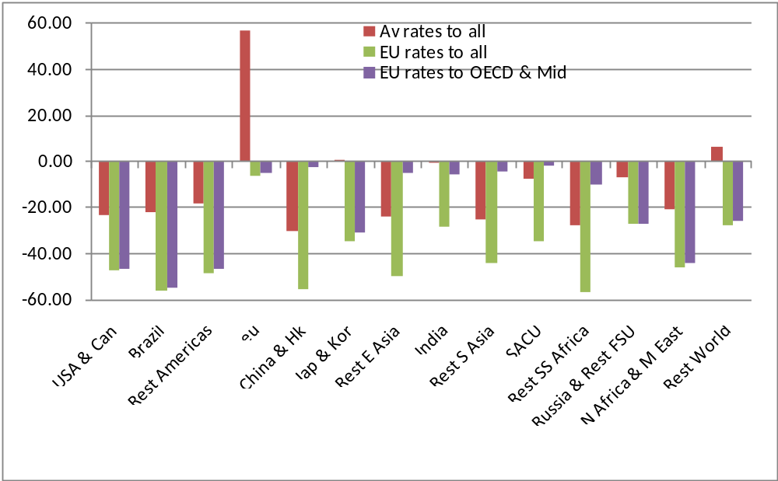
Source: Model simulations.

Figure 5.3 Welfare ($bn Equivalent variation by region)
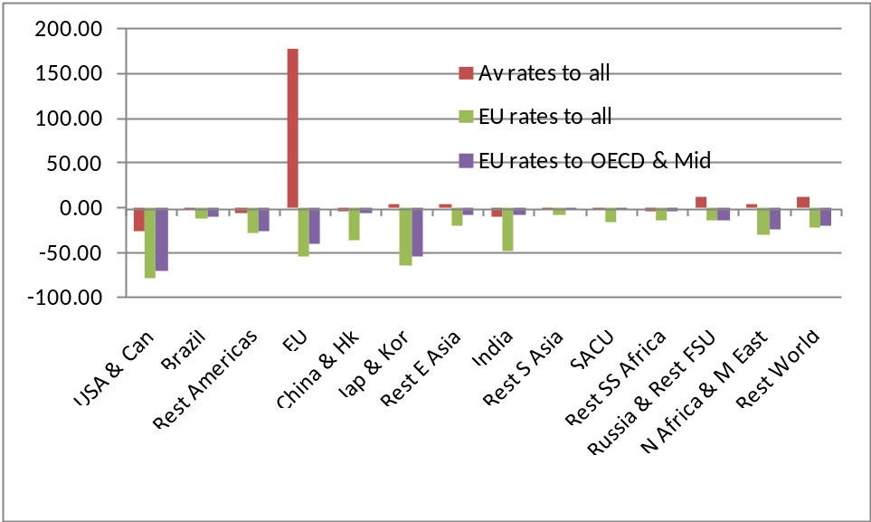
Source: Model simulations.
The welfare changes estimates by regions are broadly consistent with the real GDP estimates, but provide the useful additional indication of the magnitudes of the real changes obscured by the percentage changes in real GDP. However they do expose how large in absolute terms the adverse implications would be for least developed regions and China from substantial increases in energy tax rates even when no allowances are made for the impacts of the legitimate growth aspirations of these regions. Interestingly excluding the least developed regions from the energy tax equalisation scheme massively reduces the adverse impacts on those regions AND reduces the adverse impacts on all other regions, which suggests that developed countries could exempt the least developed regions by applying even high tax rates so as to achieve a desired global reduction in emissions without additional adverse economic costs.

Figure 5.4 Income Tax Rates (Changes in % rate)
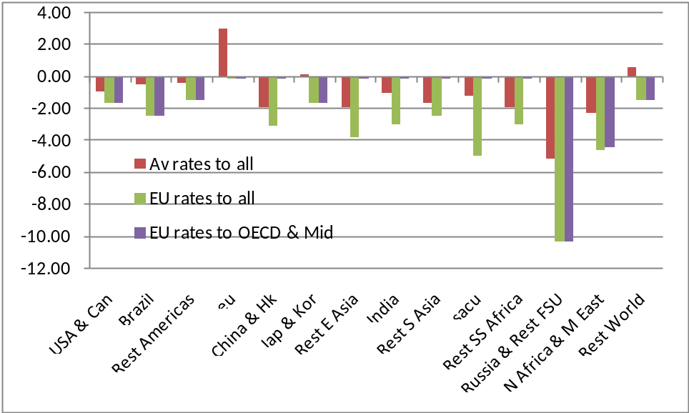
Source: Model simulations.
However there are reasons for concern with these scenarios. First the changes in direct tax rates, required to achieve budget neutrality, (Figure 5.4) are typically large relative to the tax base in many least developed economies, especially when allowance is made for the limited income tax base. This issue largely disappears when the least developed countries are left out of the tax equalisation scheme but the changes in middle income regions remain large, while, as is so often the case in this type of exercise, the impacts on the developed regions are often small in percentage terms. And second, the adverse impacts on employment in the least developed region (see Figure 5.5) are substantial, which confirms that some means of satisfying the aspirations of the least developed and developing regions will be essential to the achievement of any agreement for reducing CO2 emissions.

Figure 5.5 Employment of Unskilled Labour (% change)
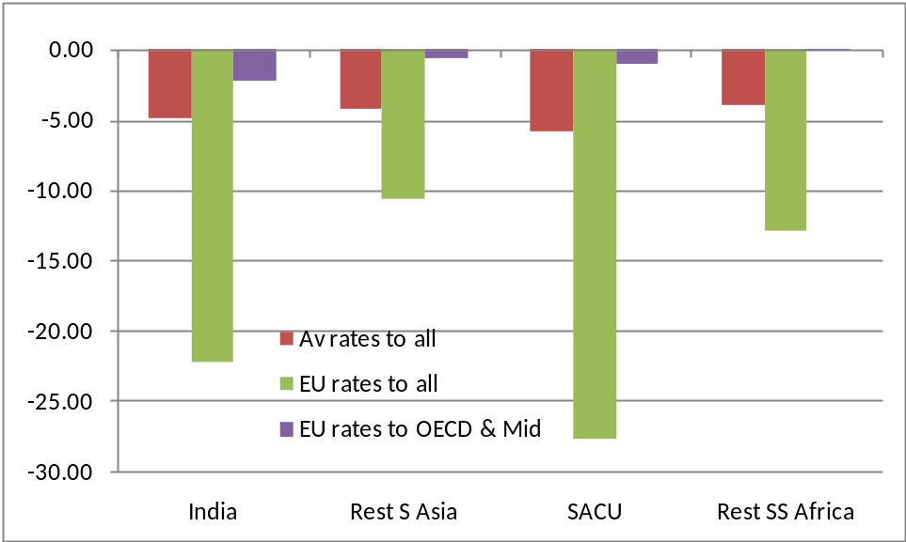
Source: Model simulations.

Emission Tax Experiments
The implications of switching from energy taxes to emissions taxes in a manner that is revenue neutral within each region, i.e., with no international coordination, are remarkably different to those resulting from equalisation of energy tax rates (see Figure 5.6). Simply switching to emission taxes has a broadly neutral impact on global GDP with most regions reporting either a small increase or small decrease in real GDP. On the other hand the adoption of region specific carbon tax rates that produce 10% reductions in emissions in every region have an appreciable positive impact on global real GDP, but the exceptions are concentrated in the least developed and middle income countries.
An interesting consequence of the differences in the initial energy tax rates between regions is that emission taxes that are energy tax revenue neutral produce major differences in emission reductions. In particular China, Russia, the Rest of South Asia and North Africa and the Middle East stand out as the regions whose low current taxes on energy use suggest that a move to emission taxes may have adverse welfare impacts. However the welfare results (Figure 5.8) do not indicate that this is likely to be the case. Only the USA and Canada lose welfare in both cases where energy taxes are replacement with emission taxes, and in the case of the revenue neutral simulations the EU and the Rest of the World lose out because their current energy tax rates are so high.

Figure 5.6 Real GDP (% change)
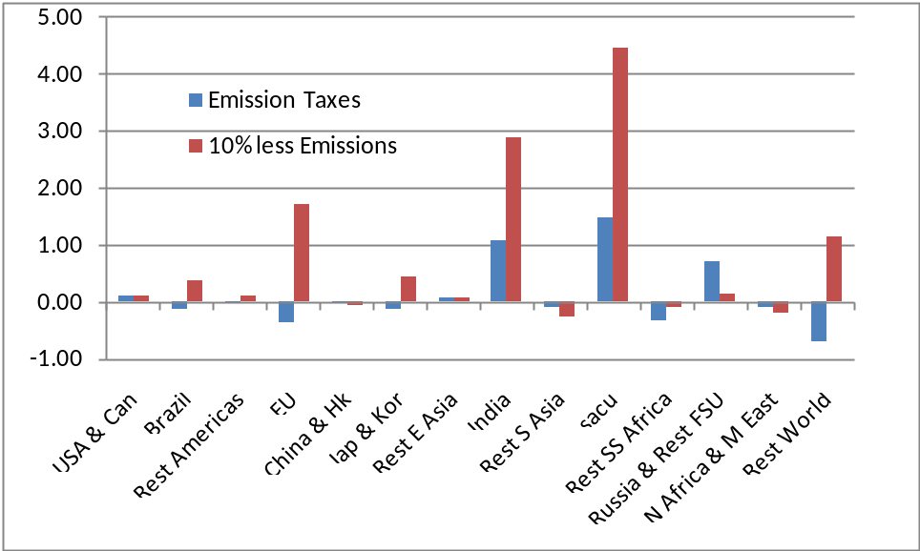
Source: Model simulations.

Figure 5.7 CO2 Emissions (% change)
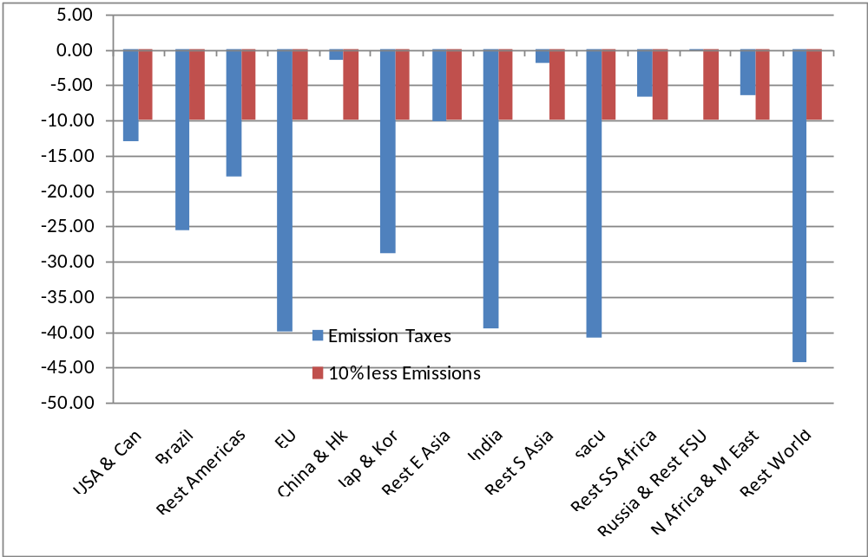
Source: Model simulations.
Overall however the implication is clear. A substantial reduction in emissions should be achievable simply through the replacement of existing taxes on energy with taxes on emissions but, as is always the case, while there are some regions that would experience net welfare losses these are small and are primarily concentrated in the developed regions that should be most able to bear the burden. Furthermore for no region are energy taxes preferable to emission taxes from the perspective of either economic welfare or emissions.

Figure 5.8 Welfare ($bn Equivalent variation by region)
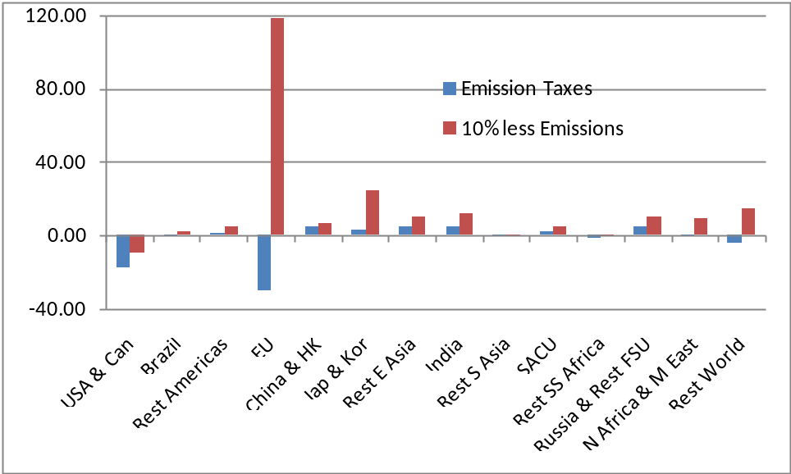
Source: Model simulations.
Indeed not only do emission taxes appear to be unambiguously preferable they also come out as relatively development friendly. The impacts on employment (see Figure 5.9) in the least developed regions are either neutral or positive with particularly strong positive impacts on employment in India. The required carbon tax rates (Figure 5.10) do however convey a warning; the required emission tax rates in regions that current have high energy tax rates and relative low emission rates given their high income – EU, Japan and Korea and Rest of the World – do end up with relatively high tax rates on emissions to achieve the same reductions in emissions. While at first this seems to be an anomaly the explanation is fairly obvious; given the currently relatively low rates of emissions the tax effort required to further reduce emissions is higher. Thus the USA and Canada come out from this type of scenario as benefiting from previously low tax rates on energy and high emission volumes.

Figure 5.9 Employment of Unskilled Labour (% change)
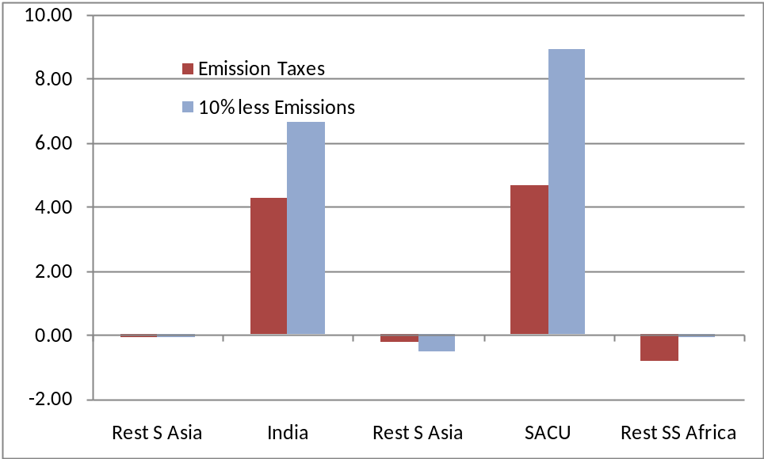
Source: Model simulations.

Table 5.10 Carbon Tax Rates (Levels %)
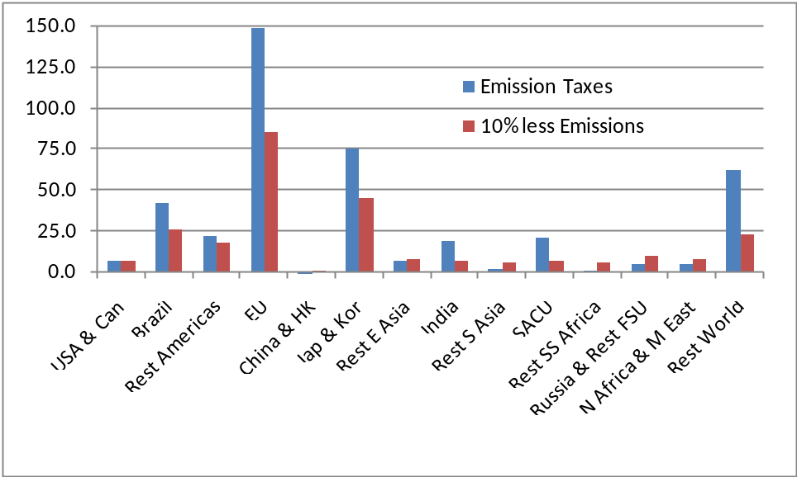
Source: Model simulations.

6. Concluding Comments
The analysis in this paper is designed to examine the effects of tax regimes on CO2 emissions. Scenario results suggest that the simple harmonisation of energy tax rates could make a substantial difference to the level of global CO2 emissions without resorting to more complex carbon trading, carbon offset or mitigation strategies. Furthermore, much of the benefits accrue even when the least developed regions are excluded from tax policies. For example, excluding the least developed regions from a requirement to equalise energy taxes only has a small adverse impact on the degree of reduction in emissions. Interestingly excluding the least developed regions from the energy tax equalisation scheme massively reduces the adverse impacts on those regions AND reduces the adverse impacts on all other regions, which suggests that developed countries could exempt the least developed regions by applying even high tax rates so as to achieve a desired global reduction in emissions without additional adverse economic costs.
In terms of tax instruments, results suggest that switching from energy taxes to emission taxes would be more effective at reduction CO2 emissions. For most regions, such a policy change would improve welfare and real GDP.

References
Ang, B. W. (1995): “Multilevel decomposition of industrial energy consumption”. Energy Economics 17 (1): 39 – 51.
Ang, B. W. and P. W. Lee (1996): “Decomposition of industrial energy consumption: the energy coefficient approach”. Energy Economics 18 (1 – 2): 129 – 143.
Chen, C. Y. and A. Rose (1990): “A structural decomposition analysis of energy demand in Taiwan”. The Energy Journal 11 (1): 127 – 146.
Dervis, K., de Melo, J. and Robinson, S., (1982). General Equilibrium Models for Development Policy. Washington: World Bank.
Dimaranan, B. V., (ed) (2006). Global Trade, Assistance, and Production: The GTAP 6 Data Base. Center for Global Trade Analysis, Purdue University.
Goulder, L.H., Parry, I.W.H., and Burtraw, D., (1997). ‘Revenue-raising vs. other Approaches to Environmental Protection: The Critical Significance of Pre-existing Tax Distortions’, Rand Journal of Economics, 28, 708-31.
Goulder, L.H., Parry, I.W.H., Williams, R.C., and Burtraw, D., (1999). ‘The Cost-Effectivenesss of Alternative Instruments for Environmental Protection in a Second-Best Setting’, Journal of Public Economics, 72, 329-60.
Hertel, T.W., (1997). Global Trade Analysis: Modeling and Applications. Cambridge: Cambridge University Press.
Lin, X. and K. R. Polenske (1995): “Input-Output Anatomy of China’s Energy Use Changes in the 1980s”. Economic Systems Research 7 (1): 67 – 84.
McDonald, S, and Thierfelder, K., (2004). ‘Deriving a Global Social Accounting Matrix from GTAP version 5 Data’, GTAP Technical Paper 23. Global Trade Analysis Project: Purdue University.
McDonald, S. and Sonmez, Y., (2004). ‘Augmenting the GTAP Database with Data on Inter-Regional Transactions’, Sheffield Economics Research Paper 2004:009. The University of Sheffield.
McDonald, S. and Thierfelder, K.., (2008). ‘GLOBE-EN: Global CGE Energy Model’, mimeo.
McDonald, S., (2007). ‘‘Prices, Social Accounts and Economic Models’, 10th Annual Conference on Global Economic Analysis, Purdue University, June.
McDonald, S., Thierfelder, K. and Robinson, S., (2007). ‘GLOBE: A SAM Based Global CGE Model using GTAP Data’, Department of Economics Working Paper 14, United States Naval Academy. http://ideas.repec.org/s/usn/usnawp.html
McDonald, Scott (2006). Deriving Reduced Form Global Social Accounting Matrices from GTAP Data, mimeo.
Nordhaus, W.D., (1993). ‘Optimal Greenhouse Gas Reductions and Tax Policy in the DICE Model’, American Economic Review, 83, 313-17.
Oates, W.E., (1995). ‘Green Taxes: Can We Protect the Environment and Improve the Tax System at the Same Time’, Southern Economic Journal, 61, 915-22.
Park, S. – H., B. Dissmann and K. – Y. Nam (1993): “A Cross – Country Decomposition Analysis of Manufacturing Energy Consumption”. Energy 18 (8): 843 – 858.
Parry, I.W.H., (2003). ‘Fiscal Interactions and the Case for Carbon Taxes over Grandfathered Carbon Permits’, Oxford Review of Economic Policy, 19, 385-99.
Pearce, D.W., (1991). ‘The Role of Carbon Taxes in Adjusting to Global Warming’, Economic Journal, 101, 938-48.

Appendix 1

Appendix 2

Standard Features of the GLOBE Model
Trade is modelled using a treatment derived from the Armington “insight”; namely domestically produced commodities are assumed to be imperfect substitutes for traded goods, both imports and exports. The properties of models using the Armington insight are well known. Import demand is modelled via a series of nested constant elasticity of substitution (CES) functions; imported commodities from different source regions to a destination region are assumed to be imperfect substitutes for each other and are aggregated to form composite import commodities that are assumed to be imperfect substitutes for their counterpart domestic commodities The composite imported commodities and their counterpart domestic commodities are then combined to produce composite commodities, which are the commodities demanded by domestic agents as intermediate inputs and final demand (private consumption, government, and investment). The presumption of imperfect substitutability between imports from different sources is relaxed where the imports of a commodity from a source region account for a ‘small’ (value) share of imports of that commodity by the destination region. In such cases the destination region is assumed to import the commodity from the source region in fixed shares: this is a novel feature of the model introduced to ameliorate the terms of trade effects associated with small trade shares.
Export supply is modelled via a series of nested constant elasticity of transformation (CET) functions; the composite export commodities are assumed to be imperfect substitutes for domestically consumed commodities, while the exported commodities from a source region to different destination regions are assumed to be imperfect substitutes for each other. The composite exported commodities and their counterpart domestic commodities are then combined as composite production commodities. The use of nested CET functions for export supply implies that domestic producers adjust their export supply decisions in response to changes in the relative prices of exports and domestic commodities. This specification is desirable in a global model with a mix of developing and developed countries that produce different kinds of traded goods with the same aggregate commodity classification, and yields more realistic behaviour of international prices than models assuming perfect substitution on the export side.
Agents are assumed to determine their optimal demand for and supply of commodities as functions of relative prices, and the model simulates the operation of national commodity and factor markets and international commodity markets. Each source region exports commodities to destination regions at prices that are valued free on board (fob). Fixed quantities of trade services are incurred for each unit of a commodity exported between each and every source and destination, yielding import prices at each destination that include carriage, insurance and freight charges (cif). The cif prices are the ‘landed’ prices expressed in global currency units. To these are added any import duties and other taxes, and the resultant price converted into domestic currency units using the exchange rate to get the source region specific import price. The price of the composite import commodity is a weighted aggregate of the region-specific import prices, while the domestic supply price of the composite commodity is a weighted aggregate of the import commodity price and the price of domestically produced commodities sold on the domestic market.
The prices received by domestic producers for their output are weighted aggregates of the domestic price and the aggregate export prices, which are themselves weighted aggregates of the prices received for exports to each region in domestic currency units. The fob export prices are then determined by the subtraction of any export taxes and converted into global currency units using the regional exchange rate.
There are two important features of the price system in this model that deserve special mention. First, each region has its own numéraire such that all prices within a region are defined relative to the region’s numéraire. We specify a fixed aggregate consumer price index to define the regional numéraire. For each region, the real exchange rate variable ensures that the regional trade-balance constraint is satisfied when the regional trade balances are fixed. Second, in addition, there is a global numéraire such that all exchange rates are expressed relative to this numéraire. The global numéraire is defined as a weighted average of the exchange rates for a user defined region or group of regions. In this implementation of GLOBE the basket of regions approximates the OECD economies.
Fixed country trade balances are specified in “real” terms defined by the global numéraire. If the global numéraire is the US exchange rate and it is fixed to one, then the trade balances are “real” variables defined in terms of the value of US exports. If global numéraire is a weighted exchange rate for a group of regions, as in this case, and it is fixed to one, then the trade balances are “claims” against the weighted average of exports by the group of regions in the numéraire.

There are obvious reasons to be concerned that the data for Russia may be inaccurate given the scale of the differences in the ratios.
In particular the version of the model described here does not make use of the satellite account data on emissions of greenhouse gases (GHG) that are available in the extended version of the GTAP database.
The nesting structure described is typical of the structures found in energy CGE models. In explorations of the implications of different nesting structures using a model for Botswana Tlhaelfang (2006) found that while the macroeconomic implications are relatively unaffected the distributional effects are more pronounced.
In practice the tax rates are defined as deviations from the taxes levied on energy inputs purchased by households.
Note that in ALL experiments there is an overriding tax replacement adjustment taking place through the income tax rates; this is needed to allow for fluctuations in incomes associated with the adoption of emission taxes.

