producer services and trade in manufactured goods

Hildegunn Kyvik Nordås
Trade and Agriculture Directorate, OECD

Abstract

This study analyses the interrelationship between goods and producer services in production and trade using the most recent input-output tables for all OECD countries. It first presents descriptive statistics that illustrate the role of services in production and trade in goods. Trade in services could in principle contribute to a broader services supplier base that supports competitiveness in high-technology and high-value added manufacturing. However, cross-border trade in producer services is often quite marginal and commercial presence appears to be the favoured mode of servicing foreign markets. Simulations using a CGE model show how reduction of services trade costs affect the production structure and trade in goods. Countries with superior organizational technology (using producer services more effectively) will specialize in manufacturing. With low, but still significant trade costs in services, large countries will have a comparative advantage for services-intensive manufactured goods, an advantage that is enhanced if the country also produces intermediate services more effectively or has lower barriers to entry in this sector.

Keywords: Producer services, trade, general equilibrium modelling.
JEL: F10, F47.

1. INTRODUCTION
Most services play a role in the production and marketing of goods. Business services provide direct inputs into the production of goods; transport, logistics, wholesale and retail trade ease the flow of products between different stages of production and from producers to final customers; R&D helps improve the quality of products and processes; health and education services improve the quality of human capital; while financial services facilitate transactions within and across international borders and channel funds to investment in sectors of comparative advantage.

When producer services are subject to trade costs, local services can be a source of comparative advantage in the same way as (skilled) labour, relatively abundant capital endowments or natural resources can. Furthermore, some generic services such as sufficiently sophisticated telecommunications, effective financial markets and reliable electricity are necessary in order to use modern capital equipment, including software (which is classified as capital in many countries). Lower costs or better quality of such services thus has a similar effect as capital-augmenting technical progress. By the same token education and health services may have a similar effect as labour-augmenting technical progress.

Manufacturing has become more complex with technological development, changing demand patterns and a changing regulatory environment. Consumers are increasingly concerned about safety and ethical aspects not only related to the products that they buy, but also to the way the consumer goods have been produced. Consumer concerns as well as new government regulation raise new challenges and a growing demand for services that complement and support trade in goods. Market research, labelling, testing and auditing in relations to social responsibility standards are examples of services that are increasingly necessary for manufacturers to get their products on to the shop-shelves.

Not all new tasks can be rationally produced inside the manufacturing firm and an increasing number of tasks are therefore provided by external suppliers. It appears that new tasks in particular; e.g. tasks related to entering new markets or complying with new regulation, are largely sourced from outside suppliers. The tasks that are conducted within manufacturing firms in contrast appear to have become increasingly specialized within clusters of related core competencies. Focusing on a narrower band of tasks helps firms improve productivity as they substitute internal economies of scope for economies of scale (Bryson et al., 2004).

In spite of a growing share of intermediate services in the manufacturing cost function, it appears that in-house services production as measured by the share of non-production workers has not declined (Pilat and Wölfl, 2005; Miles, 2007). It is therefore argued that services trade is not only a matter of outsourcing services that were previously provided in-house or locally, but more importantly it is a process of adding new tasks that are largely complementary to and supportive of in-house services production in manufacturing firms and their local suppliers. This study focuses on services that enter into the production and distribution of manufactured goods directly and how they affect competitiveness and comparative advantage in manufacturing. It proposes a general equilibrium model that captures the linkages between services and manufacturing and simulates the impact of services trade liberalization on trade in manufactured goods.

The model simulations explore to what extent international trade in servicers can alleviate the disadvantage that manufacturing firms in developing countries encounter due to lack of adequate services inputs. Would services trade liberalisation bring much needed state-of-the art intermediate services to manufacturers in developing countries? Conversely to what extent would services trade liberalization strengthen comparative advantage in high-technology manufacturing in OECD countries? Would lower costs of internationally sourced services help these manufacturers sustain their competitiveness in the face of growing competition from emerging markets? It is conceivable that if services become globalised and available to manufacturers everywhere, their role as a source of comparative advantage could diminish.

Competitiveness in manufacturing stems not only from costs and technology in the production of each part, component and final output, but also from superior ways of organizing production. Japan’s just-in-time technology and quality circles are celebrated examples. A particularly interesting and hitherto unexplored scenario is one in which countries differ in how effectively manufacturers use intermediate services. Model simulations show that in countries where companies use services more effectively net manufacturing exports will increase following services trade liberalization, although the manufacturing sector becomes “hollowed out”.

The analysis is related to Markusen (1989) who demonstrated that while trade in final goods improves the allocation efficiency of the economy, trade in intermediate inputs also reduces production costs by providing new, better or cheaper inputs. Subsequent literature has shown that one of the most important gains from trade stems from the expansion of the variety of inputs that manufacturers can choose from. With a broader intermediate supplier base, it is easier to find a good match between inputs used in the production process, reducing firms’ search costs (McLaren, 2000).

The paper that comes closest to this study in spirit is, however, Robert-Nicoud (2008) who develops a model in which offshoring of production of intermediate parts and components is distinguished from offshoring of (routine) tasks. Trade in parts and components is subject to (iceberg) transport costs while trade in tasks is subject to (iceberg) communication costs. As is well known from the new economic geography literature, at a range of intermediate trade costs, advanced manufacturing tends to cluster in the largest market, while standardised low-technology industries tend to locate where labour costs are the lowest. Robert-Nicoud (2008) shows that offshoring of routine tasks expands the range of trade costs that sustains this pattern of specialisation. Conversely, restricting trade in tasks may encourage the relocation of the entire manufacturing supply chain to low-cost countries.

A key question when constructing the model is whether intermediate services are substitutes or complements to intermediate goods and the primary factors of production. An example of substitutability is for instance better utilization of a sheet of steel in the shipbuilding industry due to better engineering. Another example is supply chain management services, which also reduces unit material input requirements. In other cases material and services inputs may be complementary, either due to technology or due to regulation. The most obvious case that comes to mind is the need for frequent laboratory tests related to the use of chemicals in pharmaceuticals, food processing and many other industries.

The rest of the study is organised as follows: Section 2 sets the stage for the empirical analysis by presenting calculations of direct and indirect services content of production and trade in manufactures, using input-output analysis. Section 3 presents the model and simulation results, while section 4 summarizes and concludes.

2. DESCRIPTIVE STATISTICS
Intermediate services inputs accounted for between 13 and 30% of total industry output, or total costs, in the manufacturing sector in the year 2000 in the countries included in the OECD input-output database, as depicted in Figure 1. Ireland clearly has the most services-intensive manufacturing sector, followed by Sweden, Italy and the United States. At the other end of the spectrum are China, Brazil and Hungary. The top nine countries have experienced an increase in the cost share of services in the manufacturing sector, while South Africa, Hungary and Canada have experienced a significant decline.
Figure 1. Intermediate services share of industry output, total manufacturing, 1995 and 2000.
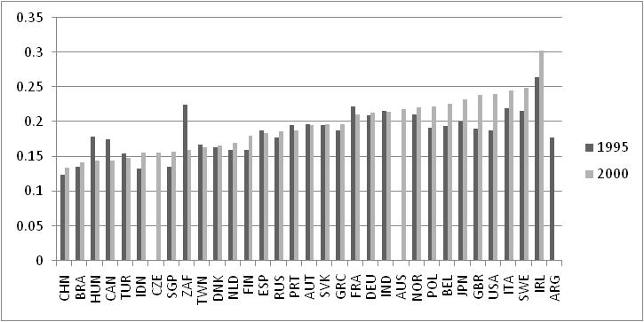
Source: Calculated from the OECD input-output database.
Note: Data for Australia is from 1998/99, Greece and Portugal 1995 and 1999, Hungary and Ireland 1998 and 2000, India 1993/94 and 1998/99, Turkey 1996 and 1998 and South Africa for 1993 and 2000.

There are many possible explanations for changes in the cost share of services in the manufacturing sector. One possibility is outsourcing of services to outside suppliers, in which case outside services suppliers replace in-house value added in the manufacturing firm. In order to investigate this explanation, I calculated the services inputs to value added ratio and compared the results for the two years. The result is depicted in Figure 2. Belgium had the highest ratio in 2000, followed by Ireland, Japan and Italy. The increase in the services share for these economies may thus be partly due to outsourcing. By the same token, the decline in the services share of gross output for Canada and South Africa corresponds to a decline in the services ratio to value added, suggesting that in-house services production has become more important in these countries.

Figure 2. Intermediate services to value added ratio, total economy
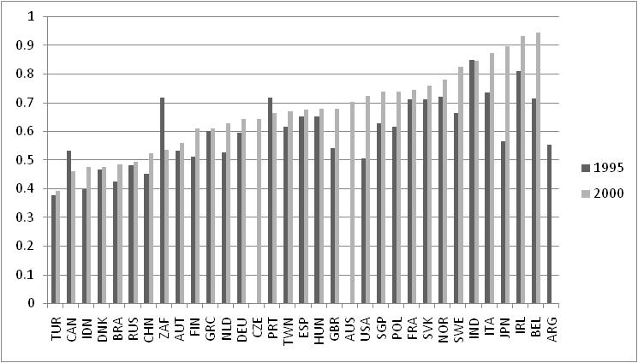
Source: Calculated from the OECD input-output database.
Note: Data for Australia is from 1998/99, Greece and Portugal 1995 and 1999, Hungary and Ireland 1998 and 2000, India 1993/94 and 1998/99, Turkey 1996 and 1998 and South Africa for 1993 and 2000.

A second possible explanation is a change in industrial structure and thus changes in the relative importance of services-intensive industries. In order to assess developments in the services intensity of individual manufacturing sectors, I calculated the services to value added ratio for all manufacturing industries for the two periods. Figure 3 depicts the median value for all OECD countries by sector for the two years, while Figure 4 depicts the median, together with the minimum and maximum for the year 2000.
Figure 3. Median intermediate services/value added ratio by sector, 1995 and 2000
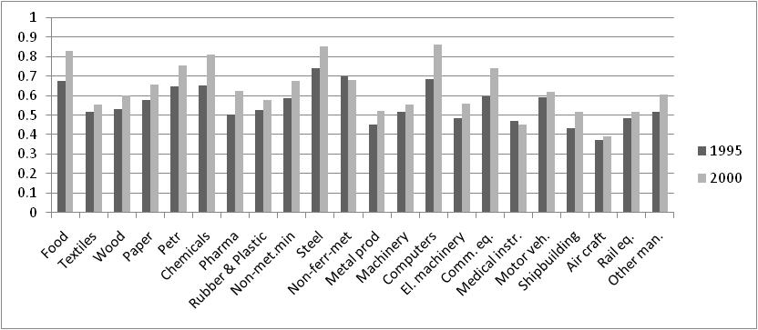 Source: Calculated by authors from the OECD input output database

It is noticed that the median services intensity of all manufacturing sectors, except non-ferrous metals and medical and scientific instruments, has increased during the 5-year period. The most services-intensive manufacturing industry in 2000 was computers and office machinery, perhaps surprisingly, closely followed by iron and steel, food and chemicals. The median only tells part of the story, however. Figure 4 shows the variation in services inputs to value added in the year 2000 for each sector. The by far largest variation is found in the computer industry where the services/value added ratio ranks from 0.12 in China to 9.15 in Finland (see note to Figure 4). Other sectors characterized by large differences in services intensity among countries are petroleum refining and communication equipment. Finally it is noted that the distribution is skewed towards a long tail on the high services intensity side.

Figure 4. Variation in the services/value added ratio by industry, 2000.
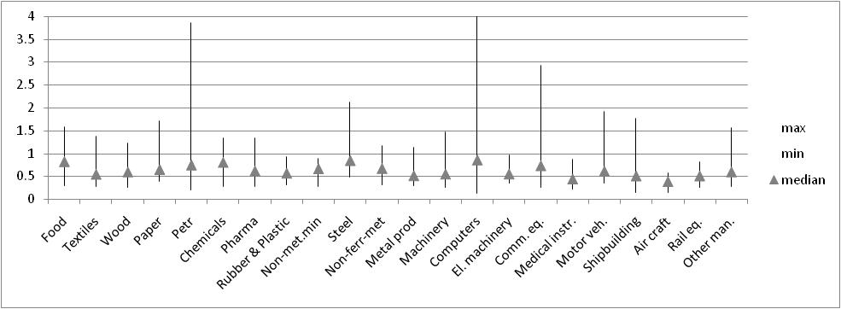
Source: Calculated from OECD input-output database.
Note: The vertical axis is cut off at 4 in order to visualise the variation in other sectors than computers, which exhibit a maximum of more than 9.

A third possible source of increasing services intensity in manufacturing is a change in relative prices, e.g. due to trade liberalisation and lower unit prices of material inputs. The change in the intermediate services price index relative to the intermediate materials price index was calculated from the EU KLEMS database for Germany, Japan, Sweden and the US from 2000 to 2005 and presented in Table 1. From this table it is clear that an increase in the relative price of services inputs has indeed occurred in Germany and Sweden, but in the United States and Japan, relative prices of intermediate goods and services have been rather stable over the period in question. The result thus calls into doubt that the rise in services relative to other sectors is mainly due to rising relative prices as famously argued by Baumol (1967; 2001).
Table 1. Intermediate service price index/material inputs price index 2000 = 1, selected countries
Country | 2000 | 2001 | 2002 | 2003 | 2004 | 2005
Germany | 1 | 1.012 | 1.062 | 1.094 | 1.091 | 1.075
Japan | 1 | 0.997 | 1.010 | 1.007 | 0.988 | 1.033
Sweden | 1 | 1.021 | 1.056 | 1.071 | 1.061 | 1.046
United States | 1 | 1.018 | 1.035 | 1.026 | 1.002 | 0.992
Note: Calculated from the EU KLEMS database. The database contains information on value of intermediate goods and services and a volume index, which is used to calculate implicit deflators separately for intermediate goods and services.

Another measure of the interaction between manufacturing and services in international trade is the services content of manufactured exports. I calculated domestic services value added embodied in manufacturing exports as a share of export value for all countries for which data are available in the OECD input-output database. The result is depicted in Figure 5.
Figure 5. Domestic services value added embodied in manufacturing exports, 1995 and 2000
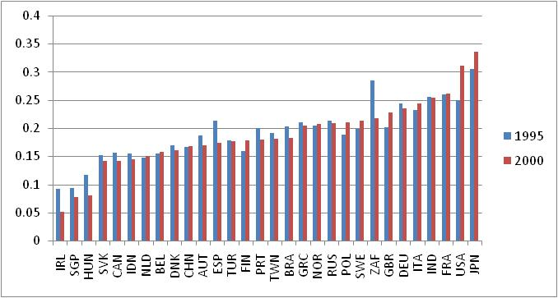
Source: Calculated by author from OECD input-output database.

Japan and USA clearly had the largest domestic services value added embodied in their manufacturing exports, and for these countries the share increased substantially from 1995 to 2000. However, in a number of countries the domestic services value added embodied in manufacturing exports has actually declined over the 5-year period analysed. This may seem surprising, and a possible explanation is that some domestic services value added has been replaced by imports. Figure 6 plots the domestic services value added embodied in manufacturing against the import share of total services inputs in manufacturing. There is a strong negative correlation between the two variables (shown by the trend line), supporting this hypothesis, and suggesting that local services can be complemented by foreign services. This is particularly noticeable in small, dynamic economies such as Ireland and Singapore where domestic services value added embodied in manufacturing exports constitute a small share of export value, and the share has, moreover dropped significantly from 1995 to 2000. However, for most other countries imported services account for less than 15% of total intermediate services inputs and for more than half of the countries the share is less than 10%.
Figure 6. Domestic services value added embodied in manufacturing exports versus import share of services inputs in manufacturing
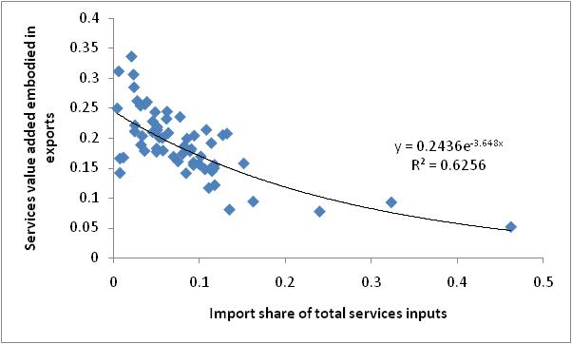
Note: The chart plots the domestic services value added embodied in manufacturing exports as depicted in Figure 5 against the import share of intermediate services in manufacturing for 1995 and 2000. The inserted trend-line is exponential, which is the functional form that gave the best fit.

3. THE MODEL
The model features two countries, one factor of production and three final goods manufacturing sectors in addition to a range of intermediate services providers. Manufacturing is defined as the conduct of a number of tasks that can be performed inside the firm or purchased from outside firms. Firms choose to perform or buy tasks depending on the relative cost of each alternative. There are N business services suppliers in the home country and n suppliers in the foreign country. They contribute to the production of manufactures, and the more diversified and specialised the more they contribute to the productivity in the downstream manufacturing sector. While spreading a given amount of expenditure on services inputs on a greater variety of services contributes to higher productivity, the model also has the property that the marginal increase in productivity in downstream firms from adding another variety declines with the number of varieties already employed. For instance the 11th variety adds more to productivity than the 101^{st.} Each services provider will have to incur some up-front costs in order to set up its business and develop its unique service. This cost will have to be recovered in the market, and the size of the market will therefore determine how many business services firms can be accommodated. Both business services and final goods can be traded, but at a cost.

Consumers are assumed to distribute their expenditure on manufacturing such that the expenditure share on each category is constant, but preferences may differ between countries. Each sector produces a consumption good (Y_{j}) using labour (L_{Yj}) and a composite (S_{j}) of intermediate services as inputs. Sectors are indexed j and varieties of the intermediate services/tasks are indexed v. Goods or services produced in the foreign country are denoted with *. Subscripts are omitted when not necessary for clarity:
(1) 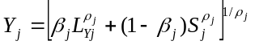,
where β is an allocation parameter which indicates how intensively manufacturing sector j uses direct labour and services respectively. The parameter ρ defines the elasticity of substitution between business services and labour (1/(1- ρ) >1). L and S can be interpreted as tasks being performed inside and outside the firm respectively, although L also includes material inputs in this version of the model. The elasticity of substitution can be interpreted as a measure of how easily tasks can be outsourced in the sector. Profit maximisation yields the ratio of tasks produced within the firm and outside the firm as follows:

(2) 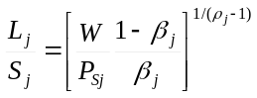

And the unit cost function of the representative firm:

(3) 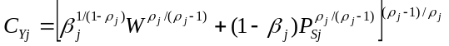

The composite of services is defined as:
(4) 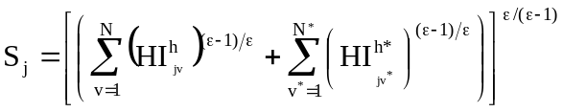

in which N and N* are the number of services in the home and foreign country respectively, I_{vj} is the amount of business services of variety v used in sector j. Superscript h denotes that the input is used in the home country. The productivity parameter H captures differences in economic fundamentals of technological capability with which intermediates (either produced at home or abroad) are transformed into final consumption goods, and ε > 1 is the elasticity of substitution between any pair of intermediate services. This way of modelling diversified services captures the well-documented fact that the joint inputs of a team of experts in different, but relevant areas of specialisation are more productive than one generalist providing the same number of man-months as the expert team. Thus, the larger the number of local and foreign differentiated services, the more a given quantity of S contributes to the production of Y. The corresponding price index for the S-aggregate equals:

(5) 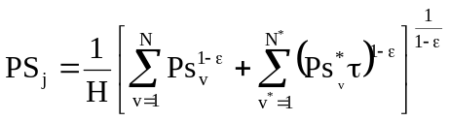

Communication costs are assumed to be of the iceberg type so τ ≥ 1. Cost minimization yields the following spending rule on local and imported tasks (country 1 is the home country), assuming symmetry among intermediate services:

(6) 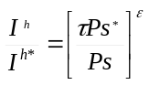

Each business service or task is produced subject to economies of scale stemming from a fixed cost of developing the task in question. Employment in each service activity is given by:

(7) 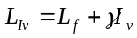,

where L_{f} is the fixed cost of inventing the service in question, while γ is the unit labour cost of producing the service variety I. With free entry in the services sector, the price of the service will be a mark-up over marginal cost defined by the elasticity of substitution between any two business services or tasks:

(8) 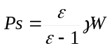

Where W is the wage rate or a composite index of primary and material inputs prices in the numerical version of the model. Using (5), (7) and the free entry condition that ensures that profits are zero, output of the representative business service firm can be calculated to;

(9) 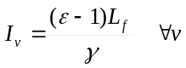
It follows from (7), (8) and (9) that employment in each services firm is εL_{f}. Consumers in both countries are assumed to have Cobb-Douglas preferences:

(10) 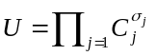

Where C_{j} represents consumption of products from sector j, and implies that consumers spend a fixed share of their income, σ_{j}, on final output j. It is assumed that final goods are traded subject to a small transport cost and that goods are differentiated according to country of origin (the Armington assumption). This allows trade and location patterns to be determined in a model with one factor and many sectors.

(11) 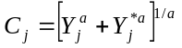

where represents the Armington elasticity. With consumer goods differentiated according to source, producers are able to obtain a mark-up over marginal costs (as given by (3)) as follows: 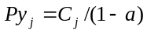 Consumers in the home country maximize utility subject to their budget constraint:

(12) 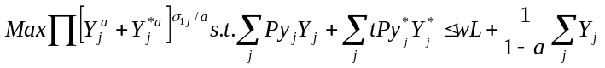

where t ≥1 is the iceberg transport cost. The last term is profits from the final goods sector that are received by consumers. This yields a similar spending rule as for intermediate services inputs as follows:

(13) 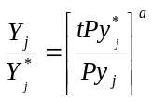

Market clearing conditions in the labour market, the market for business services, the market for final goods and the balance of payments determine the equilibrium of the model and are given as follows:

(14) 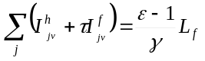
Superscript h and f denotes services sold at home and abroad respectively.

(15) 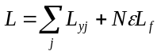
(16) 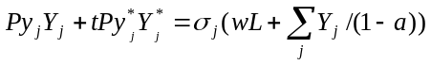
and similar for the foreign country. The balance of payment condition closes the model

(17) 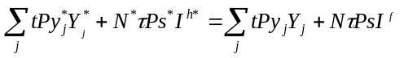

An analytical solution cannot be found unless stronger restrictions are imposed on the model, but it is possible to solve it numerically. Of interest is how falling costs of trade in services affect production structures, trade in goods and services, and real income for different constellations of the exogenous parameters. For that purpose the model is written in GAMS having three final goods sectors (primary, high services-intensive manufacturing and low services-intensive manufacturing) and one non-traded final services sectors. As a benchmark the model is solved for symmetrical countries both in terms of labour endowments, consumer preferences and technology. Next the following scenarios are explored: i) the home country has a 20% larger labour force than its trading partner; ii) the home country is 20% more efficient in its use of intermediate services or tasks (H is 20% higher); iii) The home country is more efficient in producing intermediate services or tasks (γ is 20% lower); iv) The home country has lower entry barriers in the services sector (L_{f} ) is 20% lower. In all scenarios 30 steps are run where τ increases by 0.1 for each step, holding everything else constant. The base line scenario has the following parameter values: γ = L_{f} = H = 1 for both countries, ε = 5, = 8, t_{j} = 1.01 for j= 1, 2, 3 and 10 for j = 4. L = 100 for both countries. The value of the sector-specific parameters is presented in Table 2. The cost and expenditure shares reflect values in typical high-income OECD countries calculated from the input-output tables.

Table 2. Parameter values for simulation
Sector | σ | β
Primary | 0.05 | 0.8
Less services intensive manufacturing | 0.25 | 0.75
More services intensive manufacturing | 0.20 | 0.6
Non-traded final services | 0.50 | 0.7

Table 3 presents the results in terms of percentage changes from very high pre-liberalisation services trade costs to free trade in services. Since natural barriers to trade in intermediate services can be significant (e.g. differences in language, culture, the business environment and the fact that face-to-face interactions are necessary to various extents), a realistic assumption is that trade liberalisation will reduce, but not eliminate trade costs. Therefore the development path from prohibitive trade costs to zero trade costs is interesting as well. The results are sensitive to assumptions about elasticities, but the qualitative results are robust to the full range of elasticities found in the literature.
An interesting result general result is that the gains from liberalisation are not linear. There are for instance much smaller gains from reducing trade costs from 300 to 200% than from 30 to 20%. In all of the scenarios the gains from going the last mile of trade liberalisation, reducing trade costs from 20% to zero account for between a third and half of the total gains in productivity and GDP per capita. This would for instance imply that the European Union’s services directive could have a significantly larger impact on intra-EU trade in goods and services than services trade liberalisation undertaken hitherto. In contrast developing countries that are cautious of possible adverse effects of committing to services trade liberalisation in the GATS or regional agreements need not worry as it appears that the impact would not be large, adverse or otherwise, unless the commitments are relatively radical. Bearing in mind the many natural barriers to trade in services, getting trade costs much below 15% -10% may not be realistic unless liberalisation also aims at harmonising regulation.
In order to focus sharply on the impact of services trade liberalisation on comparative advantage in manufacturing and services, the relative input shares of capital, labour and materials are kept constant in the simulations. For the sake of realism a non-tradable final services sector (e.g. government services and personal services) accounting for about 50% of domestic expenditure is introduced into the model.

The benchmark scenario: Symmetry; the trading partners are equal in all respects
In this scenario two identical countries agree to liberalise services trade between them. Initially the services trade costs are so high that imported services are about four times more expensive than locally produced services, and intermediate services are traded only to a limited extent. From this level, services trade costs are gradually eliminated and intermediate services become tradable. As shown in Table 3 below, both countries will gain. Real GDP per capita would increase by about 5% from the pre-liberalisation scenario to the fully liberalised scenario, and by about 3% if trade costs were brought down to 20% only. The structural changes and mechanisms at work are the following:
- Intermediate services providers in both countries get access to the trading partner’s market and start exporting;
- Downstream manufacturers get access to the services supplier base in both countries. Thus, the variety of intermediate services in each country more than doubles (compared to no trade in services) as in addition to market integration, both countries devote more resources to intermediate services production.
- Productivity in manufacturing and production of non-traded final services increases;
- Since the two countries are assumed to have the same technology, the same factor endowments and the same consumer preferences, services trade liberalisation has no effect on trade in manufactures in this scenario.
In conclusion the model exhibits the well-known property that even identical countries can gain from trade due to deepening specialisation, and the effect is similar to technological progress.

Home country is 20% larger
In this scenario the two countries are similar in all respects except that the home country is 20% larger than its trading partner (i.e. it has 20% larger endowments of primary factors of production). Having a larger market allows for deeper specialisation and as a result the home country has a comparative advantage in the manufacturing sector that uses services the most intensively. However, services trade liberalisation erodes comparative advantage in services-intensive industries and shifts exports away from services-intensive final goods to intermediate services in the large country. The reason is that manufacturers in the partner country get access to the same services supplier base as the home country, and the services supplier base no longer constitutes a source of comparative advantage for manufacturers. Manufacturers in the smaller trading partner experience a large increase in the services supplier base and as a result they catch up with the home country in terms of productivity in services-intensive manufacturing. Their manufacturing exports start to expand, while the home country shifts its exports towards services. The large country becomes more dependent on imports for its final consumption, while the smaller country becomes more self-sufficient in final goods as it imports more intermediate services directly instead of importing them embodied in services-intensive goods
From Table 3 it can also be observed that GDP per capita increases more in the small country. The reason is simply that as trade opens up, the diversity of intermediate inputs increases more in the small country who now can source from the broader services supplier base in the larger country. The gains from services trade liberalisation are largest for the net importer of services. Thus, for smaller and poorer countries, services trade liberalisation helps improve competitiveness in manufacturing and could trigger a significant boost to manufacturing exports. Again it should be noted that full elimination of services trade costs may not be realistic.

The home country uses intermediate services more effectively
In this scenario the two countries are similar in all respects except that the home country has a better technology for utilising intermediate services or tasks. This could for instance be due to superior organisational technology including better supply chain management. The two countries are equally efficient in producing intermediate services/tasks, however. This is perhaps the most interesting scenario since to my knowledge this scenario has not been analysed in the literature before. I do, however, think it is empirically relevant. Japanese manufacturers, for instance, have since long been admired for their efficient ways of organising production. The results are therefore presented in some more detail as depicted in Figure 7.
Figure 7. Simulation results, home country is more efficient in using intermediate inputs
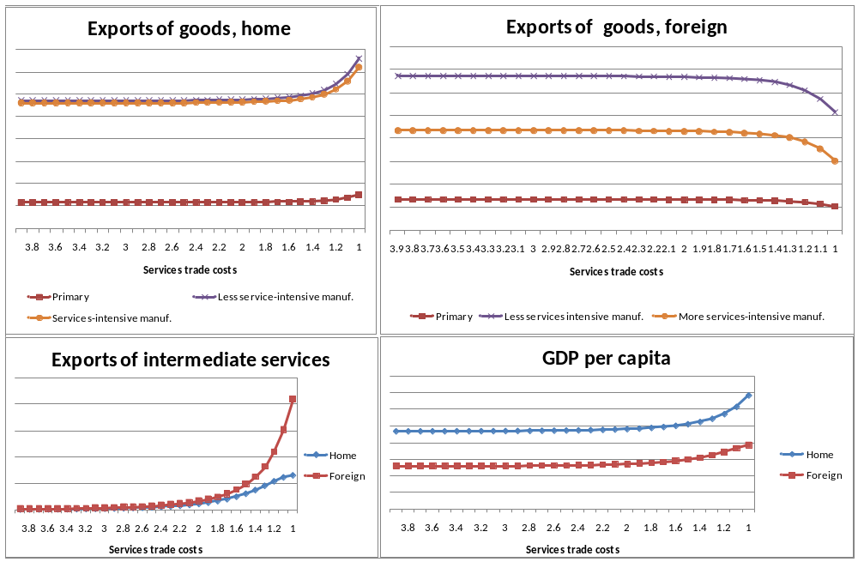

Services trade costs (iceberg) are depicted on the horizontal axis and declines from left to right in the charts. The first thing to notice, which is common for all the scenarios, is the non-linearity of adjustments as discussed above.
The home country’s comparative advantage in the services-intensive manufacturing sector is best reflected in its imports (i.e. the foreign country’s exports). Import penetration is lower in this sector and the foreign country hence exports less of high-technology, services-intensive manufactures. The reason why the home country does not export more of these manufactures in absolute terms is that expenditure on the output of the services-intensive manufacturing sector is lower than for the less services intensive goods. The expenditure shares are calculated from the input-output tables and are similar in high-income OECD countries. The charts show that services trade liberalisation strengthens the home country’s comparative advantage in services-intensive industries, and indeed in all manufacturing sectors.
Since the home country is significantly better at utilising intermediate services, but no better at producing them, its resources are shifted towards the final goods sectors, while the foreign country specialises in intermediate services production following services trade liberalisation. Thus, in this case services trade liberalisation results in a large increase in trade both in goods and services. The home country would specialise in manufacturing and offshore most tradable tasks to its trading partner while retaining a somewhat “hollowed out” but competitive manufacturing sector. This is the only scenario where the welfare gains from services trade liberalisation are higher in the more efficient country.

The home country is more efficient in producing intermediate services
In this scenario the home country has better production technology in the intermediate services sector, modelled as a 20% lower unit labour requirement in the intermediate services sector, while the countries are equal in all other respects. In a similar manner as the scenario where the home country is larger, the home country has a comparative advantage for the most services-intensive good. This time the comparative advantage stems from both a broader variety of services and lower prices for each individual service. With declining trade costs and thus convergence of the price index for intermediate services, the comparative advantage is eroded and the home country turns to exporting services directly rather than embodied in final goods. The foreign country in contrast shifts resources away from its relatively inefficient intermediate services sector towards final goods production and exports. There is a substantial gain in GDP per capita in the foreign country since the price index of intermediate services declines both due to broader variety and due to a lower average price of individual services.
This is probably the most relevant scenario for middle-income countries engaging in services trade liberalisation with high-income OECD countries. Services trade liberalisation would for sure reduce employment and output in intermediate services production in the less efficient producer as local producers would be substituted for more efficient imported services. However, this would allow them to catch up in manufacturing and trigger a sharp increase in manufacturing production and exports. GDP per capita would also increase more in the middle income country than its OECD trading partner, although both would gain.

The home country has lower entry costs in the intermediate services sector
Lower entry costs in the intermediate services sector can stem from lower cost of innovation e.g. due to better education, R&D support schemes or it can be due to lower regulatory barriers to entry. Again the home country will have a comparative advantage in services-intensive goods when trade in intermediate services is restricted. The direction of changes following services trade liberalisation is similar to the one where the home country was larger than its trading partner. The scenario is relevant for two countries with different regulatory restrictiveness indices entering a services trade liberalisation agreement. In fact manufacturers in the less liberal countries would to some extent benefit from the more liberal regulatory regime in its trading partner, through accessing its lower cost intermediate services inputs.

Table 2. Simulation results, interaction between trade in intermediate services and final goods
Percent change in key variables following a reduction in services trade costs
 | Symmetry | Large |  | Efficient use |  | Efficient production |  | Lower entry barriers
 |  | Large | Small | Efficient | Inefficient | Efficient | Inefficient | Lower | Higher
GDP per capita | 5.1 | 4.1 | 6.3 | 5.9 | 3.8 | 2.0 | 5.5 | 6.0 | 6.0
Employment share in services | 9.4 | 19.7 | -3.7 | -34.1 | 62.8 | 70.0 | -76.0 | 34.8 | -18.2
Change in services variety | 118 | 97 | 145 | 106 | 139 | 88 | 112 | 100 | 149
Export value
Primary | 0.0 | -6.3 | 6.9 | 30.8 | -22.6 | -57.3 | 49.3 | -17.8 | 15.3
Manuf. 1 | 0.0 | -6.2 | 6.8 | 32.9 | -23.8 | -56.8 | 8.0 | -17.5 | 15.0
Manuf. 2 | 0.0 | -10.8 | 13.3 | 29.0 | -30.3 | -54.5 | 62.3 | -17.5 | 16.4
Import penetration
Primary | 0.0 | 7.3 | -6.4 | -23.6 | 26.4 | 41.2 | -42.3 | 16.2 | -16.3
Manuf. 1 | 0.0 | 7.2 | -6.3 | -24.8 | 28.4 | 39.9 | -41.7 | 15.9 | -16.0
Manuf. 2 | 0.0 | 13.7 | -10.9 | -31.2 | 24.7 | 45.0 | -35.1 | 17.4 | -16.0
Note: Change in services variety represents the percentage change in number of services varieties available in each country from no trade in intermediate services to full integration of services markets.

Model 2. Interaction between intermediate goods and services.
The second model focuses on the substitution between intermediate goods and services in production; or between components and tasks. The production function is a nested CES function with three layers. At the top layer, primary and intermediate inputs are aggregated as follows:
(18) 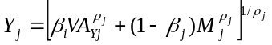,
where β is an allocation parameter which indicates how intensively manufacturing sector j uses primary factors of production (VA) and intermediate inputs (M) respectively. The parameter ρ defines the elasticity of substitution between value added and intermediates (1/(1- ρ) >1). Profit maximisation yields the ratio of tasks produced within the firm and outside the firm as follows:

(19) 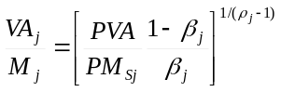

At the second level, capital (K) and labour (L) are aggregated into value added by a Cobb-Douglas function:

(20) 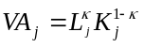

While intermediate inputs consist of goods (Q) and services (S) as follows:

(21) 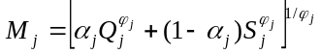

At the third level intermediate goods and services inputs are distributed on local and imported varieties according to equation (4) for services and for goods by a similar structure:

(22) 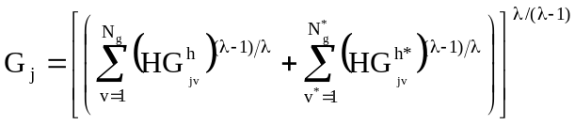

H is as before a productivity parameter reflecting the efficiency of using intermediate inputs. The unit cost function of the representative final goods manufacturing firm is:

(23)

Where PVA is a weighted average of the wage rate (w) and the user cost of capital (r) as follows:
(24) 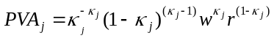
PM is the weighted average of the price index of intermediate goods and services as follows:
(25) ,
and PS is given by (5) replacing, while by the same token PG is given by:
(26) 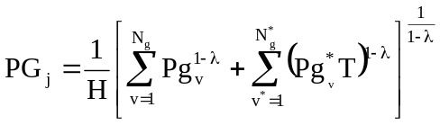
T is the (iceberg) transport cost of intermediate goods between the two countries, and λ is related to the elasticity of substitution between any two intermediate goods in the same way as ε is related to the elasticity of substitution between services.

In this version of the model it is assumed that the fixed cost of entering the market is incurred in terms of an exogenously given capital investment (e.g. R&D or physical investment). Total costs incurred by each firm in the intermediate services and goods sectors are therefore given by:

(27) 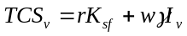
(28) 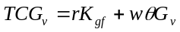

Profit maximizing yields mark-up pricing as before in the intermediate services sector (equation 9), while the corresponding procedure for intermediate goods providers yields:

(29) 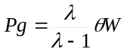

Output of the representative firm is now determined by relative factor prices, as opposed to in the first version of the model where output was determined by the exogenous parameters alone. Output of the representative goods and services firms are given as follows:

(30) 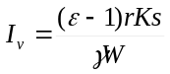

(31) 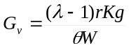

Spending rules on the various inputs in the production function are similar to the previous model, but with a more complex production structure, there are more of them. The spending rule between value added and intermediate inputs are already given by (19). Within the value added aggregate, relative factor demand is given by:

(32) 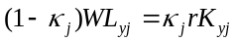

Within the intermediate input aggregate, relative demand for goods and services are given by:

(33) 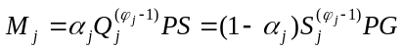

Relative expenditure on intermediate services is given by (6) with the necessary adjustments in notation, while relative expenditure on intermediate goods is given by:

(34) 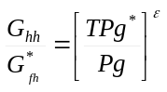

The market clearing conditions for the labour market, capital market and intermediate goods and services are given as follows:

(35) 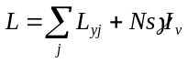
(36) 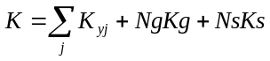
(37) 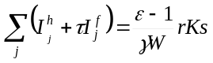
(38) 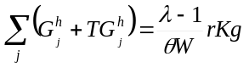

The balance of payment closes the model.

The model is run for the following parameter values for the symmetry case:
L=100 for both countries, K = 200 for both countries, γ = θ = Kg = H = 1 for both countries, Ks = 1.1, ε = 3, λ = 5, T = 1. A symmetry scenario for T = 1.2 was also explored. It yielded qualitatively the same results as for the symmetric case of T = 1, but with lower trade in intermediate goods and lower GDP per capita. The results are presented in Table 4.

Table 4. Simulation results, interaction between intermediate goods and services
Percent change in key variables following a reduction in services trade costs
 |  | Large
 | Symmetry | Large | Small
GDP per capita | 9.3 | 8.0 | 10.8
Labor share in GDP | -0.1 | 0.0 | -0.3
Cost share of services | 6.7 | 5.8 | 7.8
Cost share of goods | -2.3 | -2.1 | -2.7
Exports of goods | -2.2 | -0.3 | -4.7
Goods variety | -2.6 | -2.6
Services variety | 112.7 | 91.2 | 139.2

Services trade liberalisation in this model results in a large increase in services variety in both countries (compared to no trade in services). Resources are shifted from production of intermediate goods and final goods and services towards intermediate services, and the cost share of services in manufacturing increases. The economy uses material inputs more effectively and overall productivity increases, as reflected in a higher GDP per capita. Income distribution between labour and capital is not much affected.

4. SUMMARY AND CONCLUSIONS
This paper has analysed the interrelationship between trade in goods and intermediate services. It is first shown that there is a large variation among manufacturing sectors within countries and within manufacturing sectors between countries in terms of how intensively they employ intermediate services. It is also documented that the extent of trade in intermediate services is quite limited. Nevertheless, small open economies such as Ireland and Singapore has a relatively large and growing import share of intermediate services. Their experience demonstrates that the potential for trade in intermediate services can be significant. Nevertheless, a closer look at the trade data reveals that a significant share of trade in services is accounted for by license fees in these two countries. These are payments e.g. from foreign affiliates to their parent companies for use of trade marks or proprietary technology. A large contribution of licence fees to total trade in services thus suggest that services are largely provided through commercial presence of foreign affiliates. Trade liberalisation in services must therefore be broadly defined and include restrictions on foreign investment as well as on business travel and temporary work permits (the so-called mode 4 in the GATS) in order to provide meaningful market access.

The paper next constructs a model that is suitable for analysing the interrelationship between trade in goods and services. It is argued that with relatively high trade costs for services, a local intermediate service supplier base that offers a broad variety of services at relatively low cost is a source of comparative advantage in services-intensive goods. Although the services-intensity of manufacturing sectors varies between countries, it is generally the case that high-technology industries such as computers and office equipment are relatively services-intensive.

Having a relatively broad base of services suppliers at relatively low cost is associated with having a large domestic market for such services, superior technology in the production of such services or low barriers to enter the intermediate services sector. In a world of high trade costs in services, countries with relatively low costs of intermediate services will specialize in services-intensive goods and be net exporters of such final goods. High trade costs in intermediate services may stem from explicit or implicit barriers to trade in services. Examples are strict visa requirements and procedures for foreign business travellers, discriminatory qualification requirements for foreign services suppliers and cumbersome regulation. However, it is likely that trade costs stemming from the fact that services are not standardized resulting in incomplete contracts that are more costly to enter and monitor across than within jurisdictions are significant. In addition some services transactions require face-to-face interactions between services supplier and customer. Significant services trade costs are therefore likely to remain even in the event of trade liberalisation. Free trade in services is nevertheless a useful benchmark towards which real world scenarios can be compared.

The model simulations demonstrate that a country with a relatively broad and cost effective intermediate services supply sector resulting in comparative advantage for services-intensive final goods sectors will see this comparative advantage eroded with declining services trade costs. Its exports of final goods will decline, particularly in the most services-intensive industries. However, instead of exporting services embodied in goods, the home country will to a larger extent export the services directly, while increasingly importing final goods. Hence instead of embodying intermediate services in exports of final goods, the home country’s intermediate services will to a larger extent be embodied in its imports of final goods.

An interesting scenario is when the home country has superior technology for using, but not producing intermediate services. This could be empirically relevant particularly for services that can be standardised and traded over electronic networks, and for countries that have firms with highly sophisticated ways of organizing production. In this scenario falling services trade costs will result in specialisation in final goods production in the home country, while it will increasingly import intermediate services. A country with superior organisational technology will thus experience offshoring of intermediate services and a revival of manufacturing, albeit somewhat hollowed out, following falling trade costs in intermediate services.

References
Baumol, W.J. (1967), “Macroeconomics of unbalanced growth: the anatomy of urban crisis”, The American Economic Review, 56, 415-426.
Baumol, W.J.( 2001), “Paradox of the services: exploding costs, persistent demand”, in Ten Raa and Schettekat (eds) The Growth of Services Industries: the Paradox of Exploding Costs and Persistent Demand, Edward Elgar.
Bryson, J.R, Daniels, P.W. and Warf, B. (2004), Service Worlds; People, Organisations, Technologies, London: Routledge.
Dicken, P. (2003), Global shift: Reshaping the Global Economic Map in the 21st Century, Sage, London.
Essaij, A. (2008), “Technical regulation and specialization in international trade”, Journal of International Economics, forthcoming.
Grimes, S. (2006), “Ireland’s emergence as a centre for internationally traded in services”, Regional Studies 40, 1041-1054.
Jensen, J.B. and Kletzer, J.G. (2005), “Tradable services: understanding the scope and impact of services outsouring”, Institute for International Economics Working Paper 05-09.
Krugman, P. and Venables, A.J., 1995, “Globalization and the inequality of nations”, The Quarterly Journal of Economics, 110, 857-880.
Manova, K. (2008), Credit constraints, equity market liberalizations and international trade”, Journal of International Economics, forthcoming.
Markusen, J. R. (1989), “Trade in producer services and in other specialized intermediate inputs”, The American Economic Review, 79, 85-95.
McLaren, J. (2000), “Globalization and vertical structure”, The American Economic Review, 90, 1239-54.
Miles, I. (2007), “Business services and their users: a literature review”, Chapter 2 in Rubalcaba, L. and Kox, H. (eds), Business Services in European Economic Growth, Houndmills: Palgrave MacMillan.
Pilat, D. and Wölfl, A. (2005), “Measuring the interaction between manufacturing and services”, OECD STI Working Paper no 2005/5.
Robert-Nicoud, F., (2008), “Offshoring of routine tasks and (de)industrialisation: Threat or opportunity – And for whom?”, Journal of Urban Economics, forthcoming.
Shelling, T. (1978), Micromotives and Macrobehavior, W. W. Norton and Company.
Yi, K-M, 2003, “Can vertical specialisation explain the growth of world trade?”, Journal of Political Economy, 111, 52-102.

E-mail: Hildegunn.nordas@oecd.org The views expressed in this paper are personal and should not be attributed to the OECD.
Manova (2008) found that labour-intensive manufacturing industries are more dependent on external finance than e.g. extractive industries and that credit constraints therefore may prevent labour-abundant countries from exploiting their comparative advantage.
A recent study has found that lack of technical expertise has indeed induced developing countries to specialise in sectors that are less subject to technical regulation (Essaji, 2008).
The process of vertical disintegration in a growing market is nicely described by Schelling (1978).
See for instance Bryson et al. (2004) for a comprehensive review.
The domestic services value added share of manufacturing exports is calculated as follows: 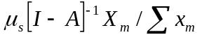where μ is a row vector where the elements are the value added share of gross output if the sector is a services sector and zero otherwise. The term in square bracket is the inverted input-output matrix and X is a column vector where the elements are total exports if the sector is a manufacturing sector, zero otherwise, and finally I divide with total manufacturing exports.
The simulations start with iceberg trade costs of 4 (i.e. the import prices is four times higher than the price received by the exporter, or equivalently the exporter must ship four times more services than what eventually arrives at the manufacturing plant of the customer. The services supplier could for instance spend four times as much time and resources on travel and complying with regulation than with the customer). Trade costs are reduced stepwise, by 0.1 for each step until they are eliminated.
An interesting approach to measuring tradability of services is to analyse its geographical concentration within a large country. If there is a commercial presence of this service in most locations where it is demanded, and thus the service is not traded over long distances domestically, it can probably not be traded easily across national borders either. Jensen and Kletzer (2005) performed such a study for the United States and found that the following services sectors were the most tradable: within NAICS code 51: Other information services, motion pictures and video industries, sound recording industries, software publishing; within NAICS code 52: Securities, commodities, funds, trusts and other financial investments; within NAICS code 54: Scientific research and development services; within NAICS codes 53, 55, 56, 61, 62, 71,72: no sectors
The higher the elasticity of substitution between individual intermediate services, the more similar are the services to each other and the less are the gains from expanding variety of services.
The home country has a broader variety even though it has the same primary factor endowments because it can produce more services with the same factor inputs.
See Grimes (2006) for a case study of Ireland.

