REGIONAL KNOWLEDGE SUBSIDY AND THE ANALYSIS OF
TRANSFER OF PRODUCTIVITY GAINS

Giorgio Garau and Patrizio Lecca

DRAFT VERSION—DO NOT CITE

Abstract. In this work we present a regional computable general equilibrium (CGE) model for the autonomous Region of Sardinia used for the main purpose to evaluate the impact on a recipient region of R&D subsidy. The model allows for potential knowledge spillover effect arising from interregional and international trade. We also attempt to analyze and measure the distribution of productivity gains generated by the policy by means of the distribution rule of the Total Factor Productivity Surplus (TFPS) developed by Fontela (1989) in a Input Output framework. We find that the cross-border spillover may improve the long run rate of growth generating a large amount of TFP. Moreover from the analysis of the surplus distribution we identify Heavy Industry as a “progressive” sector while Energy and Primary substantially absorb productivity gains from the rest of the system.

Keywords: Regional CGE, Technical Change and Surplus Distribution
[JEL:]R13; R58

- Introduction

Innovations in R&D, knowledge spillover and human capital accumulation have been identified in literature as the most important driving forces behind economic growth. Such forces are able to determine the growth that cannot be explained by the accumulation of traditional production factors such as physical capital and labour. Lucas (1988) emphasizes the role of human capital externalities while Romer (1990), Grossman and Helpman (1991) and Aghion and Howitt (1992) focus on the capacity of industrial innovation in R&D to be a determining source of growth by means of the mechanism of knowledge accumulation. In all the above contributions, the capacity of public policy to impact the rate of long-run growth is put in evidence. Government policies can affect economic growth by encouraging firms to devote more resources to R&D activities with e.g. market incentives. Also, R&D subsidy may promote economic growth by stimulating domestic R&D and encouraging international spillover of knowledge.
In literature has been also stressed the important role played by the internationalization in promoting knowledge spillover. Yet, more open economies leads to more competition that encourages the adoption of new technology increasing the efficiency of the economic system which result in a greater productivity. In other words, internationalization may be the source able to give vigour to the transmission of knowledge between countries (Parente and Prescott, 1994; Coe and Helpman, 1995; Holmes and Schmitz, 2001) and contribute to the creation of the conditions for a better local innovation since as pointed out by Bazo et al. (2006), internationalization and local knowledge reinforce each other, reinforcing their individual impact on productivity.
In this paper, we focus on the complementarities between, foreign trade, local and global stock of knowledge in a regional economy. As regions are more open than nations, we would expect stronger effect of foreign R&D capital stock on domestic productivity since, as suggested by the estimates of Coe and Helpman (1995), more open economies have larger productivity benefit from foreign R&D stock than less open economies. By importing more high quality and sophisticated inputs (either intermediate or capital goods), the local production may improve its efficiency and in turn the competition of the local system with respect to other regions. Therefore, the capacity to exploit the stock of global knowledge depends on the expansion of international trade. As a matter of fact, knowledge moves from one place to another according to the level of trade liberalization existing in the international market. The presence of rigidity might be mitigated by trade liberalization policies or removing tariff protections on imports.
It is our intention in this work to investigate the system-wide impact of a subsidy on R&D considering also, in accordance to the recent empirical and theoretical findings mentioned above, the complementarities between international trade and foreign capital stock. To this end, a regional computable general equilibrium (CGE) analysis for the autonomous Region of Sardinia is presented. The model, that we call SGEM, incorporates induced technical change (ITC) through enlarging the envelope of all possible technologies; basically we are including an intangible factor in the production function. The intangible factors given by the regional level of knowledge endowment is divided in appropriable and non-excludable knowledge. The first one is treated as primary factor which accumulate according to the traditional perpetual inventory change. The second one, instead, derives from the potential knowledge spillover effect arising from interregional and international trade.
Usually, regional assistance in Sardinia has been concentrated almost entirely on manufacturing sector through physical capital and labour subsidies. The need to evaluate the effect of regional R&D subsidy comes from the recent strategic policies undertaken by the Regional Government of Sardinia. So, we evaluate the system wide impact of an R&D subsidy introducing cross-border spillover effects which allow us to consider the role played by the international trade and foreign R&D stock in affecting the key macroeconomic variables.
One particular issue we are taking into account in this work which has not been generally given proper attention in previous works on this topic, is the transfer of surplus or productivity gains generated by the policy that arise as consequence of price variations. The economic literature has often treated separately the technical change generation from the distribution of productivity gains among economic agents. In his seminal paper Fontela (1989) has stressed the need of including in a comprehensive growth model, both the technical change and the transfer of productivity gains. By following Fontela the distribution of productivity gains are analysed. Basically we attempt to investigate, how the innovation gains generated in a given sector (as result of the policy implemented) should affect the rest of the economy.
The paper proceeds with the outline of the basic SGEM model. In section 2 we explain the endogenization of ITC in SGEM. The SAM of Sardinia with knowledge accounting is discussed in the third section. The fourth section is devoted to explain the simulation results. In the last two sections the distribution of the surplus with the main outcomes will be showed. Finally, remark and conclusion will be drawn.

- SGEM: the basic model
SGEM is a single-region dynamic CGE model built according to the Walrasian general equilibrium analysis formalized in the 1950s by Arrow and Debreu (1954) and Arrow and Hahn (1974). The specification of the production and demand parameters that allow the abstract general equilibrium model to be converted into a realistic model of an actual economy has been done through the well known calibration method using the Social Accounting Matrix (SAM) for Sardinia for the year 2001. The set of prices at which the excess demand is zero is the result of an optimization process, leading market clearing prices to equal marginal cost in each sector.
In SGEM five economic activities or sectors are considered: Agriculture and Mining, Heavy industry, Light industry, Energy and Services. Intermediate and primary inputs constitute the production input of the model. SGEM is made up also of three domestic institutional sectors: firms, households and government. The external institutions are split in Rest of the Italy (ROI) and Rest of the World (ROW). We adopt assumptions typically used for a small-open economy: the region is too small to affect prices in international and interregional markets. As a consequence the ROI and ROW prices are taken to be exogenous. In addition, since Sardinia belongs to a common currency area the model takes the nominal exchange rate to be fixed.
The model’s production structure is illustrated in figure 1. Intermediate inputs (X), labour (L) and capital (K) constitute the production inputs of the model. L and K are combined in a CES production function in order to produce the value added, Y allowing for substitution among primary factors of production. The demand for L and K is obtained from the first order condition of profit maximization. This means that the demand for both K and L is positively related to the volume of value added Y and is a decreasing function of their prices (rk and w, respectively).

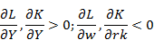

Leontief technology between X and Y is imposed, so the combination of the value added and intermediate inputs can be shown with an L-shaped isoquant. The intermediate goods produced locally or imported are considered as imperfect substitutes. Basically, we mix regional and imported goods under the so called Armington assumption through a CES function. The demand function for regionally produced and imported intermediate inputs (from ROI and ROW) derives from the solution of a cost minimization problem. Furthermore the imports from the rest of the world are split into Europe (EU), North America (NA), Middle and South America (SA), Africa (AFC), Oceania (OCE) and Asia (ASA).
The regional commodities supply is bought by industries and by domestic and external institutions. That is to say, each industry in the region produces a composite commodity that can be exported or sold in the regional market. An export demand function closes the model where the foreign demand for Sardinian goods depends on the term of trade effect and on the export price elasticity.

Figure 1
Production Structure of the Basic Model

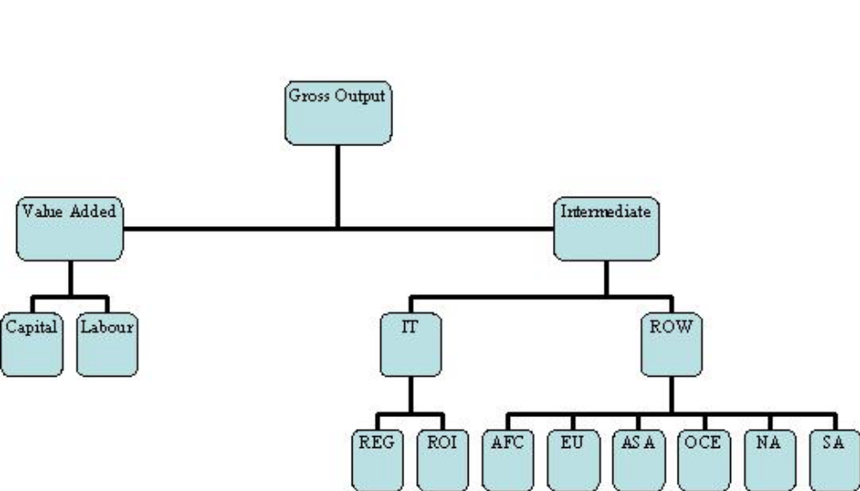

The household sector is split into six income groups whose consumption demand is given by the LES function derived from the maximization of the Stone-Geary utility function (where leisure is not considered). Government is a consolidated sector, merging central and local government levels and its expenditure is held constant throughout. Government consumption is then considered as adding to final demand rather than as being a public good.
The updating of the capital stock follows a simple capital adjustment rule, which represent the law of motion for sectoral capital stock (Gunning and Keyzer, 1995). By assuming a fixed rate of depreciation , we have:

where is the capital stock for the next periods (t+1) and is the investment in the actual period t by sector of destination i. The adjustment rule introduced in the model follows the one initially proposed by Bourguignon et al. (1989) according to which the investment capital ratio is determined by the rate of return to capital (rk) and the user cost of capital (uck), allowing the capital stock to reach its desire level in a smooth fashion over time:
where
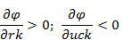

Because of the particular characteristics of regional economy, regional CGE model should be different from their national and international counterparts in some aspects. Regional economy in fact, is a more open economy compared to nations. Therefore, for a national or standard CGE model, it is appropriate to assume that investment equal saving, however this is likely to be improper when the regional dimension is considered. Again, while balance of payment constraint is suitable at national level, it can determine some inconvenient effects at regional level (see Harrigan et al., 1991). Consistently, the decisions of private sector saving must be separated from the decisions of investment and also they must be independent. This closure is required especially if we consider private saving not determined by the financial adjustment that occurs in the region but is instead the product of national forces.
A correct specification of the labour market is also suitable since its specification can affect the outcome of the model via wages and labour forces. SGEM follows the idea that local unemployment rate affect real consumption wage negatively (Blanchflower and Oswald, 1994); Accordingly, regional wage is flexible and respond to the excess demand for labour. Many studies have empirically studied the inverse relation between wage and local unemployment and most of them have confirmed the presence of the wage curve for most OECD countries. Several estimates regarding Italy have denied the existence of the wage curve up to the erly '90s (Lucifora and Origo, 1999). However, as it has been confirmed by the work of Devicienti et al. (2007) after the national labour market reform (Income Policy Agreement, July 1993) wages became more responsive to local unemployment. After the reform a new bargaining system has been introduced. Centralized bargaining process still remain in order to set the industry wide national wage but with indexation to the Government's target inflation (which is always lower than the real inflation). The top up component which is instead the additional wages distributed to the workers is now set according to the firm and regional condition.
In the regional wage bargaining regime (see application of this closure in Harrigan et al., 1995 and McGregor et al. 1996), the wage-setting function is defined as follow:

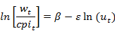
where cpi is the consumer price index, is a parameter calibrated to the steady state and u is the regional unemployment rate. is the elasticity of wages related to the level of unemployment rate and it can also be interpreted as an index of wage flexibility.
In SGEM there is not natural population change but it allows for labour forces adjustment through a migration model commonly employed in AMOS (Harrigan et al.1991, McGregor at al. 1995). The model starts with zero net migration flow and in any period migration is taken to be positively related to the gap between regional, ( w/cpi ) and national, ( w^{N}/cpi^{N} ) real wage and negatively related to the gap between national, (u^{N}) and regional unemployment rates:

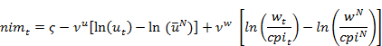
where nim is the rate of net migration and is a parameter calibrated in order to get zero net migration. −0.08 and 0.06 are the coefficients, econometrically estimated by Leyard et al. (1991) for the UK economy. Someone can raise objection concerning these parameters which are estimated using UK data. Unfortunately, the lack of data at regional level (especially in Sardinia) precludes a more suitable approach.
As regard the transfers of income among institutions, the receipt and payment among every institution (Household, Firm, Government, ROI and ROW) are an increasing function of the cpi.
The equations of the model are solved simultaneously for a given finite time horizon. Since the model does not incorporate jumping variables the result are clearly those of the recursive one. The model can be run also for two static specific time closure: Short Run (SR) and Long Run (LR). In the SR the supply side is maintained fixed, so capital and labour supplies are fixed to their base year value. In the LR, instead, we run SGEM by relaxing all supply side constraints allowing for capital and labour adjustment. The capital stock is at its optimal level, then the rental rate and the user cost of capital are equal. As regard the labour supply, the population is fully adjusted so that the system exhibits zero net migration.
For each time closure SGEM is run in order to find a set of prices that clears all markets: the supply of each produced good equals its demand. The vector of equilibrium prices we find is the result of myopic expectations since agents are not forward-looking.

3. Incorporating Knowledge in SGEM
The creation of knowledge is the source of ITC in the model. The approach we follow consist to enlarge the set of substitution possibilities in the value added production function by allowing substitution between tangible (K and L) and intangible (H, knowledge) inputs. The magnitude of shifting between these alternative technologies is related to their relative prices and the elasticity of substitution, that define the shape of Y :
In other words, we are considering knowledge services as a primary factor where the relative prices change and the accumulation of knowledge capital determine its inter-sectoral distribution. Relative price change may encourage substitution of knowledge for tangible inputs arising technical change as a consequent increase in the quantity of knowledge which in turn, the accumulation process, create the condition for an output effect by increasing also the quantity of tangible inputs.
This is an alternative approach, with respect to the traditional one according to which the induced technical change is determined by augmented inputs technological coefficients. To some extent our approach is quite similar to the one used by Bovenberger and Smulders (1995), Goulder and Shneider (1999) and Sue Wing (2003) to model ITC for climate policy analysis. However, in our case we consider the knowledge inputs as part of the value added allowing substitution only between primary factors.
In this context, we allow for an explicit endogenization of technical change (TC) through the inclusion of knowledge capital in the production function. We consider this way to proceed wholly consistent with the recent theory of growth according to which the adoption of new idea and the consequent accumulation of knowledge is an engine of growth (Grossman and Helpman, 1991) and it may be subject to depreciation over time due to obsolescence.
We distinguish between the appropriable (H) and non-excludable knowledge (), but with a different treatment. H, accumulate following the perpetual inventory formulation. Given R, the investment in R&D, we have:
where,
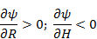

The relationship between knowledge stock and investment in R&D, that is, the adjustment accumulation mechanism is similar to the physical capital one, since we are treating knowledge service as a priced factor:
where is the knowledge capital accumulation rate; it is related to the rental price of capital and to the user cost of knowledge . Essentially, we are introducing a specific knowledge stock adjustment according to which accumulation is driven by the gap between and .
is the result of external spillover enjoyed by all firms in sector j. The external spillover represents the non-excludable knowledge that originate from the foreign R&D stock. Based on some econometric finding (i.e. Coe and Helpman, 1995) and recent applied economic models (i.e. Diao et al., 1999) the external spillover are assumed to be generated through the import of intermediates goods.
where is a calibrated parameter obtained in order to get the initial level of in value added production function; is the external spillover coefficient which in turn by following Coe and Helpman (1995) and Diao et al. (1999), is related to the import-weighted foreign R&D stock:
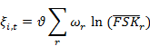
This equation allow us to link the knowledge spillover with the foreign R&D capital stock FSK_{r} and the international trade, , which is the fraction of import from r on Gross Regional Product, (GRP) (where r = EU, NA, SA, ASA, AFC, OCE, ROI). is the spillover elasticity of the regional productivity with respect to foreign R&D stock. While is a proxy of the capacity to exploit the level of technology existing in foreign country, is a measure of the intensity of spillover or a metric to appraise the technological closeness of the region.

4. Data and calibration
The accounting framework used in this work is the Social Accounting Matrix (SAM) for Sardinia, RSAM, related to the year 2001 (Ferrari, Garau and Lecca, 2007). The R&D expenditure and import concerning EU, NA, SA, AFC, OCE and ASA are supplied by ISTAT (2005) and OECD (2004) respectively.
The model calibration process takes the economy to be initially in long-run equilibrium. The parameters are generally given by the RSAM. As in a determinist approach some parameters remains unspecified, we need to find them outside of the model. For this reason the elasticity of substitutions (in trade and production) as well as others behavioural parameters are based on econometric estimation or best guess (see Table 1).
Table 1
Default parameters
and | 2
and | -0.03  0.05  -0.08  0.06

is the unemployment elasticity econometrically estimated by Devicenti et al. (2007) for the South of Italy. and are the coefficients in the migration function, econometrically estimated by Leyard et al. (1991) for the UK economy. Someone can raise objection concerning these parameters which are estimated using UK data. Unfortunately, the lack of data at regional level (especially in Sardinia) precludes a more suitable approach.

4.1. Knowledge accounting. The lack of information at regional level on intangible components, obstruct a straightforward determination of a precise scheme which includes R&D services in a SAM framework. We have proceed in the following way. From the National Account System, a vector of regional R&D investment expenditure by sectors, has been found (ISTAT, 200?). In order to determine a vector of investment by sector of origin , an aggregate version of the Yale Technology Matrix, YTM (Evenson et. al., 1989) has been used for. The YTM, reported in table ?, has been set during 1972-89 based on patent granted in Canada, where the row represent the industries that produce knowledge while in the columns the industries is receiving technology. The YTM has been widely used in order to account for knowledge linkage for different countries, although we are aware that some specific-country elements can affect the knowledge flows. For instance, Evenson and Putman (1993) have used the YTM for Italy, Basant (1993) for India and H. van Meijl has used it for France. By multiplying the YTM, for the diagonal vector of investment in R&D by sector of destination j, , we obtain the investment by sector of origin i, .
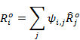
The intangible capital has been determine by using the perpetual inventory change equation that in a steady state condition with zero growth leads to the following formulation:
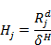
where is the depreciation rate of knowledge capital. As we have assumed that knowledge capital behave as a tangible capital that accumulate over time subject to depreciation, a corresponding amount of saving , generated from knowledge income must be determined. Since in equilibrium saving equal investment we have:
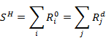
Both and are allocated respectively in the shaded parts of the sub matrix F and in the knowledge capital formation vector HF in table 2. The resulting knowledge income and saving is allocated exclusively to the Household, respectively the shaded part of the sub-matrix YF and SH in table 2.
We make the assumption that the intangible components are already embodied in the RSAM. In particular is conceptually embodied in the value added and is already included in the investment vector of the RSAM. Furthermore Household income and saving derived from the intangible component, are already incorporated in the Household wealth. So the new components previously determined may be subtracted for the corresponding values of the RSAM. Unfortunately this simple operation may lead to some negative figures. Hence we have decide to use a Cross Entropy (CE) model in order to maintain preserved the total values of the RSAM and by imposing some macro variable control as a constraints we allocate the new component to the corresponding sub-matrices.
Essentially, we base our estimations on the well known works of Golan, Judge and Robinson (1994) and Robinson, Cattaneo and El-Said (2001). The application of the CE approach on the RSAM is used as a simple balancing method as well as an adjusting procedure to incorporate new information in order to produce a well defined scheme of data. The Cross entropy model and the set of additional restrictions that constraint some sub-matrices of the RSAM are reported in appendix.

5. Policy analysis
By using the model explained in the previous sections we report the percentage change with respect to the initial steady state of a 3% subsidy on rental rate of knowledge capital in all economic activities in order to see the effect of R&D promoting policy in the economy system-wide. We compare two scenarios. In the first one we do not consider possible spillover effect, that is to say we are not accounting for non-appropriable knowledge. In the second simulation the impact of the subsidy is evaluated introducing in the model cross-border spillover effect, which instead determine the level of the free knowledge enjoyable by all firms.
From the simulation carried out we would expect that the subsidy reduces the production cost of knowledge encouraging substitution effects of intangible input for tangible input. We remind that the ITC effect in our case is given by an increase in the quantity of knowledge which does not create technical change per se but through the accumulation process, would be able to generate the condition for an output effect by increasing also the quantity of tangible inputs.
In the SR where all factors are constrained, the unemployment rate goes down as the labour market is assumed to be in ”unemployment equilibrium”, therefore the increase in labour demand has been satisfied by the reserve of the unemployed workers with consequent diminishing of unemployment rate. According to the RB closure a reduction in unemployment cause an increase in the real wage as a direct consequence of the grater bargaining power of employees. So, we see that both the real and the nominal wage go up with respect to the benchmark equilibrium values. Increasing wages, in the absence of expansionary supply, have led the price of goods to increase, so we record positive proportionate change of the consumer price index and investment price index for both tangible and intangible capital.
In the long run all supply side constrain are relaxed allowing for labour and capital (tangible and intangible) adjustment. The unemployment rate goes back to its benchmark value due to the labour market adjustment (the labour forces are increased through migration) so the real wage adjust as well to its initial steady state equilibrium. As the prices go down we get positive competitive effect. The exports rise especially in Heavy industry for which we have the lower change in regional price.
In order to evaluate whether the policy have arisen some sectoral structural change, we report the percentage change with respect to the initial steady state of the share of sectoral output on total output. An increase in output share for an economic activity implies that this sector will grow faster than the rest of the economy as a result of subsidy. For all scenarios, we see that the sectoral share of Heavy industry is always increased between the first and the last periods. Although substantially less than Heavy industry, the other sectors benefiting are Primary and Light Industry. On the other hand, Energy and Services experience a significant drop in their share of total output. The positive variation for Heavy industry has been determined by positive variation in both the share of regional and export demand on total output. The positive structural change for the Primary sector is due to the positive impact of the subsidy on the regional demand which is though partially offset by a decrease in the share of export on total output. Furthermore, the negative regional demand effect in Energy is exacerbated by its negative change in export demand.

Table 1- The Impact of R&D subsidy under different scenarios on key macroeconomic indicators (% change with respect to initial steady state).
No Spillover | SR | 10 | 20 | 30 | 40 | 50 | LR
Key Macro-economic Variables
Grp Factor Cost | 0,041 | 0,895 | 1,610 | 2,116 | 2,482 | 2,750 | 3,546
Consumer price index | 0,186 | -0,586 | -1,149 | -1,526 | -1,787 | -1,972 | -2,494
Unemployment rate | -0,562 | -1,158 | -0,716 | -0,506 | -0,369 | -0,272 | 0,000
Total employment | 0,062 | 1,110 | 1,829 | 2,319 | 2,674 | 2,934 | 3,715
Nominal gross wage | 0,203 | -0,551 | -1,128 | -1,511 | -1,776 | -1,964 | -2,494
Real gross wage | 0,017 | 0,035 | 0,022 | 0,015 | 0,011 | 0,008 | 0,000
Inv. price index TANG | 0,187 | -0,511 | -1,059 | -1,425 | -1,678 | -1,857 | -2,354
Inv. price index INTANG | 0,162 | -0,761 | -1,331 | -1,719 | -1,994 | -2,192 | -2,765
Share of sectoral output on total output
Primary Sector | -0,108 | 0,675 | 1,134 | 1,442 | 1,661 | 1,818 | 2,270
Heavy Industry | -0,119 | 1,265 | 1,951 | 2,441 | 2,809 | 3,085 | 3,946
Light Industry | 0,022 | 0,300 | 0,419 | 0,467 | 0,493 | 0,509 | 0,544
Energy | 0,146 | 0,034 | -0,142 | -0,249 | -0,323 | -0,375 | -0,526
Services | 0,044 | -0,699 | -1,061 | -1,306 | -1,485 | -1,618 | -2,024
Spillover | SR | 10 | 20 | 30 | 40 | 50 | LR
Key Macro-economic Variables
Grp Factor Cost | 0,042 | 1,114 | 2,109 | 2,914 | 3,609 | 4,247 | 5,870
Consumer price index | 0,185 | -0,744 | -1,495 | -2,057 | -2,514 | -2,910 | -3,979
Unemployment rate | -0,583 | -1,519 | -1,067 | -0,888 | -0,794 | -0,750 | 0,000
Total employment | 0,065 | 1,380 | 2,397 | 3,201 | 3,906 | 4,560 | 6,129
Nominal gross wage | 0,203 | -0,699 | -1,463 | -2,031 | -2,491 | -2,888 | -3,979
Real gross wage | 0,018 | 0,046 | 0,032 | 0,027 | 0,024 | 0,023 | 0,000
Inv. price index TANG | 0,185 | -0,670 | -1,399 | -1,944 | -2,382 | -2,760 | -3,791
Inv. price index INTANG | 0,161 | -0,906 | -1,669 | -2,255 | -2,743 | -3,176 | -4,247
Spillover | 0,000 | 0,001 | 0,001 | 0,001 | 0,001 | 0,002 | 0,002
Share of sectoral output on total output
Primary Sector | -0,107 | 0,788 | 1,403 | 1,868 | 2,252 | 2,588 | 3,492
Heavy Industry | -0,119 | 1,429 | 2,370 | 3,150 | 3,856 | 4,527 | 5,732
Light Industry | 0,024 | 0,388 | 0,560 | 0,650 | 0,716 | 0,767 | 1,101
Energy | 0,145 | -0,022 | -0,251 | -0,415 | -0,551 | -0,672 | -0,936
Services | 0,043 | -0,806 | -1,305 | -1,697 | -2,043 | -2,366 | -3,059
6. Productivity gains and surplus distribution
In this section it is our intention to present the approach we use to capture the amount of surplus or productivity gains generated by the policy and the transfer of such surplus among agents. To this end, we generalize the Fontela’s approach in a CGE context. Fontela (1989; 1994) proposes a measure of Total Factor Productivity Surplus (TFPS) to observe the distributional rule of technical change. That is to say, we are able to evaluate not only the amount of productivity gains available for distribution but also the appropriation process of such surplus.
The computation of TFPS. Fontela (1989) calls the differences between output and inputs, both measured at constant prices, TFPS:

(6)
where corresponds to the amount of real resource flows between time t and time 0, is the flow of output of sector i towards sector j and is its base year price. Since , the expression (6) can be re-written in terms of price variations:

(7)
Whereas equation (6) measures the creation of TFPS using the index number approach, equation (7) can be interpreted as a distributional rule of TFPS where the surplus distribution depends on the price variations of outputs (first element on the right hand-side) and inputs (second element on the right hand-side).
By considering the benchmark equilibrium prices as constant prices and the prices we get after the policy simulation as current prices, for a given t year we define: X and 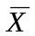, and , and , and 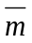, 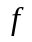 and 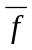; the matrix of intermediates flows, a vector of labour income, the capital return, the import flows and the final demand respectively in current and constant price. We can then get the following definition of TFPS:
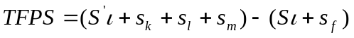 (8)
where is a unit vector, 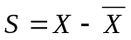, 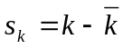, 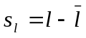, 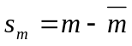and 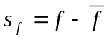
By considering a given year t, when the single element of the S matrix, 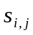>0, it means that industry j is transferring surplus to the industry i,; if 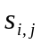<0 it means that industry j is paying relatively less for the inputs provided by industry i. Particularly interesting is the net industry contribution 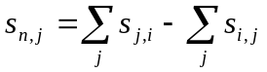. If 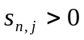this means that industry i is transferring surplus to the rest of the economy more than it is gaining from all other sectors. If wages and rental capital increase then 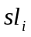 and 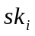 are positive; it means that industry i is transferring surplus to its primary inputs.
When the price of commodity is falling, industries are transferring additional surplus to consumers making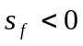 . On the contrary when 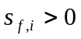then consumers are transferring surplus to industry i which is making the price greater than the base year price.

The Long Run TFPS
The study of TFP in terms of output surpluses or innovation gains provides some insights into the previous analysis and offers a new tool for policy evaluation. From the table showed below we see that the total TFPS generated which is measured in term of its contribution in production, it is higher when we are accounting for international spillover. The TFPS account for 0.33% when spillover are neglected and it is about 0.53% if international spillover are accounted. Cross-border spillover increase productivity thereby increasing the capacity of the system to generate TFPS through reduction in prices. If we consider the contribution of the TFPS on total surplus distributed we see that under No Spillover the TFPS contribution is about 25.8% while in the case of Spillover is 25.6%. So this means that there is a greater relative capacity of the international spillover of lowering the return to primary income. In both cases, Heavy Industry is the sector able to generate the higher innovation gain, while Primary and Energy are absorbing part of the innovation gains from the rest of the economy. However, in both scenarios, Energy and Services are able to reduce the cost of the returns to labour and capital (Tanglible and intangible) more than other sectors

No Spillover | Primary Sector | Heavy Industry | Light Industry | Energy | Service | Total
TFPS on production (%) | -0,223 | 0,963 | 0,708 | -0,325 | 0,035 | 0,338
Sectoral TFPS on total | -3,74 | 63,18 | 38,14 | -2,90 | 5,32
Total TFPS on total available surplus (%) | -60,59 | 65,53 | 49,57 | -65,27 | 2,61
Lowering the cost of primary factors on total available surplus (%) | 160,59 | 34,47 | 50,43 | 165,27 | 97,39
Distribution Process
Lowering or raising the price of intermediate inputs (%) | 64,33 | 28,90 | -21,30 | -10,21 | -7,35
Lowering price to consumers (%) | 35,67 | 71,10 | 121,30 | 110,21 | 107,35
Spillover
TFPS on production (%) | -0,361 | 1,289 | 1,138 | -0,500 | 0,127 | 0,528
Sectoral TFPS on total (%) | -3,91 | 55,11 | 39,54 | -2,85 | 12,12
Total TFPS on total available surplus (%) | -62,08 | 62,43 | 50,06 | -62,27 | 5,70
Lowering the cost of primary factors on total available surplus (%) | 162,08 | 37,57 | 49,94 | 162,27 | 94,30
Distribution Process
Lowering or raising the price of intermediate inputs (%) | 65,32 | 26,58 | -20,40 | -5,60 | -5,27
Lowering price to consumers (%) | 34,68 | 73,42 | 120,40 | 105,60 | 105,27

7. Conclusion
In this work our intention was to understand the important role played by the knowledge as a factor of regional development. We have seen that the Region may take advantage from its openness (in the interregional and international trade market) if it is able to exploit the knowledge embody in the imported goods which actually depend on the capacity of the regional system to internalize the technological level embody in the imported good. We have shown that with the transfer of TFP gains the subsidy on Knowledge have impacts on the distribution of the productivity gains generated by the policy. In other words, the policy has increased the system wide efficiency making better off the consumers through low price of commodities. We think also that the policy should pay more attention upon the appropriation process distribution of the welfare gains of innovation. Indeed, some policy may reinforce the power of some agents leading important drawback to the others. To a large extent, a preliminary analysis of the distribution of the innovation gains generated by the policy should be required in order to avoid possible rental position (e.g. the trade unions) that could vanished the system wide effect of the policy.
 |  | Commodities |  |  | Factors |  |  |  | Institutions |  |  | Capital Formation |  |  | Foreing Sector
 | . | j | . | Capital | Labour | Knowledge |  | Households | Firms | Gov |  | K | H |  | ROW |  | T
Commodities | i | X |  |  |  |  |  |  | C |  |  |  | HF |  | E
 | .
 | Capital
Factors | Labour | F |  |  |  |  |  |  |  |  |  |  |  |  | FW
 | Knowledge
 | Households
Institutions | Firms |  |  |  | YF |  |  |  | T |  |  |  |  |  | TW
 | Gov
 | K | Dk
Capital Formation |  |  |  |  |  |  |  |  | S
 | H |  |  |  |  |  |  | SH
Foreing Sector | ROW | I |  |  | YW |  |  |  | C W |  |  | B
Total | T
Table 2

SAM structure -Knowledge within the SAM-

Appendix
CE model. The earlier ill-specified RSAM provide the prior distribution coefficient 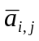 and data on column sum 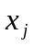.We minimize the entropy distance between the prior 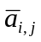 and the new estimated coefficient matrix 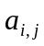:
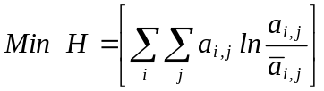 (A1)

subject to: 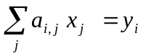 (A2)
and
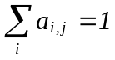 and 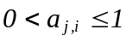 (A3)
Where 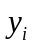 are the resulting sum in row. Considering k aggregates constraints and an n-by-n aggregator matrix G, we can write:
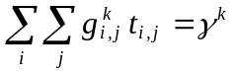 (A4)
With equation A4 we introduce in the set of constraints, some aggregate macro control in order to incorporate intangible component in the corresponding sub-matrices of the RSAM. The macro variable control concern the value added, the balance of primary income, the investment and saving.

Variables
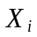 Total output 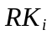 Rate of return to Capital
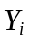 Value added 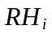 Rental rate of Knowledge
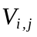 Intermediate input  User cost of Capital
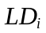 Labour demand 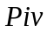 Investment Price index
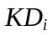 Capital demand 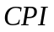 Consumer Price index
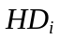 Knowledge demand  Unified wage rate
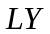 Labour Income 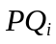 Commodity Price
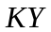 Capital Income 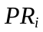 Regional Price
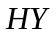 Knowledge Income 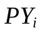 Value added price
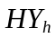 Household income 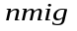 net in migration
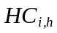 Household Consumption un Unemployment rate
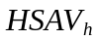 Household Saving GRP Gross Regional Product
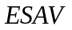 Enterprise saving PM_{i} Import Price
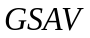 Government Saving PE_{i} Export Price
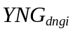 Domestic non Gov. income 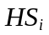 Knowledge Stock
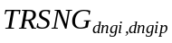 Transfer between reg. non Gov. Inst. 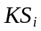 Physical Capital Stock
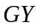 Government Income LS Labour Supply
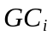 Government Consumption 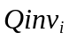 Investment (origine)
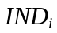 Capital Investment (Destination) 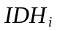 Knowledge Investment
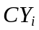 Value added Technical coefficient IMT_{i} Tax on import
IBT_{i} Indirect Business Tax M_{i} Import
 Spillover effect E_{i} Export
Parameters
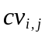 Input output coefficient Depreciation rate
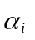 Share Parameter in all functions ir Interest rate
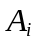 Scale factor in all functions DSHR Income share between inst.
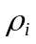 Elasticity Parameter in CES/CET MTRF Share transfer between inst
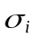 Elasticity of substitution Frish Frisch parameter for LES
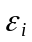 Exchange rate (numéraire) Un(N) National unemployment rate
btax_{i} business tax rate Spillover elasticity
mtax_{i} Import tax rate KP_{i,j} Invest. matrix origin-destination

Production
- 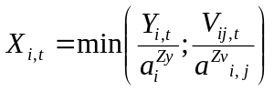
- 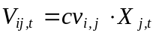
- 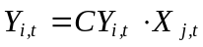
- 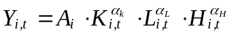
- 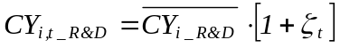
- 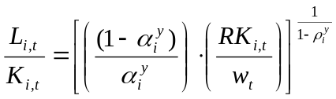
- 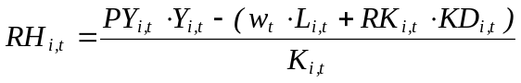

Household
- 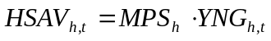
- 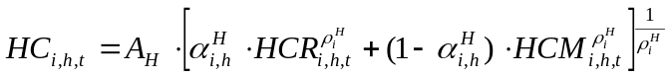
- 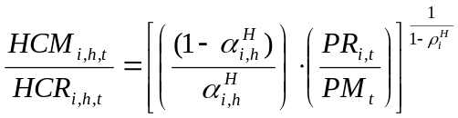

Factor income and transfer
- 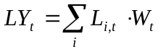
- 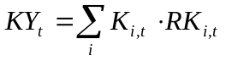
- 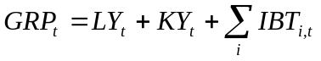
- 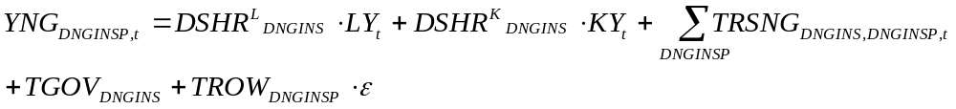
- 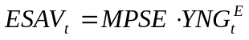
- 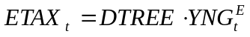
Government
- 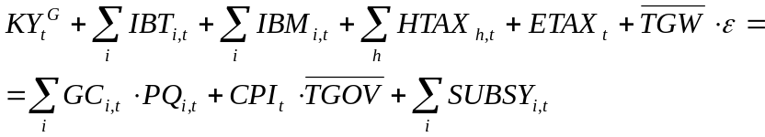
- 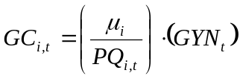
- 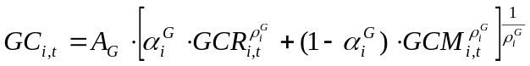
- 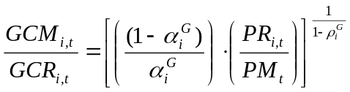
Investment and physical and knowledge stock
- 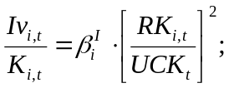
- 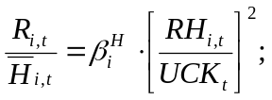
- 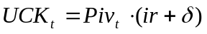
- 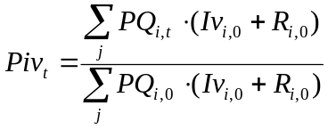
- 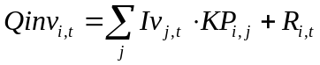
- 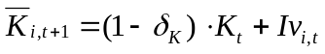
- 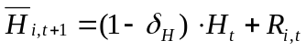
Population update
- 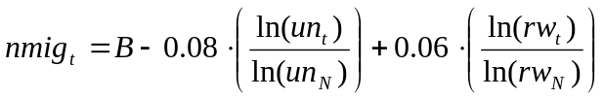
- 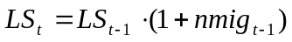
Factor market equilibrium
- 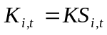
- 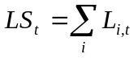
Foreign trade
- 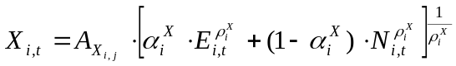
- 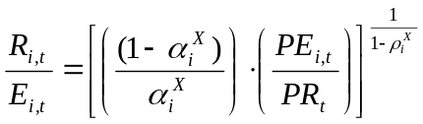
- 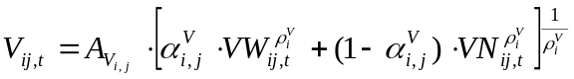
- 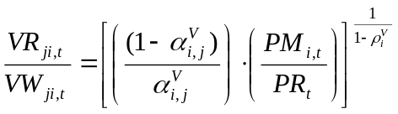

Prices
- 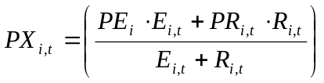
- 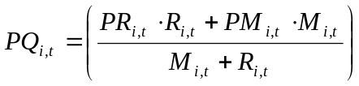
- 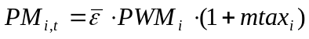
- 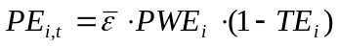
- 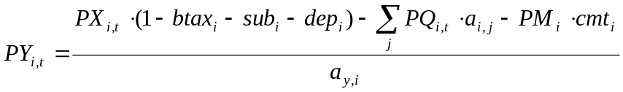
Other equations
- 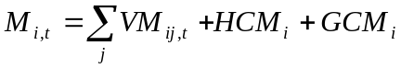
- 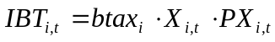
- 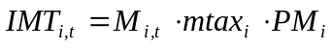
- 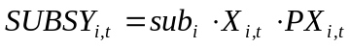

Table A1
The SAM for Sardinia extended to knowledge (2001; millions of Euro)
 | AGR | ADV | OTH | ENE | SER | LAB | CAP | KWL | IBT | SOP | HG1 | HG2 | HG3 | HG4 | HG5 | HG6 | FIRMS | GOV | KFOR | HFOR | IIP | ROI | ROW | Total
AGR | 175 | 8 | 480 | 1 | 69 | - | - | - | - | - | 54 | 67 | 56 | 97 | 27 | 43 | 0 | 0 | 1 | 0 | 0 | 797 | 6 | 1880
ADV | 80 | 3023 | 1295 | 357 | 1446 | - | - | - | - | - | 119 | 221 | 196 | 332 | 142 | 170 | 0 | 2 | 1568 | 7 | 0 | 2393 | 1864 | 13215
OTH | 129 | 193 | 1409 | 124 | 1362 | - | - | - | - | - | 471 | 677 | 630 | 1163 | 375 | 588 | 0 | 6 | 3585 | 7 | 0 | 1726 | 214 | 12657
ENE | 33 | 287 | 121 | 266 | 453 | - | - | - | - | - | 105 | 122 | 118 | 178 | 59 | 83 | 0 | 5 | 0 | 0 | 0 | 40 | 0 | 1870
SER | 167 | 1174 | 1216 | 128 | 8248 | - | - | - | - | - | 1216 | 1654 | 2036 | 3506 | 1347 | 1627 | 0 | 7380 | 953 | 4 | 0 | 751 | 672 | 32079
LAB | 581 | 980 | 1520 | 217 | 10920 | - | - | - | - | - | - | - | - | - | - | - | - | - | - | - | - | - | - | 14219
CAP | 166 | 416 | 542 | 230 | 6204 | - | - | - | - | - | - | - | - | - | - | - | - | - | - | - | - | - | - | 7558
KWL | 0 | 12 | 7 | 0 | 0 | - | - | - | - | - | - | - | - | - | - | - | - | - | - | - | - | - | - | 19
IBT | 22 | 864 | 831 | 193 | 1313 | - | - | - | - | - | - | - | - | - | - | - | - | - | - | - | - | - | - | 3223
SOP | -103 | -327 | -61 | -21 | -2113 | - | - | - | - | - | - | - | - | - | - | - | - | - | - | - | - | - | - | -2626
HG1 | 0 | 0 | 0 | 0 | 0 | 1143 | 866 | 2 | 0 | 0 | 14 | 0 | 0 | 0 | 0 | 0 | 116 | 756 | 0 | - | 0 | 0 | 10 | 2908
HG2 | 0 | 0 | 0 | 0 | 0 | 1633 | 1121 | 2 | 0 | 0 | 0 | 33 | 0 | 0 | 0 | 0 | 267 | 1737 | 0 | - | 0 | 0 | 24 | 4818
HG3 | 0 | 0 | 0 | 0 | 0 | 1816 | 897 | 2 | 0 | 0 | 0 | 0 | 14 | 0 | 0 | 0 | 117 | 759 | 0 | - | 0 | 0 | 11 | 3616
HG4 | 0 | 0 | 0 | 0 | 0 | 4974 | 1837 | 7 | 0 | 0 | 0 | 0 | 0 | 23 | 0 | 0 | 189 | 1232 | 0 | - | 0 | 0 | 17 | 8280
HG5 | 0 | 0 | 0 | 0 | 0 | 1750 | 547 | 2 | 0 | 0 | 0 | 0 | 0 | 0 | 7 | 0 | 58 | 379 | 0 | - | 0 | 0 | 5 | 2749
HG6 | 0 | 0 | 0 | 0 | 0 | 2902 | 721 | 4 | 0 | 0 | 0 | 0 | 0 | 0 | 0 | 6 | 52 | 336 | 0 | - | 0 | 0 | 5 | 4025
FIRMS | 0 | 0 | 0 | 0 | 0 | 0 | 897 | 0 | 0 | 0 | 82 | 90 | 42 | 315 | 108 | 158 | 179 | 44 | 0 | - | 0 | 0 | 64 | 1979
GOV | 0 | 0 | 0 | 0 | 0 | 0 | 672 | 0 | 3223 | -2626 | 339 | 330 | 35 | 1232 | 414 | 571 | 885 | 2721 | 0 | - | 124 | 0 | 21 | 7942
KFOR | 257 | 488 | 337 | 324 | 2677 | 0 | 0 | 0 | 0 | 0 | 499 | 1615 | 484 | 1401 | 259 | 762 | 54 | -7554 | 0 | - | 0 | 3219 | 3184 | 8007
HFOR | 0 | 0 | 0 | 0 | 0 | 0 | 0 | 0 | 0 | 0 | 2 | 2 | 2 | 7 | 2 | 4 | 0 | 0 | 0 | 0 | 0 | 0 | 0 | 19
IIP | 4 | 49 | 71 | 0 | 0 | 0 | 0 | 0 | 0 | 0 | 0 | 0 | 0 | 0 | 0 | 0 | 0 | 0 | 0 | - | 0 | 0 | 0 | 124
ROI | 204 | 2950 | 3235 | 33 | 1004 | 0 | 0 | 0 | 0 | 0 | 0 | 0 | 0 | 0 | 0 | 0 | 0 | 0 | 1500 | - | 0 | 0 | 0 | 8926
ROW | 166 | 3097 | 1655 | 18 | 495 | 0 | 0 | 0 | 0 | 0 | 7 | 7 | 3 | 26 | 9 | 13 | 62 | 139 | 400 | - | 0 | 0 | 0 | 6097
Total | 1880 | 13215 | 12657 | 1870 | 32079 | 14219 | 7558 | 19 | 3223 | -2626 | 2908 | 4818 | 3616 | 8280 | 2749 | 4025 | 1979 | 7942 | 8007 | 19 | 124 | 8926 | 6097

Table A2
Aggregate version of the Yale Technology Matrix

 | AGR | MIN | CPH | RAP | MET | MEE | ELE | OTH | TRA | ENE | CON | SER | OCS
AGR | 0 | 0 | 0 | 0 | 0 | 0 | 0 | 0 | 0 | 0 | 0 | 0 | 0
MIN | 0.005 | 0.375 | 0.016 | 0.003 | 0.087 | 0.057 | 0.088 | 0.024 | 0.038 | 0.018 | 0.216 | 0.055 | 0.021
CPH | 0.036 | 0.006 | 0.395 | 0.042 | 0.016 | 0.006 | 0.017 | 0.045 | 0.004 | 0.010 | 0.004 | 0.014 | 0.407
RAP | 0.020 | 0.008 | 0.049 | 0.324 | 0.020 | 0.039 | 0.046 | 0.104 | 0.107 | 0.003 | 0.137 | 0.078 | 0.064
MET | 0.013 | 0.025 | 0.008 | 0.014 | 0.222 | 0.152 | 0.019 | 0.051 | 0.034 | 0.022 | 0.274 | 0.116 | 0.049
MEE | 0.031 | 0.039 | 0.024 | 0.023 | 0.025 | 0.478 | 0.030 | 0.090 | 0.019 | 0.036 | 0.028 | 0.075 | 0.100
ELE | 0.003 | 0.007 | 0.007 | 0.001 | 0.013 | 0.084 | 0.537 | 0.018 | 0.032 | 0.016 | 0.035 | 0.070 | 0.177
OTH | 0.074 | 0.004 | 0.009 | 0.006 | 0.005 | 0.028 | 0.046 | 0.526 | 0.013 | 0.003 | 0.063 | 0.090 | 0.133
TRA | 0.001 | 0.000 | 0.000 | 0.000 | 0.001 | 0.005 | 0.000 | 0.000 | 0.922 | 0.001 | 0.002 | 0.046 | 0.022
ENE | 0.026 | 0.092 | 0.039 | 0.000 | 0.000 | 0.026 | 0.000 | 0.000 | 0.000 | 0.474 | 0.053 | 0.289 | 0.000
CON | 0.000 | 0.000 | 0.000 | 0.000 | 0.000 | 0.000 | 0.000 | 0.000 | 0.000 | 0.000 | 0.000 | 0.000 | 0.000
SER | 0.000 | 0.000 | 0.000 | 0.000 | 0.000 | 0.000 | 0.000 | 0.000 | 0.000 | 0.000 | 0.000 | 0.000 | 0.000
OCS | 0.000 | 0.000 | 0.000 | 0.000 | 0.000 | 0.000 | 0.000 | 0.000 | 0.000 | 0.000 | 0.000 | 0.000 | 0.000
Source: Evenson et al. 1989.

References

Adelman, I. and S. Robinson (1989) Income distribution and development. In H. Chenery and T. N. Srinivasan (Eds.), Handbook of development economics, vol. 2, pp. 949-1003. (Amsterdam;North-Holland).
Annabi, N., F. Cisse, J. Cockburn and B. Decaluwe (2005) Trade Liberalisation, Growth and Poverty in Senegal: A Dynamic Microsimulation CGE Model Analysis,( CIRPEEWorking Paper 05-12). www.cepii.fr/anglaisgraph/workpap/pdf/2005- /wp05- 07.pdf.
Antille G. and E. Fontela (2003) ”The Terms of Trade and the International Transfers
of Productivity Gains”. Economic System Research, Vol. 15, N.1. Blanchflower, D. G. and A. J. Oswald (1994). The wage curve. (Cambridge; The MIT Press).
Brooke, A., D. Kendrick, A. Meeraus and R. Raman. (1998). GAMS -A user’s guide. (Washington: GAMS Development Corporation).
Deaton, A. and J. Muelbauer (1996) Economics and Consumer Behavior, (Cambridge University Press: New York).
De Melo, J. (1988). ”Computable general equilibrium models for trade policy analysis in developing countries: A survey”. Journal of Policy Modeling, 10(4), 469-503.
Dellink, R.B. (2005). Modelling the Costs of Environmental Policy: a Dynamic Applied General Equilibrium Assessment. Cheltenham: Edward Elgar Publishing. (WUR).
Dervis, K., De Melo, J., and Robinson, S. (1982). General equilibrium models for development policy. Cambridge, UK: Cambridge University Press.
Devarajan, S., and S. Robinson. 2002. The influence of computable general equilibrium models on policy. TMD Discussion Paper No. 98. Washington, DC: International Food Policy Research Institute.
Dixon, P. B., and Rimmer, M. T. (2006). The Displacement effect of Labour-Market Programms: MONASH Analysis. The Economic Record, vol. 82.
Fontela E. (1989). Industrial Structure and Economic Growth: an Input Output Perspective. Economic System Research, Vol. 1, N.1.
-(1994). Inter-industry Distribution of Productivity Gains. Economic System Research. Vol. 6. N.3.
Garau G. (1993). La distribution des gains de la croissance: une analyse entr`ees sorties, ed. Lang, Berna, 1996.
-(2002). Total Factor Productivity Surplus in a SAM Context, I International Conference on Economic and Social Statistics, Canton, China.
Ferrari G., Garau, G. and Lecca, P. (2005). The Social Accounting Matrix for Sardinia. Mimeo.
Gunning, J. W., and Keyzer, M. A. (1995).Applied general equilibrium models for policy analysis. In J. Behrman and T. N. Srinivasan (Eds.), Handbook of development economics, vol. 3A (pp. 2025-2107). Amsterdam: North-Holland.
Harrigan, F. McGregor, P.G., Dournashkin, N., Perman, R., Swales, J.K. and Yin, Y.P. (1991) ’AMOS: A macro-micro model of Scotland’, Economic Modelling, Vol.10, pp424-479.
Harris, R. (1984), Applied General Equilibrium Analysis of Small Open Economies with Scale Economies and Imperfect Competition, American Economic Review, 74, December, 1016-31.
Jung, H.S. and Thorbecke, E. (2003), The Impact of Public Education Expenditure on Human Capital, Growth, and Poverty in Tanzania and Zambia: A General Equilibrium Approach. Journal of Policy Modeling. 25: 701-725.
Layard, R., Nickell, S. and Jackman, R. (1991) Unemployment: Macroeconomic Performance and the Labour Market, Oxford University Press, Oxford.
Lo Cascio, M., Garau, G. and Fontela E., (1993). Factor Productivity Surplus and Market Structure. Paper presented at the 10th International Conference on Input Output Techniques, Sevilla.
McGregor, P. Swales, J.K. and Yin, Y. (1996). A Long-run Interpretation of Regional Input-Output Analysis. Journal of Regional Science, Vol. 36, pp. 479-501.
McGregor, P. Swales, J.K. (2003). The Economics of Devolution/Decentralisation in the UK: Some Questions and Answers. Discussion Paper. Department of Economics University of Strathclyde.
OECD, Main Science and Technology Indicators (2004); Economic and social data Services. http://www.esds.ac.uk/international/about/about.asp.
Partridge, M. D. and D. Rickman.(2004). CGE Modelling for Regional Economic Development Analysis. Draft book chapter for State of the Art in Regional and Urban Modeling. www.crerl.usask.ca/research/P artridge/CGEModeling.pdf.
Plassmann, F. and Tidemann, N. 1999. A dynamic regional applied general equilibrium model with five factors of production. Department of Economics, Birmnigham University of New York.
Pyatt, G. (1988). A SAM approach to modeling. Journal of Policy Modeling, 10(3), 327-352.
Pyatt, G. and J. Round (1988). Social Accounting Matrices: A Basis for Planning. Washington, DC: World Bank.
Robinson, S., Yunez-Naude, A., Hinojosa-Ojeda, R. A., Lewis, J. D., and Devarajan, S. (1999). From stylized to applied models: Building multisector CGE models for policy analysis. North American Journal of Economic and Finance, 10, 5-38.
Shestalova V. (2001). General equilibrium analysis of international TFP growth rates, Economic Systems Research, 13 (4), 391-404.
Shoven, J. B., and Whalley, J. (1992). Applying general equilibrium. Cambridge: Cambridge University Press.
Vargas, E., Schreiner D., Tembo G. andMarcouiller D. (1999). Computable General Equilibrium Modeling for Regional Analysis. The Web Book of Regional Science. http://www.rri.wvu.edu/WebBook/Schreiner/contents.htm.
Yeldan, E. (1997). Financial liberalization and fiscal repression in Turkey: Policy analysis in a CGE model with financial markets. Journal of Policy Modeling, 19(1), 79-117.
Zalai, E. (1998). Computable general equilibrium modelling and application to economies in transition. CERT Discussion Papers, 4. Retrieved from: http://www. sml.hw.ac.uk/cert/wpa/ddpapers98.html.

University of Sassari, Italy; giorgio@uniss.it. University of Cagliari, Italy; plecca@masterstat.it.
See also Jung and Thorbecke (2003).
The original work of Blanchflower and Oswald (1994) has been replicated and extended in several other works. The results sometimes are quite different. For instance, Montuenga et al. (2003) show that regional wage curves exhibit more variability than originally indicated by Blanhflower and Oswald.

