Improving competitive facility location via GIS
Rafael Suárez-Vega, Dolores R. Santos-Peñate and Pablo Dorta-González
University of Las Palmas de Gran Canaria
Spain

Abstract
In this paper a competitive location problem is treated. We consider a proportional choice rule derived from the Huff model, where facility location and other attributes, such as size and service quality, are considered. The model we propose incorporates additional geographical information such as the proximity to principal roads, the slope of the terrain and the distance to the distribution centres, in order to determine the most profitable locations for a new store. We use a GIS based model to combine the estimated capture obtained using the Huff model and the geographical information to find the potential locations for a new facility. We present an example where the problem is solved considering Euclidean distances.

- Introduction
In this paper we investigate the follower competitive location problem in the leader-follower model. In this case, a new firm wants to establish a facility in a market where other competing firms already exist. We suppose that each facility is characterized by its quality level that may combine aspects like size, prices, parking areas, opening hours, accessibility, etc. Customers take their choice according to the attraction or utility that they perceive from the facilities. The attraction perceived by the customers from the facilities has been represented mathematically by an attraction function which is increasing of the quality level and decreasing of the distance. Attraction functions are used to define the customer choice rule, which represents the customer’s behaviour and the flows of consumers in the market.
Assuming certain customer’s preferences, the firms, whose natural objective is the maximization of the market share or the profit, take their location decisions, influencing with their actions the results and strategies of their competitor. This movement of individuals defines the basis of the location-spatial interaction models.
The first spatial interaction models were gravity models, which assume analogies between the human behaviour and the Newtonian gravity laws. The basic gravity formulation, in which the movement of individuals between two points is inversely proportional to the distance separating these two points, was applied by Reilly (1931) and Converse (1949) to analyze retail market areas. Later, Huff (1964) proposed an alternative model to overcome certain limitations of the Reilly-type approach. According to this new model, the probability that a customer at i buys at a facility j is given by
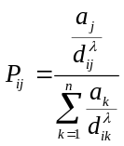
where 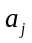 represents the size of a service center j, 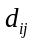 is the distance (or travel time) from demand point i to facility j, and λ is a parameter which reflects the effect of the distance on the consumer’s behaviour and whose value is estimated empirically. The quotient 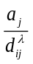 can be interpreted as an attraction function representing that the attraction felt by a customer at point i towards facility j is directly proportional to the size of the facility and inversely proportional to a power of the distance between them.
Following Huff model, Drezner (1994) solved this problem considering that each point in the plane was a potential location for the new facility. This author used the Weiszfeld algorithm to obtain the best location. This is a gradient based method that yields with a local optimum, so the procedure must be run several times and the best solution obtained is selected. This model only take into account with the locations (facilities and demand points) the amount of demand and the size of the facilities but ignores others geographic aspects like distance to main roads, distance to distribution centres, land use or slope of the terrain, amount others. There exists a problem when the feasible region contains holes, for example lakes or natural protected areas, because the algorithm does not exclude these areas in the evaluation.
We have used GIS procedures to improve the results obtained using this spatial interaction model. Previous works combining this geographic tools and interaction model are described in Birkin et al (1996) and Birkin et al (2004). The main use of GIS in this area has been centered in obtaining influence areas and estimated market but for discrete situations, that is, when the potential locations are prefixed.
The remainder of the paper is structured as follows. The problem to be solved and the employed data are presented in Section 2. The procedures used to solve the problem are described in Section 3. Finally, we present the results obtaining applying the tools previously developed in Section 4 and some conclusions in Section 5.

- The problem
We are interested in determining the best location for a new hypermarket in Gran Canaria, an island belonging to the Canarian Archipelago (Spain) sited about 100 km from Morocco and 1000 km from Spain. According to the Law of Regulation of Commercial Activity in the Canaries (1994) a hypermarket is a large store which is a combination of a food store and a department store with a minimum sales area of 2500 m². In this application, the quality level is measured by the hypermarkets' sales surface (m²). To determine the best location for this new centre we combine for each feasible point the estimated capture obtained using Huff model, the distance to the main roads, the distance to the distribution centres (trading ports), the land use and the slope of the terrain.
The problem has been solved using ArcGis9.1® to treat with the geographic information and an algorithm programmed in C++ to obtain the estimated capture. The available data is described next:
- Demand: The island population is aggregated in 32 nodes. Most of the nodes coincide with municipalities, only the most populous ones have been disaggregated in several nodes. Each node has associated a demand equivalent to its population (see Table 1). This information is treated by ArcGis like a point layer that contains the coordinates, the name and the population of the node.

#Node | Municipality | Demand | #Node | Municipality | Demand
1 | Agaete | 5763 | 17 | Ingenio | 10149
2 | Gáldar | 21998 | 18 | Ingenio | 13404
3 | Sta. Mª Guía | 13966 | 19 | Agüimes | 12386
4 | Arucas | 30833 | 20 | Agüimes | 6953
5 | Las Palmas G.C. | 30971 | 21 | Sta. Lucía | 40988
6 | Las Palmas G.C. | 103017 | 22 | Sta. Lucía | 896
7 | Las Palmas G.C. | 27371 | 23 | Moya | 8674
8 | Las Palmas G.C. | 103017 | 24 | Firgas | 6614
9 | Las Palmas G.C. | 103017 | 25 | Teror | 11459
10 | Telde | 49946 | 26 | Sta. Brígida | 18662
11 | Telde | 33853 | 27 | San Mateo | 7146
12 | San Bartolomé | 25000 | 28 | Valsequillo | 7710
13 | San Bartolomé | 8263 | 29 | San Nicolás | 8101
14 | San Bartolomé | 53996 | 30 | Tejeda | 2452
15 | Mogán | 12142 | 31 | Artenara | 1252
16 | Mogán | 4608 | 32 | Valleseco | 4263
Table 1: Population for the different network nodes

- Existing centres: There already exist eight hypermarkets operating in the island which are located at nodes 5, 6, 8, 9, 10, 14, 19, and 21, with sales areas 10880, 9927, 5113, 5200, 14456, 8003, 3196, and 6750 m², respectively. This point layer contains the coordinates, the name and the sales surface of each hypermarket.
- Trading ports: This is a point layer with the coordinates of the ports which act as importation and distribution centres in the island. In this case there exist two ports located at the N and NE of the island.
- Main roads: The network considered is stored in a polyline layer that is built on an approximation of the main roads of Gran Canaria. This layer contains length (meters), transportation time (minutes), origin and destination for each edge.

Figure 1 shows the actual market where the different municipalities, colored by population, are presented. Note that the 46.57 % of the total population and the 48.99 % of the hypermarkets sales area are concentrated in the capital of the island (nodes 5 to 9). The rest of hypermarkets, and an important part of the demand, are distributed on the eastern and southern sides of the island. The centre and the western part are abrupt areas with low density of population.
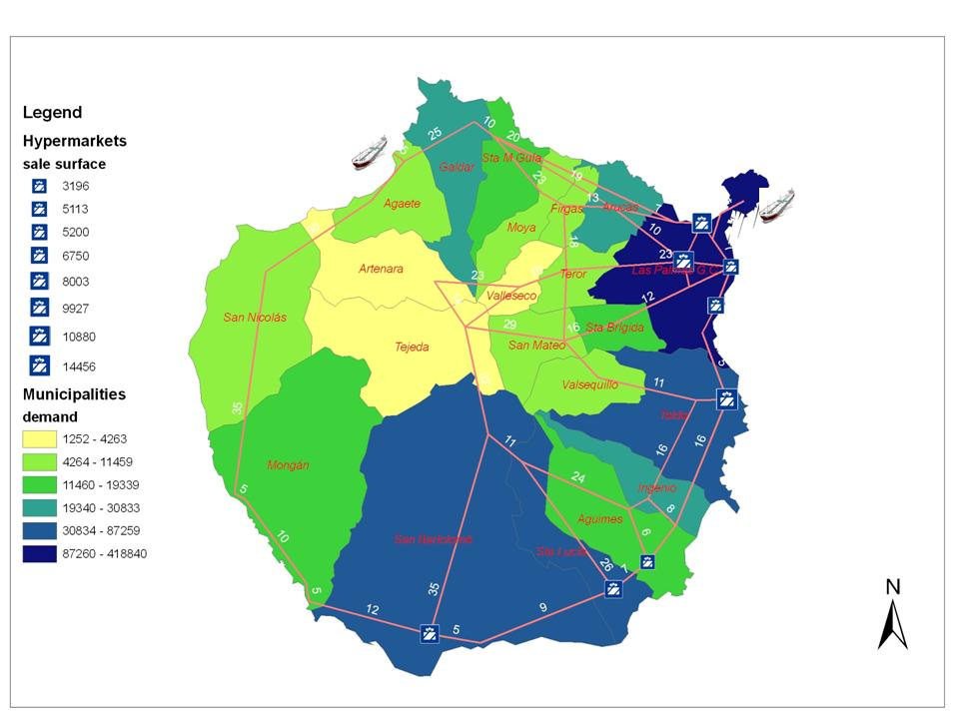
Figure 1. Gran Canaria existing market

- Slope: This is a raster layer containing the slope, in percent, of the island. It was obtained from an elevation data file supplied for the Shuttle Radar Topography Mission (SRTM), an international project spearheaded by the National Geospatial-Intelligence Agency (NGA) and the National Aeronautics and Space Administration (NASA). This data have a resolution of 90 m/pixel.
- Land use: We use a raster file obtained from the project CORINE LAND COVER 2000 of the European Environment Agency. This file has a resolution of 100 m/pixel.

The objective is to obtain a weighted combination of the following objectives:
- M1: Maximize the estimated captured by huff model.
- M2: Choose a location where the establishment of a new hypermarket is in concordance with the land use of the area. In this line, natural protected areas or water bodies, among other, are discarded. The feasible areas have been weighted in relation with the proximity of the land use with the objective of locating a new hypermarket.
- M3: Minimize the distance to the distribution centres (trading ports).
- M4: Minimize the slope of the terrain where the new hypermarket must be built. For technical reasons, areas with slope higher than 30 % are excluded of the analysis.
- M5: Minimize the distance to the main road.

The results of the previous objectives have been normalized from 1 to 100 to combine in the same objective function. The final weighted function is:

- Resolution Tools
To solve the problem we have used ArcGis 9.1 combined with a C++ algorithm. The process is shown in Figure 2.
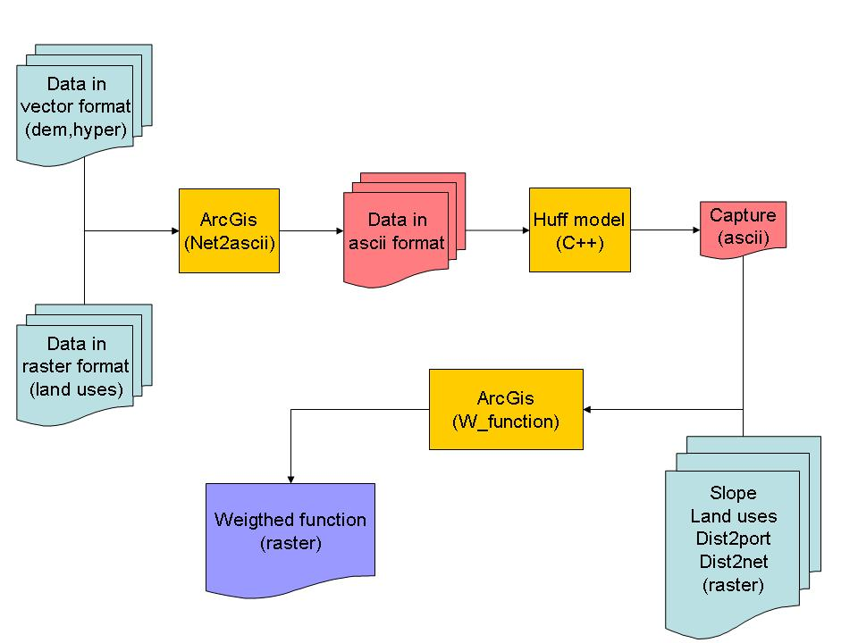
Figure 2. Process to obtain the weighted function

Next, the different tools employed to obtain the final weighted function are briefly described.

  - Net2ascii model
The ArcGis model Net2ascii is employed in a previous step to obtain the estimated capture using the Huff model. This model is synthesized in Figure 3. To solve the interaction location model it is needed to transform the geographic information into ASCII files. Therefore, the vector files with the demand and the hypermarket are converted to raster layers. A raster layer is a matrix of cell (named pixel) which contains a determinate value and it can be represented by giving a color to each pixel in function of its value.
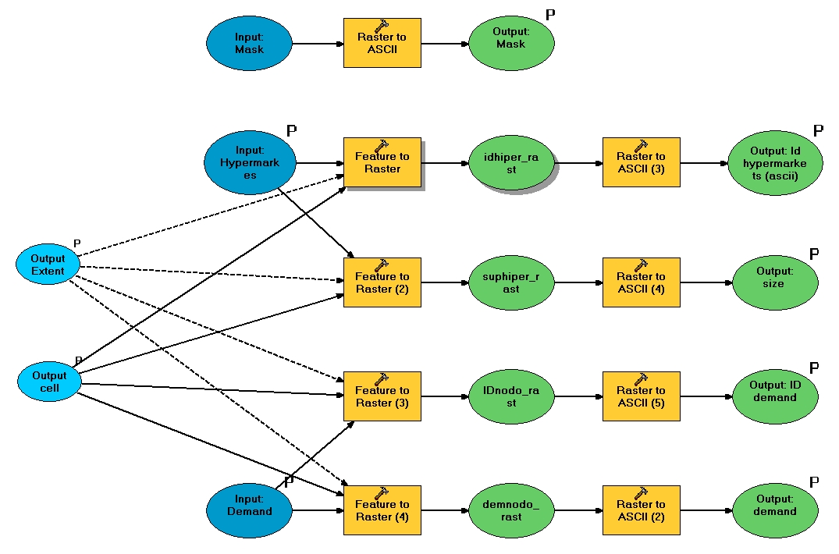
Figure 3. Net2ascii model

Next, all the raster layers are exported to ASCII files. These files contain a heading with all the information needed to georeferencing the data. That is the number of rows and columns, the dimension of each pixel (in meters) and the position of pixel in the low-left corner of the file. With this information, it is possible to determine the geographic location of each pixel knowing the row and column where it is.
Then for each hypermarket and demand node we know the position where they are (row and column) in the matrix. For those positions we store the identification and the population (for the demand nodes) or the size (for the hypermarket). Note that each of this location is represented by only one pixel because this information comes from a point layer.
The mask is a raster file and it is only used to indicate to the algorithm the pixels that must be considered. For this work, we use the land use, excluding the sea areas.

  - Huff model
This C++ algorithm calculates the estimated capture for each pixel P following the formula
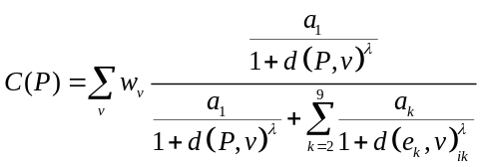,
Where
- are the demand nodes.
- is the size (in thousand square meters) of the new hypermarket. In this example we have considered 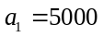.
- 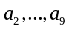 are the sizes (in square meters) of the existing hypermarkets.
- 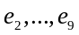 are the locations of the existing hypermarkets.
- is a parameter that reflects the distance decay. In this case, three values are considered, 0.5, 1, and 2, in order to consider both concave and convex decay functions.
- 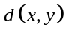 represents the Euclidean distance between points x and y. As the length of the pixel is known, this function is easy calculated because the location of each point is determined by its column and row.

The result of this algorithm is an ASCII file containing the heading with the georeferencing information and a matrix where the capture for each pixel is stored. This file can be imported by ArcGis to make a raster layer (see Figure 4).

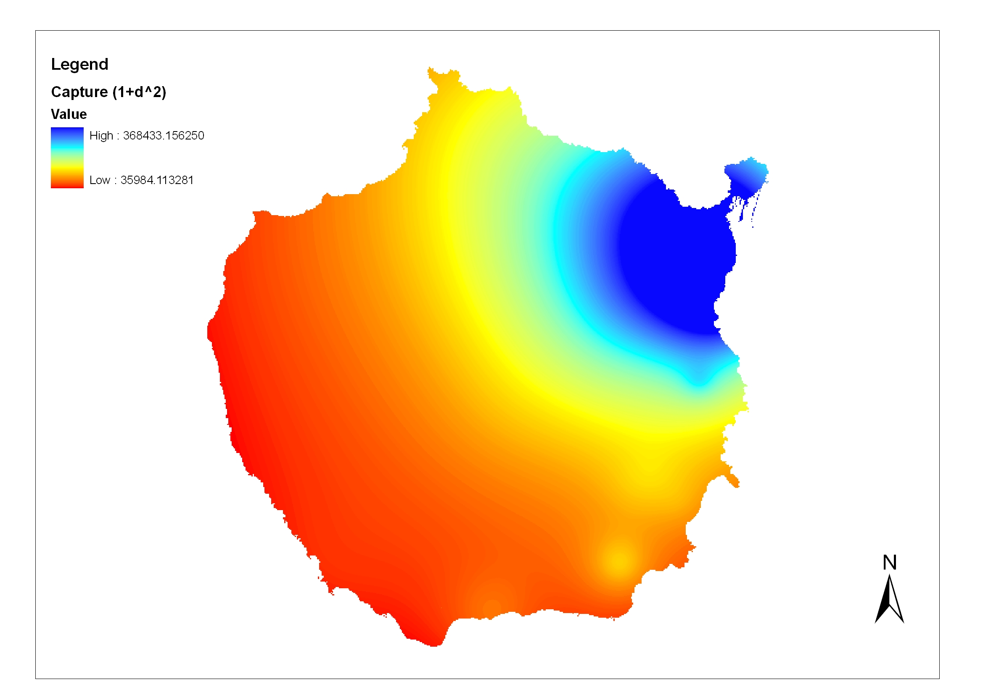
Figure 4. Capture map for λ = 2

  - W_function model
This model combines five raster files to obtain the final weighted function. As shows Figure 5, this model has as inputs the raster files containing the capture (obtained by Huff model), the land uses, the distance to the ports, the slope of the terrain and the distance to the main roads. It also admits as parameter the weights for each raster file.

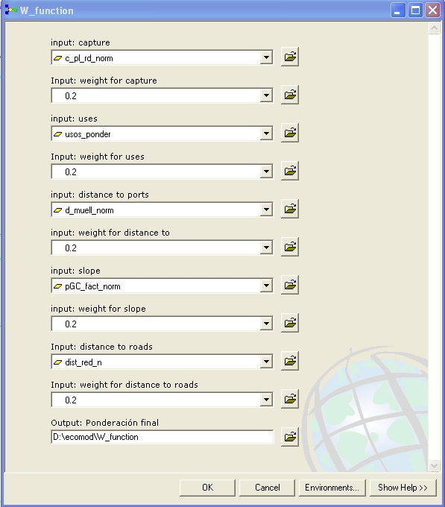
Figure 5. Interface of W_function model

Note that every raster layer has previously normalized into a scale from 1 to 100. For the slope layer, those pixels with slope greater than 30 (percent) have been transformed to NoData value and they will not be considered in the weighted function.
With respect to the land uses layer, the following weighing was made:

Type of use | Weight
Industrial areas | 100
Urban areas | 80
Vegetated and leisure areas | 60
Agricultural areas | 50
Rest | NoData
Table 1. Weight for the different land uses

- Results
To find the best areas to locate the new hypermarket the models have been run considering nine different scenarios. The Huff model was solved taking values for λ of 0.5, 1, and 2, in order to take into account both concave and convex decay functions. By other hand, three combinations of weight for M1, M2, M3, M4, and M5 were used. The first gives the same weight to the five objectives, 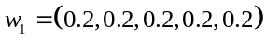. The second considers that the Huff captures has the most important role in the weighing, 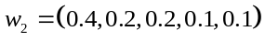. And the third pattern gives a higher importance to the land uses and the distance to the ports and less to the Huff captures, 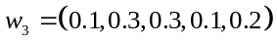.
Figure 6 shows the maps obtained for 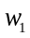 for the different values of λ. Figure 7 presents the weighted maps when the three weight patterns are applied to the model with λ = 2. In all the scenarios the most promising areas are around the capital of the island, Las Palmas de Gran Canaria.

- Conclusions

An overseeing of the maps may give to the decision's makers an idea of what is the valuation of the potential areas to locate the hypermarket. The study can be most exhaustive and we can select the areas with high values in the weighted function, for example we can extract the areas with values highest than 80 or 90. We can also discard those promising areas with a surface less than a prefixed. For example, to locate a hypermarket with 5000 m² of sales surface it may be necessary an area of almost 10000 m² because of we have to provide parking space. Then we have to discard the promising areas which their surface is less than this threshold. The model can be improved adding new layers, specific for the problem, including information that may affect the customers’ choice or the promoter’s strategy.
As the correct pattern for the parameter values generally is ignored, a possible solution can be to solve the problem several times varying the parameter values and comparing the results or calculating the mean for each pixel and choosing those zones that are most promising independently of the scenario.
Finally, this procedure can be extended to the case where network distance instead Euclidean distance is considered.

- References
Birkin, M., G. Clarke, M. Clarke and R. Culf (2004) Using spatial models to solve difficult retail location problems in Applied GIS and Spatial Analysis, J. Stillwell and G. Clarke (eds). Willey, England.
Birkin, M., G. Clarke, M. Clarke and A.G. Wilson (1996) Intelligent GIS: Location decisions and strategic planning, Geoinformation, Cambrigde.
Converse P.D. (1949) New laws of retail gravitation, Journal of Marketing, 14: 379-384.
CORINE LAND COVER 2000 (European Environment Agency) http://dataservice.eea.europa.eu/dataservice/metadetails.asp?id=667
Drezner, T. (1994) Optimal continuous location of a retail facility, facility attractiveness, and market share: An interactive model, Journal of Retailing, 70(1): 49-64.
Huff DL (1964) Defining and estimating a trading area, Journal of Marketing 28: 34-38.
Reilly WJ (1931) The law of retail gravitation, New York, Knickerbocker Press.
Shuttle Radar Topography Mission (NASA) http://www2.jpl.nasa.gov/srtm/

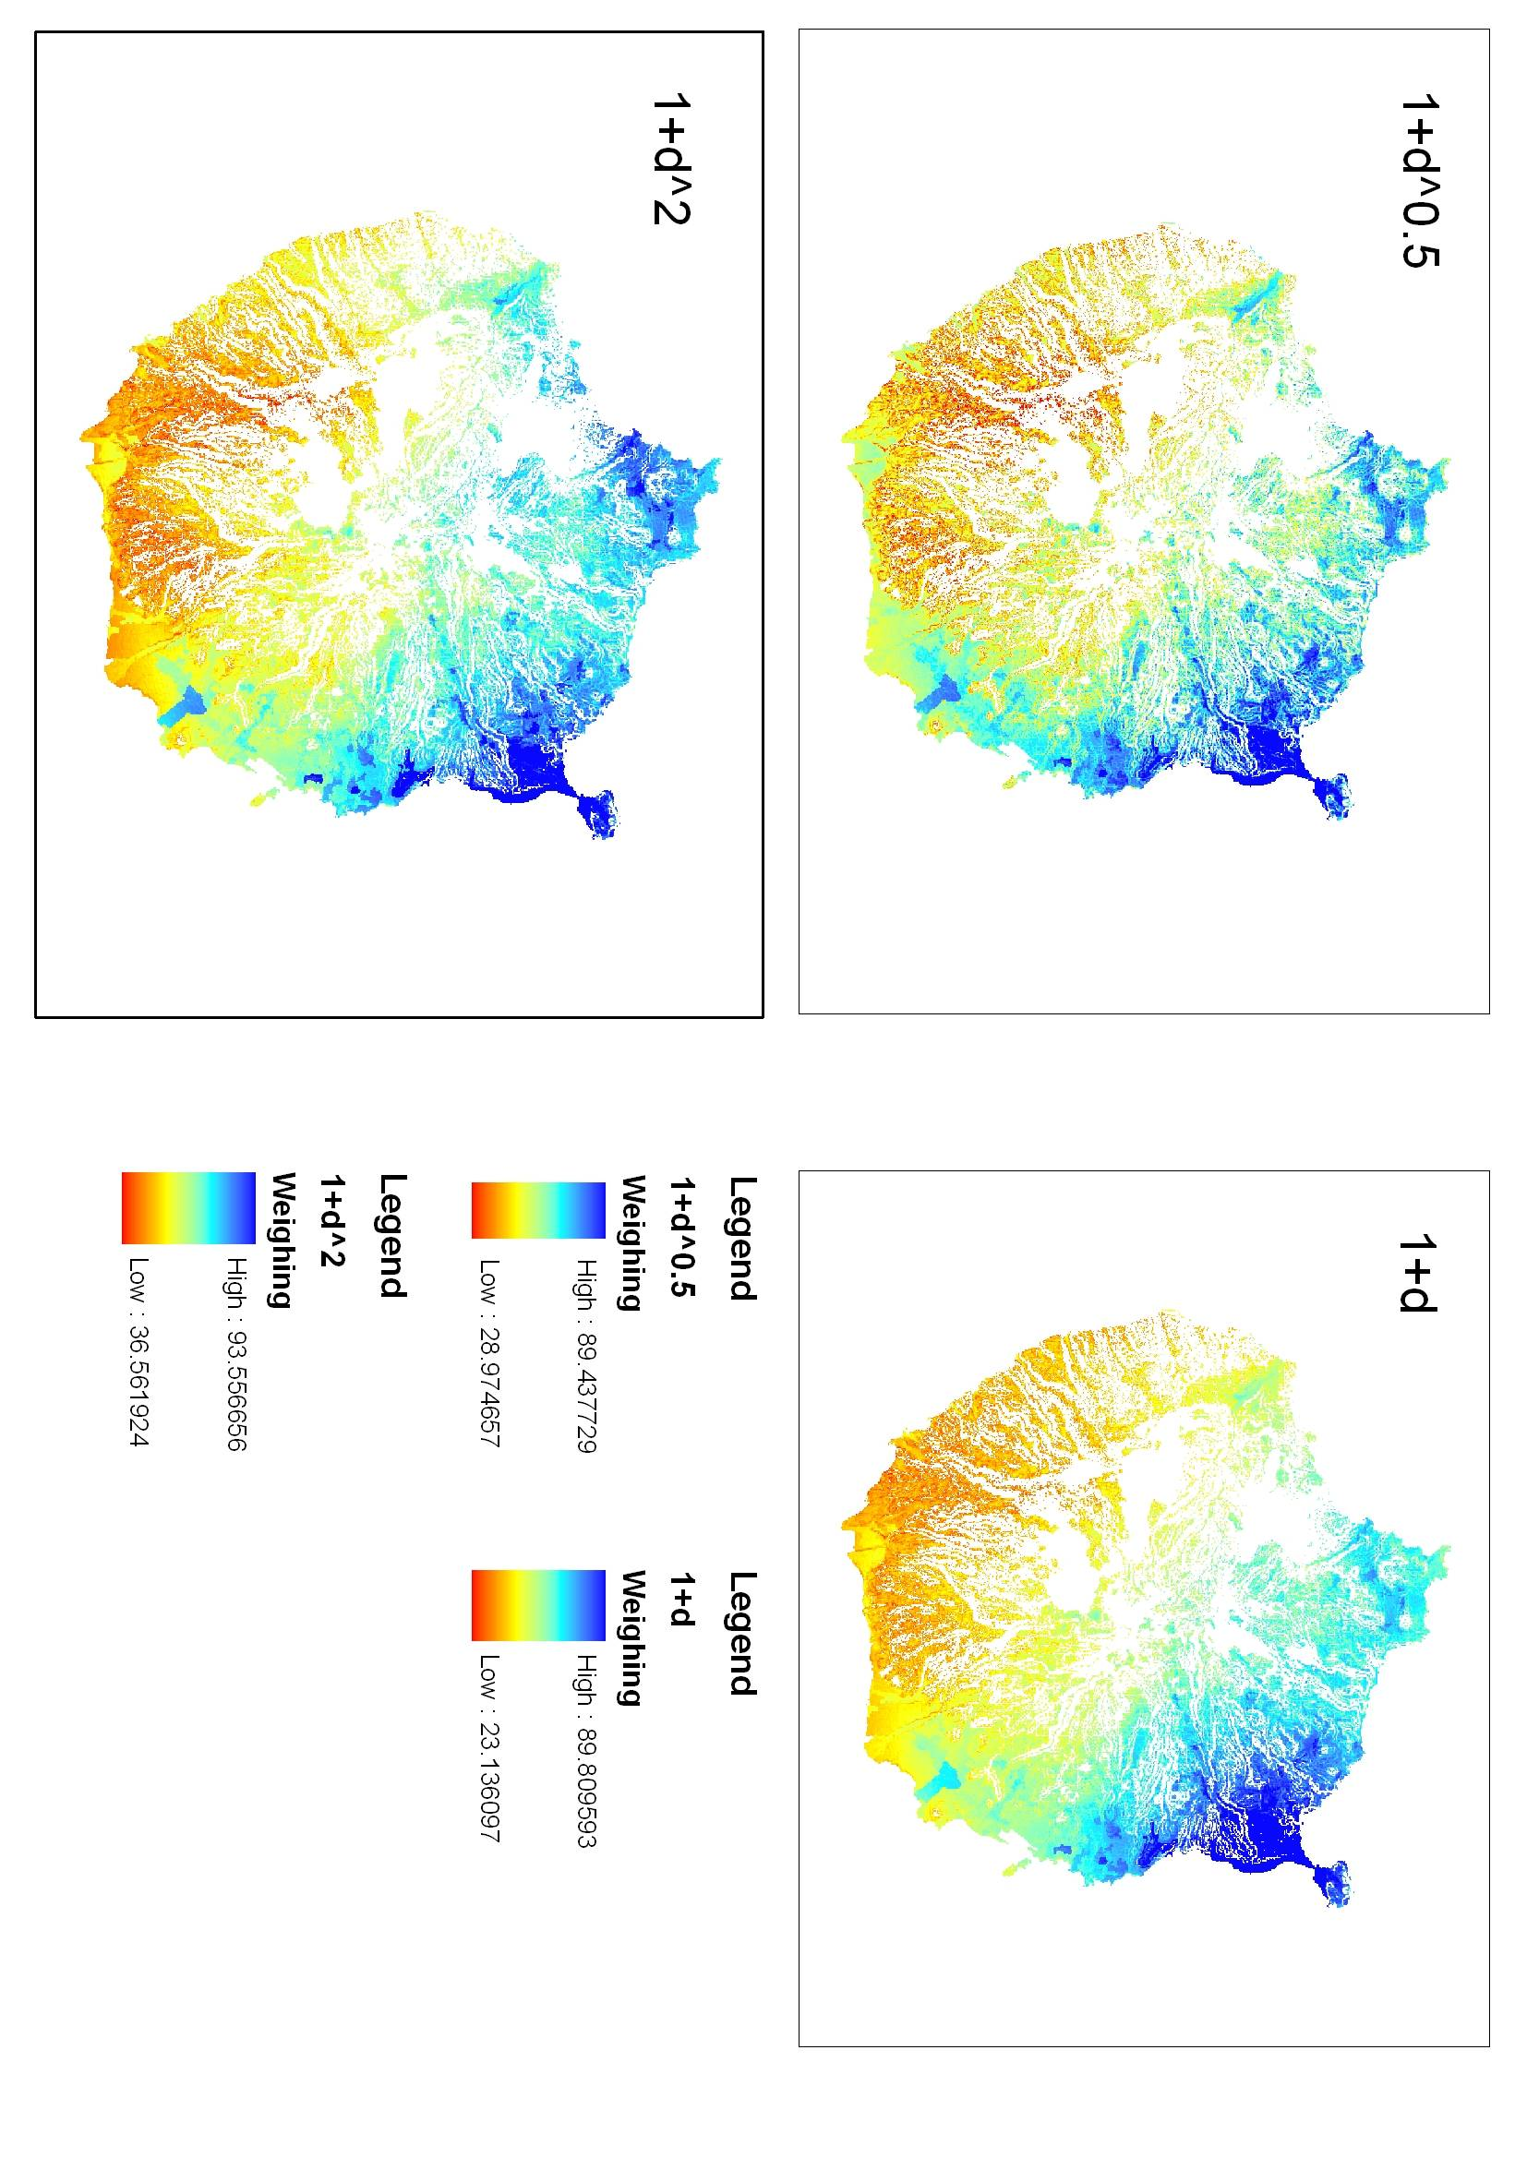
Figure 6. Weighted maps for the different values of λ when all the weights are equal
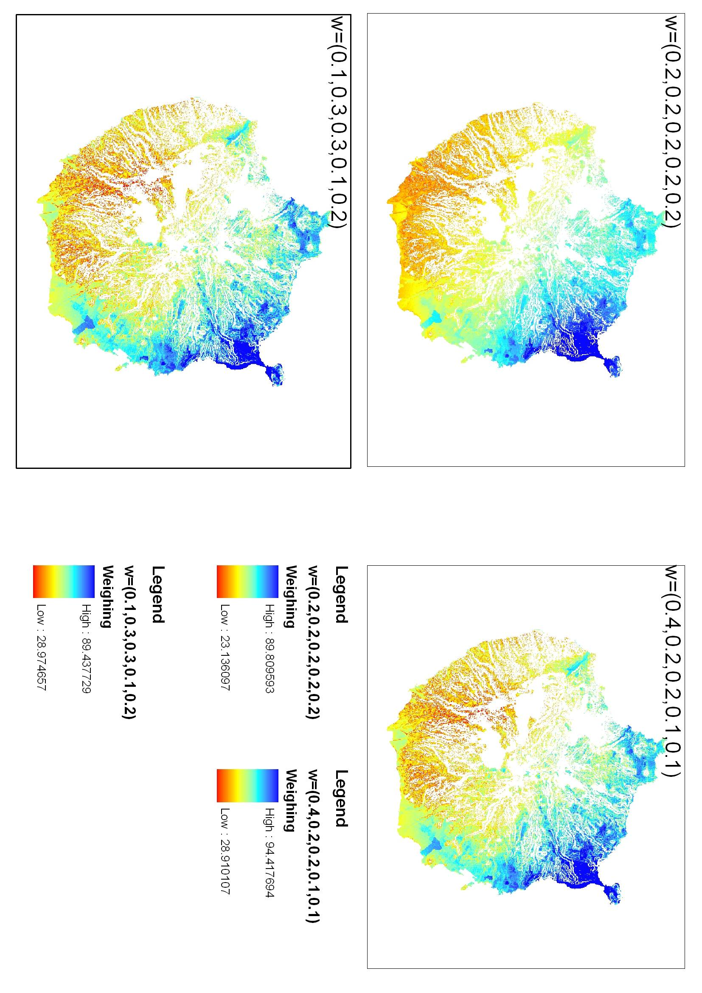
Figure 7. Maps for different weights pattern when λ = 2

