Thursday, 20 April, 2006

poverty impacts of trade liberalization:
The Case of Indonesia

Guntur SUGIYARTO and Erwin Corong

Abstract

The rapid pace of Indonesia’s unilateral trade liberalization and the imminent agricultural liberalization arising from the Doha Development Agenda have been the subject of policy debates. A computable general equilibrium linked to a micro simulation model of the Indonesian economy was developed to shed light on these issues. Simulation results indicate that removing agricultural tariffs alone generates adverse effects. While, the removal of agricultural tariffs coupled with the abolition of agricultural taxes benefits the economy, households and the poor. Alternatively, a more comprehensive liberalization strategy—involving all sectors, seems the best scenario as the degree of poverty reduction intensifies.

Keywords: Doha Development Agenda, Poverty Impacts, Computable General Equilibrium, Microsimulation, Indonesia

JEL: D58, E27, F13, I32, O13, O15, O24, O53, Q10

I. Introduction

The Indonesian government has actively pursued various unilateral, bilateral, regional, and multilateral trade agenda since the last two decades. Indonesia is a member of the World Trade Organization (WTO), Asia Pacific Economic Cooperation (APEC), Association of South East Asian Nation (ASEAN) Free Trade Area, ASEAN-China Free Trade Area, ASEAN-China, Japan, Korea (ASEAN+3). It has also played an active role in the World Trade Organization (WTO), by co-leading the G33 group of countries in the ongoing negotiations for the Doha Development Agenda (DDA). The DDA’s objective is to help developing countries by: removing trade distorting domestic and export subsidies; and ensuring market access to help promote economic growth, economic development, and alleviate poverty.
However, the government’s involvement in various trade agreements, including the Wold Bank (WB) and International Monetary Fund (IMF) structural adjustment programs, has intensified the country’s trade liberalization process. As a result, Indonesia has, in some instances, unilaterally hastened the pace of liberalization beyond its WTO commitments (WTO, 2003).
This rapid pace of unilateral trade liberalization and the imminent agricultural liberalization resulting from the DDA have not only become politically sensitive, but also been the subject of policy debates. Indeed, this has raised questions such as: (i) What are the economy-wide and poverty impacts of trade liberalization in Indonesia? (ii) Since the country is still protecting its agricultural sector, is there any justifiable reason for this? (iii) What are the effects of farm trade liberalization that might result from the DDA? and (iv) Since most farm workers are amongst the very poor, will they benefit from the DDA and, if so, how?
The objective of this study is to investigate the economy-wide and poverty impacts of a unilateral, but DDA consistent trade liberalization in Indonesia. This is important as further liberalization may bring about economy-wide and poverty impacts arising from resource reallocation effects that may lead to changes in prices, factor income and poverty. A computable general equilibrium (CGE) micro simulation model for Indonesia is employed to evaluate the possible macroeconomic, sectoral, and household poverty impacts of a unilateral, but DDA consistent trade liberalization in Indonesia

II. Literature Review

Trade liberalization of agricultural products under the DDA is built on the long-term objective of establishing a fair and market-oriented trading system through a program of fundamental reform. The DDA calls for substantial reductions in trade-distorting domestic support and all forms of export subsidies, as well as improvements in market access. These are the three 'pillars' in the agricultural trade liberalization discussions.
Potential gains from improvement in market access have been shown to be the most important among the three. Market access is the key to successful liberalization, for it could account for two-thirds of the potential global gains and over half of the potential gains to developing countries (Hertel and Keeney, 2005). Within the scope for market access, empirical studies have shown that agricultural market access is one of the most potentially significant issues on the DDA (Brooks and Sugiyarto, 2005)
.
Hertel and Winters (2005) led a team of researchers that analyzed the possible poverty impacts of DDA on a number of developing countries, including Indonesia. In general, they concluded that a more ambitious DDA would lead to significant poverty reductions in the long-run, and that, developing countries must not only allow for deeper tariff cuts, but must also implement complementary policies aimed at helping households to take advantage of greater opportunities (Hertel and Winters, 2005).
Robilliard and Robinson (2005) analyzed the economy-wide and poverty impacts of DDA on Indonesia. They found that full liberalization under the DDA results in a reduction in poverty, as the wage and employment gains outweigh the changes in commodity prices critical to poor households. More importantly, they warned that the poverty impacts of DDA crucially depends on households gains in the labor market.
Similarly, Brooks and Sugiyarto (2005) analyzed the economic and welfare impacts of DDA on Indonesia using a conventional CGE model. They observed that the removal of agricultural tariffs generates adverse effects. Whereas, the tariff removal in agriculture coupled with the elimination of agricultural taxes marginally benefits the economy. On the other hand, a comprehensive tariff elimination—involving all sectors—appears to be beneficial.

2.1 Trade and Poverty Linkage
Winters (2001), Winters, Mcculloch, and Mckay (2004), and Hertel and Reimer (2004) stressed the need to investigate possible channels through which trade liberalization may affect households, and poverty. These include: (i) The price and availability of goods; (ii) factor prices, income, and employment; (iii) government taxes and transfers influenced by changes in revenue from trade taxes; (iv) the incentives for investment, innovation, which affect long-run economic growth; (v) external shocks, in particular, changes in terms of trade; (vii) short-run risk and adjustment costs
Notably, CGE models have been the preferred tool in indentifying the above mentioned linkages. This is because CGE allows for counter factual analysis, making it capable of indentifying channels through which certain shocks may affect the economy. Indeed, CGE models act as a policy laboratory, by providing a numerical evaluation of the economy-wide impacts arising from a policy shift.
The use of CGE models to analyze poverty and income distribution can be traced to the to the initial work of Adelman and Robinson (1978), and Lysy and Taylor (1980). Since then, different approaches have emerged. A popular but restrictive approach is to assume a lognormal distribution of income within each category where the variance is estimated from the base year data (De Janvry, Sadoulet, and Fargeix 1991). While, Decaluwé et al (2000) argued that a beta distribution is preferable to other distributions because it can be skewed left or right and thus may better represent the types of intra-category income distributions commonly observed. Regardless of the distribution, the CGE model is used to provide the changes in average income for each household category, while the variance of this income is assumed fixed.
An alternative approach is to use the actual distribution of income among different household categories based on the household survey without imposing a functional form. Cororaton et al. (2005) used this approach to analyze the poverty impacts of DDA for the Philippines. Under this framework, the CGE model and the household module is linked in a sequential manner. That is, the CGE model generates the economic, sectoral, volume and price effects. In turn, the changes in average household income and the cost of the household consumer basket (weighted consumer prices) for each representative household group in the CGE model is then applied to all households under the same category in the household module. Thus after each policy shock, the changes in individual household welfare and poverty characteristics can be captured.
Robinson and Robilliard (2005) employed a sophisticated approach to analyze the poverty impacts of DDA for Indonesia. Realizing the importance of the labor market, they employed a CGE micro simulation (MS) model, with which the MS contains a labor allocation model. In this case, the CGE model produces the price, wage, and aggregate employment vectors. These vectors are then fed to the MS module in a sequential fashion to generate changes in individual wages, incomes, and employment status, and poverty. Over all, consistency is achieved by ensuring that the changes in the MS module corresponds to the macro variables generated by the CGE model.

III. The Model

Following Cororaton et al (2005), this paper utilized a CGE model of the Indonesian economy linked to the Indonesian National Socio-Economic Household Survey data—the SUSENAS (Survei Sosial Ekonomi Nasional).
Basic Structure of the Model: The model is developed based on the 1999 Social Accounting Matrix (SAM) of the Indonesian economy. It has 23 production and commodity sectors composed of 5 Agriculture, Fishery and Forestry; 9 Industry; and 9 Services (Table 1). The factors of production are distinguished into two major categories, capital (including land), and labor—which are further classified into 7 and 16 categories respectively (Table 2).
The production structure of the model assuming constant returns to scale is depicted in Figure 1. Sectoral output is produced through a three-stage process. The first stage involves the simultaneous determination of optimal capital, and labor input. Then, the optimal capital, and labor inputs are aggregated through a Cobb-Douglas (CD) function to form a capital-labor composite in the second stage. Finally, the intermediate inputs, and the capital-labor bundle are combined via a Leontief function to produce sectoral output.
The model’s salient feature lies on the detailed representation of the factor market—as there are 16 labor and 7 capital categories. The labor types are distinguished by location (urban and rural), and by class of work (agriculture, production, clerical, and management professionals). On the other hand, capital inputs are differentiated into: land, urban, rural, private, government, and foreign capital.
Figure 2 illustrates the basic price relationships in the model. Output price (px), affects export price (pe), and local prices (pl). Indirect taxes are added to the local price to determine domestic prices (pd), which together with import price (pm), results in the composite price (pq). The transaction cost is then added to the composite price to determine the consumer price (pc). Import price (pm), is in domestic currency, and is affected by the world price of imports, exchange rate (er), tariff rate (tm), and indirect tax rate (itx). All prices adjust to clear the factor and product markets.
Figure 3 presents the volume relationships in the model. On the supply side, output (X) is specified as a constant elasticity of transformation (CET) between export (E) and domestic sales (D). The allocation between exports and domestic sales, depends on the export price (pe), the local price (pl), and the elasticity of substitution between exports and domestic goods. For instance, an increase in the price of exports relative to the local price, results in an increased export allocation, and a corresponding reduction in allocation for domestic sales. The magnitude of reallocation however, depends on the value of the elasticity of substitution.
The demand side is specified as a constant elasticity of substitution (CES) function between imports (M) and domestic good (D). This is otherwise known as the “Armington” assumption, to account for product differentiation between imported and domestically produced goods. The allocation between imports and domestic goods depends on the import price (pm), the domestic price (pd), and the elasticity of substitution between domestically produced and imported commodities. That is, a decrease in local import price relative to domestic price gives rise to higher import demand vis a vis domestically produced goods. Once again, the magnitude of reallocation depends on the value of the elasticity of substitution.
The supply side of the model assumes profit maximization, while the demand side assumes cost minimization. Thus, the first order conditions on the supply side generates the necessary supply and input demand functions, while the first order conditions on the demand side provides the necessary import and domestic demand functions.
Households: There are 10 Representative Household Groups (RHGs) in the SAM (Table 3), which are classified according to agriculture and non-agriculture, and participation of the household head in the labor market (i.e. dependent or active). In addition, the non-agriculture households are further differentiated by location, urban and rural. However, merely using the RHGs in the SAM to assess the household poverty impacts arising from a policy shift is not adequate. To address this, the year 1999 Indonesian socio-economic household survey (SUSENAS) was utilized. To ensure consistency between the RHGs in the SAM and the households in the SUSENAS, the households in the latter were classified into the same categories as in the RHGs of the SAM.. This involves a mapping of household attributes between the SAM and the SUSENAS.
Figure 4 provides a stylized illustration of the link between the CGE model and the SUSENAS. The CGE model generates the economic, sectoral, volume and price effects of the intended policy simulation. Then, the change in disposable income and the price of the household consumer basket (weighted consumer prices) of the 10 RHGs in the CGE model is applied to all households with the same characteristics in the SUSENAS. This allows the possibility of capturing the changes in individual household poverty characteristics through Foster, Greer, and Thorbecke (FGT) class of poverty measures.
Poverty Measures: Poverty is measured through FGT, Pα class of additively decomposable measures (Foster, Greer and Thorbecke, 1984). The FGT poverty measure is
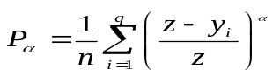 (1)
Where α is the poverty aversion parameter; n is population size; q is the number of people below the poverty line, y_{i} is income and z is the poverty line/threshold.

Poverty is measured before and after the policy shift using the actual distribution of income among the 10 household categories in the SUSENAS. The FGT poverty measure depends on the values that the parameter α take. At α=0, the poverty headcount is calculated, by accounting for the proportion of the population that falls below the poverty threshold. At α=1, the poverty gap is measured indicating how far on the average, the poor are from the poverty threshold. Finally, at α=2, the poverty severity index is obtained. The severity index is more sensitive to the distribution among the poor as more weight is given to the poorest below the poverty threshold. This is because the poverty severity index corresponds to the squared average distance of income of the poor from the poverty line hence, gives more weight
Model Closure. Nominal government consumption is equal to exogenous real government consumption multiplied by its (endogenous) price. Fixing real government spending neutralizes any possible welfare/poverty effects of variations in government spending. The only variations are due to changes in the nominal price of government consumption.
Total nominal investment is equal to exogenous total real investment multiplied by its price. Total real investment is held fixed in order to abstract from inter-temporal welfare/poverty effects. The price of total real investment is endogenous. The propensities to save of the various household groups in the model adjust proportionately to accommodate the fixed total real investment assumption. This is undertaken through a factor in the household saving function that adjusts endogenously.
The current account balance (foreign savings) is held fixed and the nominal exchange rate is the model's numéraire. The foreign trade sector is effectively cleared by changes in the real exchange rate, which is the ratio of the nominal exchange rate multiplied by the world export prices, divided by the domestic price index.
Labor market assumes a Neo-classical closure. Hence, labor supply is equal to labor demand across all labor categories. Labor is fully mobile across sectors, but is limited within the specific category. Whereas, capital is sector specific.

3.1 Basic Structure of the Economy at the Base

Table 4 presents the economic structure of the Indonesian economy based on the 1999 SAM. By and large, the pattern of trade shows the dominance of the industrial and the services sector, which accounts for over 90 % of total exports and imports in the country. In particular, industrial exports and imports comprises more than half of total trade (i.e. 74 and 51 % respectively). While, services export and import contributes 20 and 42 % respectively. In contrast, agriculture has the least export and import share, with only 5 and 7 %. Nevertheless, total agriculture exports share is roughly one fourth of total exports when agricultural related food processing is accounted for.
The principal exporters are Chemical industry (20 %), food processing (20 %), main mining (14 %) and trades (12 %). Taken together, these four sectors generates a combined export total of 66 %. Whereas the primary importers are the: Chemical industry; other transportation and communication; and papers and metal products. Once again, it is worth noting that total agriculture imports, when combined with food processing, accounts for roughly 14 % of total imports. On the other hand, fishery, forestry, and main mining have the highest export to import ratio. This is not surprising given the enormous fish, forest, and petroleum resources that Indonesia has.
In terms of value added, the agricultural sector generally has the highest value added to output ratio when compared with industry, and services. In spite of this, agriculture’s contribution to the overall value added is relatively small. It contributes about 20 % of domestic value added (GDP), whereas, industry and services has 42 and 38 % respectively. Labor intensity is uniformly higher in agriculture—implying the amount of surplus labor employed and being absorbed by the sector.
On the whole, Industry has the highest output share with 50 %, followed by services, and agriculture with 34 and 16 % respectively (Figure 5).

3.2 Household Income and Poverty Profile

Income from labor and capital are the major source of earnings for the entire population. Total wages paid to laborers accounts for 70 % of total household income, while return to capital is about 28 %. Wages paid by the services sector, and returns to capital in the industrial sector accounts for the largest share in the total Indonesian household earnings. On the contrary, wages and return to capital in agriculture has the lowest.
Table 5 presents the household income sources at the base. Clearly, all households earn a significant part of their income from wages. Landless agriculture households derives 90 % of total income from wages. While, high income non-agricultural household based in the rural area has the lowest wage to income ratio, at 50 %, though has the highest income share from capital with 47 %.
Income from abroad is not a significant source of earnings among Indonesian households. Large agriculture and high income non-agricultural household based in the rural area, has the highest income from abroad with 3.7 and 3.3 % income share respectively. On the other hand, rural dependent non-agriculture households benefits the most from inter-household transfers.
Table 6 shows the poverty indices (based on the SUSENAS) at the base. In 2002, about 33 million people representing 18.2 % of the entire population are living below the poverty line. In general, agriculture dependent households are more susceptible to poverty when compared with their non-agriculture dependent counterparts. Moreover, among non-agriculture dependent households, rural inhabitants appear to be more prone to poverty relative to their urban counterparts.
Medium agriculture farmers have the highest poverty incidence, followed by landless agricultural farmer households. While urban non-agriculture white collar and urban non-agriculture dependent households, have the lowest poverty headcount with 3.0 and 4.7 % respectively.

IV. Policy Experiments

Three policy experiments in line with the DDA were undertaken in this study:

AGLIB Full tariff elimination in Agriculture

AGLIBPRO Full tariff and indirect tax elimination in Agriculture

TOTLIB Full tariff elimination in all sectors

AGLIB captures the increasing access for agricultural products demanded by the DDA. This is reflected by the elimination of tariff for imported Agriculture products. AGLIBPRO depicts the impact of a pro active agricultural product liberalization, in which the Indonesian government removes not only the agricultural tariffs but also the agricultural domestic taxes to level the playing field. Finally, TOTLIB reflects a full tariff elimination in all sectors for broader cross-sectoral implications, in line with the DDA for Indonesia.
The set of simulation examined in this paper is consistent with simulations in Brooks and Sugiyarto (2005). Results from the model used in this paper, however, are more complete due to the model's more disaggregation and link to the household survey data set.

V. Simulation Results

5.1 AGLIB: Full tariff elimination in Agriculture

Macro Effects: Tariff elimination in agriculture leads to a 0.15 % reduction in the local price of imported products (Table 7). With this, consumer prices decrease by 0.15 %, resulting in a minimal increase in consumption (0.003 %). Similarly, the decline in agricultural import prices reduces the domestic cost of production by 0.15 %, giving rise to a real exchange rate depreciation of 0.05 %. This enhances producers' competitiveness in the international market as Indonesian exports become relatively cheaper.
Allocation for domestic sales decreases by 0.01 %, while exports rises by 0.09 % as producers reallocate towards the international market. The higher increase in exports relative to the 0.08 % import growth sustains the trade surplus which exists at the base. Over all, the decline in local import prices coupled with the reduction in domestic cost of production results in a marginal increase in output and real Gross Domestic Product (GDP).
Sectoral Effects: Tariff elimination in agriculture brings about varying impacts among the three major sectors (Table 8). Agriculture and services output contracts, while industry output expands. This promps a decline in agriculture’s share to total output from 16 to 15 % (Figure 6). In contrast, Industry’s share to total output increases from 50 to 51 %, while services’ share remained constant at 34%.
The contraction in agriculture stems from the decline in local price of agricultural imports, inducing consumers to substitute towards them (away from locally produced agricultural goods). Whereas, the output expansion in industry arises from the reduction in domestic cost of production—mainly due to cheap imported intermediate agricultural inputs. Thus, the expansion in industrial output leads to higher factor utilization, as industry absorbs displaced laborers from other sectors.
Figure 7 shows the changes in sectoral imports. Clearly, agricultural imports increases, whereas all industry and services imports fall—though the reduction in industrial imports is higher than that of services. On the other hand, the change in export volume is minimally higher in agriculture relative to industry and services.
On the whole, the reduction in consumer prices is deeper in agriculture. This comes in the wake of a massive fall in agriculture import prices, as only tariff in agriculture is eliminated. Thus, consumer pay relatively less for agricultural products (Figure 8).
Agriculture: The decline in agriculture import prices induces consumers to substitute towards cheaper imported agricultural products. Total agricultural imports go up by 3 %, resulting in a marginal reduction (0.01) in agricultural output. Fisheries, food crops and livestock registers the highest increase in imports (8, 4 and 6 % respectively). Over-all agricultural export increases by 0.38, with fishery generating the highest increase in output and exports.
Industry: Tariff elimination in agriculture favors the industrial sector. Indeed, total industry output and export increases by 0.04 and 0.09 % respectively, while imports dip by 0.16 %. Food processing benefits the most with a decline in the domestic cost of production—as it takes advantage of cheaper imported agricultural imports. Thus, food processing’s output, domestic sales and exports increases.
Services: At first glance, it seems that agricultural tariff reduction is not beneficial to the services sector. This is so because the entire sector’s output, consumer demand, and domestic sales decreases. However, closer examination reveals that these decreases are marginal. In addition, total exports increases (0.05 %), whereas total imports fumble (0.14 %), indicating that the sector gains modestly from selling in the international market.
Factor Market: Table 9 presents the factor market impacts of AGLIB. Factor returns diminishes as the price of value added decreases by 0.1 %—owing from the decline in both return to capital and over-all wage. The reduction in wage however is higher (0.13 %) than the decline in capital (0.02 %), suggesting that wage workers endure the impact of declining factor returns. Self-employed rural workers experiences the largest reduction in wages, whereas self-employed urban production workers bear the lowest wage reduction (Table 10 and Figure 9). In contrast, both urban and rural production employees attain wage increases, due mainly to the expansion of the industrial sector.
Household Income and Cost of Commodity Basket: The changes in households’ disposable income are presented in Table 11. Evidently, factor income of all households declines. Households dependent on agriculture suffers the highest reduction in income (Figure 10), mainly due to lower factor returns in agriculture. In contrast, non-agriculture dependent households regardless of location experience a lower reduction in factor income. Over-all, non-agriculture dependent households residing in the urban area bears the lowest decline in factor income.
Table 11 presents the changes in the cost of commodity basket for each RHG. Notably, agricultural households experience the highest reduction in the cost of commodity basket followed by rural based household. This is not surprising given that agriculture dependent, as well as rural based households mostly consume agricultural products.
Poverty: The changes in poverty indices arise from: (i) the changes in household income; and (ii) the changes in the nominal value of the poverty line—derived from the changes in the weighted price of the household’s commodity basket (reflected though the changes in consumer prices).
The percentage changes in the three poverty indices, headcount, gap, and severity, are presented in Table 12. Overall, poverty headcount increases marginally by 0.03 % (also illustrated in Figure 11). This is equivalent to roughly 10,308 households additionally falling into poverty. The national poverty gap and poverty severity increases as well implying that the already poor, especially agriculture dependent households, expose themselves to despicable poverty. Medium Farmers experience the highest increase in poverty headcount (0.13 %), whereas large farmers suffer the largest increase in poverty gap and severity.
In contrast, all low income non-agricultural households living in urban and rural area benefits from a decline in poverty. This stems from two reasons. First, they are able to take advantage of the increase in production wage (as a result of the industrial sector expansion). Second, the reduction in the cost of their commodity basket is higher than the decline in their disposable income. This is true for dependent and high income households as well, since poverty gap and poverty severity decreases among them.

5.2 AGLIBPRO: Full tariff and indirect tax elimination in Agriculture
Macro Effects: Tariff and indirect tax elimination in agriculture, to ensure market access for agricultural imports leads to a 0.20 % reduction in the local price of imported products (Table 7). This change is higher relative to AGLIB, as the elimination of indirect taxes permits a larger reduction in domestic prices. Thus, consumer prices decrease by 0.24 %, leading to a 0.02 % increase in consumption.
As expected, cheaper agricultural imports flood the domestic market, as total Indonesian import volume increases by 0.08 %. This effectively reduces the cost of domestic production (0.06 %), paving a way for real exchange rate depreciation (0.09 %)—making Indonesian exports cheaper in the international market. The fall in the domestic cost of production allows the industrial sector’s output to expand, giving rise to an economy-wide increase in domestic sales and exports (0.01 and 0.14 % respectively). In sum, national output rises by 0.04 %.
Sectoral Effects: Output expands for the three major sectors (Table 14), with industry experiencing the largest increase (0.07 %), followed by services (0.02 %). Agriculture registers the lowest increase (0.01 %) as the tariff and indirect tax elimination in the sector allows imported agricultural products to compete in the local market—resulting in consumer substitution towards cheaper agricultural imports. On the other hand, industrial imports go down as the real exchange rate depreciation made industrial imports expensive relative to the base.
Agriculture: The decline in local import prices brings about an increase in import volume (4 %) for the entire agriculture sector. Fisheries, livestock, and food crops sub-sector generates the largest increase in import demand with 11, 7.6, and 5.6 % respectively. However, the decline in agricultural import prices does not translate to a reduction in the domestic cost of production as the price of value added in agriculture increases. Indeed, domestic agricultural producers lose their competitiveness as the weighted agricultural domestic prices and output prices increase (0.22 and 0.23 % respectively), thereby resulting in a 0.22 % reduction in exports. In spite of this, over-all agricultural output goes up marginally by 0.01 %. Livestock, fishery, and forestry output expands, while food crops and other crops contract.
Industry: Tariff and indirect tax elimination in agriculture favors the industrial sector as both its output and exports increase by 0.07 and 0.20 % respectively. The foremost gainers are wood products, food processing and textile, while, construction, and other mining are the major losers. At this point, it is worth noting that the outward oriented industrial sector benefits from tariff and indirect tax elimination in agriculture as the entire sector experiences a decline in the domestic cost of production. In fact, this is the reason behind the increase in exports for the industrial sector.
Services: The expansion in both industry and agriculture output stimulates greater demand for service infrastructure. With this, the entire services sector output, domestic sales, and exports increases.
Factor Market: The price of value added for the entire economy increases by 0.09 %, as both the return to capital and over-all wage increases by 0.01 and 0.10 % respectively (Table 15). The rise in the wage rate is higher than the increase in capital, implying that benefits accrue more to wage workers. Resource reallocates towards agriculture and services as the price of value added increases in both sector.
Table 16 presents the labor market impacts of AGLIBPRO. Wages of agricultural laborers in the urban area registers the highest increase followed by agricultural laborers in the rural sector. While management professionals in the urban sector experiences the greatest reduction in wage (0.3 %) as a result of the decline in factor returns from the industrial sector (Figure 12).
Household Income and Cost of Commodity Basket: The increase in factor returns, resulting from the rise in wage and return to capital payments brings about an increase in disposable income for all households (Table 17). Large farmers experiences the highest increase whereas, high income households residing in the urban area attains the lowest improvement in disposable income (Figure 13).
All households increase their ability to purchase goods and services as the cost of commodity basket declines. Dependent, as well as high income households residing in the urban area experiences the highest reduction in the cost of commodity basket, while medium and large farmers bear the lowest decrease (Figure 14). Essentially, the fall in the cost of commodity basket stems not only from the decline in local import prices but more importantly from indirect tax elimination in agriculture. Hence, all households gain as agricultural products constitutes a significant part of their consumer basket.
Poverty: National poverty headcount decreases by 1.2 %, representing 394,125 people finding their way out of poverty (Table 18 and Figure 15). Rural low income households achieve the highest reduction (1.54 %) in poverty headcount, whereas rural high income households attain the smallest reduction (0.76 %). Notably, the decrease in national poverty gap and severity is higher, suggesting an improvement in status among those who remain poor. The highest reduction in poverty gap and severity accrues to urban high income households and agriculture employees.

5.3 TOTLIB: Full tariff elimination in all sectors
Macro Effects: Full tariff elimination results in: 3 % decline in the local price of imported goods, 1.7 % increase in import volume and, 1.9 % fall in local import prices (Table 19). Despite the fall in consumer prices, total domestic consumption decreases minimally (0.1 %) as producers’ sell less in the domestic market and reallocate towards the international market. This arises from the reduction in domestic cost of production, causing real exchange rate to depreciate by 1.3 %. With this, total exports go up (1.7 %), while allocation for domestic sales shrinks by 0.43 %. On the whole, total Indonesian output and real GDP increases by 0.1 and 0.3 % respectively, with the higher increase in the latter a result of export expansion.
Sectoral Effects: Tariff elimination brings about an output expansion in industry and services (0.11 and 0.17 %), and a marginal contraction in agriculture output (0.03 %). Industrial exports and imports increases, while, agriculture and service imports falls (Table 20). Over-all, the price reduction in industry is deeper since the sector’s weighted tariff rate is higher at the base. Hence, local import prices for industrial products fall more compared with agriculture.
Agriculture: Contrary to AGLIB and AGLIBPRO, the decline in local import prices does not induce consumer substitution towards imported agricultural products. Indeed, consumption falls by 0.2 %. At first glance, it seems that the decline in consumption, despite the fall in agricultural commodity prices is counter intuitive. However, the decline in consumption arises from agricultural producers’ reaction to the real exchange rate depreciation. As Indonesian agricultural exports become cheaper, producers reallocate towards the international market, thereby selling less in the domestic market.
Industry: Full Tariff elimination favors the industrial sector as import protection walls collapses. The proliferation of cheap imports brings down the cost of intermediate inputs, resulting in a reduction in the domestic cost of production. With this, total industry output, exports, and imports increases by 0.11, 1.85, and 4 % respectively. Paper production and textile benefits the most from tariff elimination as both their output and export expands the most.
Services: The services sector benefits the most from full tariff elimination. This is traceable to the increase in vital service infrastructure demand by both agriculture and industry. Thus, total consumption for services increases by 0.23 %. The restaurant sub-sector registers the highest increase in exports, output.
Factor Market: Table 21 presents the factor market impacts of TOTLIB. The economy-wide price of value added decreases by 0.9 % as both the return to capital and over-all wage falls. The reduction in wage rate (1 %) is higher than the decline in capital (0.7 %), implying that wage workers endure the impact of lower factor returns. Moreover, the reduction in wage under TOTLIB is higher when compared with AGLIB and AGLIBPRO. Agriculture registers the highest reduction in the price of value added, making agricultural laborers experience the largest decline in wage.
Household Income and Commodity Basket: Table 23 shows the changes in households’ disposable income and the cost of the household consumer basket. Clearly, disposable income of all households declines, with agriculture dependent households enduring the highest reduction in factor income. By and large, non-agriculture dependent households based in the urban area experiences the lowest decline in disposable income (Figure 16).
The cost of commodity basket of all households falls as a result of tariff elimination (Table 23 and Figure 17). The removal of import protection generates a decline in all commodity prices, thereby benefiting households indirectly. Indeed, the reduction in the cost of all RHGs commodity basket is higher that the fall in disposable income, implying an improvement in living status of all households.
Poverty: Table 24 shows the changes in poverty indices. Poverty headcount falls by 2.6 %, suggesting that 857,754 people are escaping poverty. In general, poverty reduction favors the non-agriculture dependent households, particularly those residing in the urban areas. Urban high income households experience the largest reduction in poverty, while medium farmers and rural dependent household realize the smallest reduction in poverty (Figure 18). Notably the decline in poverty gap and severity is higher than the reduction in poverty headcount implying an improvement in the status of those who remain poor. As pointed above, this is due to the larger decline in the cost of household commodity basket outweighing the decline in disposable income.

VI. Concluding remarks

The general trend of tariff reduction as part of trade liberalization in Indonesia is desirable and in line with the DDA. More trade liberalization in the future, however, should be conducted cautiously, especially if its impact on poverty is also taken into account.

The CGE model developed in this study was able to shed light on the economy-wide impact of a unilateral but DDA consistent trade liberalization in Indonesia. The general result seem to indicate that the existing tariff is not only distorting the economy but also not pro poor.
The prevalence of agriculture protection may not be beneficial to the Indonesian economy in the long-run, especially if only agricultural tariff is eliminated. This is because the presence of cheap agriculture imports that induces consumers to substitution towards them, resulting in agricultural output contraction and reduction in income for farm workers. Cheaper agriculture imports flood the domestic market, inducing consumers to substitute imported agricultural products for domestic goods. As a result, agriculture output contracts, effectively reducing the income of agriculture dependent households. National poverty headcount, gap, and severity increases implying that the already poor, especially agriculture dependent households, expose themselves to despicable poverty.
In contrast, a more proactive stance, where agricultural product liberalization is combined with the removal of indirect taxes on agriculture appears promising. The effects of a complete farm trade liberalization that is consistent with the DDA seems beneficial to the poor. Agriculture, industry, and services output expands, resulting in an increase in factor returns. In particular, wage of agricultural laborers increases substantially, suggesting that farm workers benefits from the resource reallocation effects. Farm workers benefit the most as their wages, and factor income increases relative to other workers. To a large extent, the abolition of domestic agricultural taxes allows domestic agriculture producers to compete with agricultural imports. Disposable income of all household increases, while the cost of commodity basket falls, leading to a reduction in poverty. Thus, Poverty headcount, poverty gap and poverty severity falls, suggesting an improvement in status among those who remain poor should a DDA type reform is carried out.

In conclusion, an ambitious approach, involving full tariff elimination in all sectors appears to be the best poverty reducing policy for Indonesia. Industrial and services output expands, while agriculture output contract. Industrial exports and imports increases, while, agriculture and service imports falls, thereby sustaining the trade surplus. Resources reallocate away from agriculture towards industry and services. The impact of all these adjustments is a decline in wages, and consequently income for almost all households. However, this fall is outweighed by the reduction in consumer prices as a result of tariff elimination. Hence, poverty decreases substantially. Nonetheless, the decline in poverty is higher among non-agriculture dependent households, especially those residing in the urban areas, where poverty incidence is already the lowest. This stems from the ability of non-farm workers to take advantage of additional opportunities posed by the expanding industrial and services sector. Thus, the challenge for the government is to implement complementary policies especially targeted to farm workers and the poor. Through improved access to labor market, they would then be able to take advantage of the opportunities being offered by trade liberalization and the DDA.

References:
Adelman I. and S. Robinson. 1978. “Income Distribution Policy: A Computable General Equilibrium Model of South Korea”. Stanford University Press.
Brooks D. and G. Sugiyarto. 2005. “Can the Poor Benefir from the Doha Agenda? The Case of Indonesia”. ERD Working Paper No. 72. Asian Development Bank, Manila
Cororaton C. and J. Cockburn, and E. Corong. 2005. “Doha Scenarios, Trade Reform, and Poverty in the Philippines: A CGE Analysis.” Chapter 13 in T. Hertel and L.A. Winters (eds) Poverty and the WTO: Impacts of the Doha Development Agenda. Palgrave Macmillan and The World Bank, Washington D.C.

Decaluwé, B., A. Patry, L. Savard, and E. Thorbecke. 2000. “Poverty Analysis within a General Equilibrium Framework.” Working Paper 9909. Department of Economics, Laval University, Québec, Canada.

De Janvry, A., E. Sadoulet, and A. Fargeix. 1991 “Politically Feasible and Equitable Adjustment: Some Alternatives for Ecuador.” World Development Vol. 19, Issue No. 11: 1577–94.

Foster, J., J. Greer, and E. Thorbecke (1984), “A Class of Decomposable Poverty Measures” Econometrica, Vol. 52 No. 3

Hertel, T. & R. Keeney (2005). “What’s at Stake: The Relative Importance of Import Barriers, Export Subsidies, and Domestic Support”, in Martin, W. & Anderson, K. eds. Agricultural Trade Reform and the Doha Development Agenda, World Bank.

Hertel T. and J. Reimer. 2004, “Predicting the Poverty Impacts of Trade Reform: A Survey of Literature.” Manuscript.

Lysy, F. and L. Taylor. 1980. “The General Equilibrium Income Distribution Model” in L Taylor, E. Bacha, E. Cardoso, and F. Lysy (eds) Models of Growth and Distribution for Brazil. Oxford University Press

Ravallion M. 1992. “Poverty Comparisons: A Guide to Concepts and Methods”. Living Standards, Measurement Study. Working Paper No. 88, World Bank, Washington D.C.

Robilliard A. S., and S. Robinson. 2005. “The Social Impact of a WTO Agreement in Indonesia” Chapter 11 in T. Hertel and L.A. Winters (eds) Poverty and the WTO: Impacts of the Doha Development Agenda. Palgrave Macmillan and The World Bank, Washington D.C.

Winters, L.A. 2001. “Trade Policies for Poverty Alleviation: What Developing Countries Might Do.” Paper prepared for a session sponsored by the Centre for Economic Policy Research, at the Royal Economic Society Annual Conference, University of Durham, April 9-11.

Winters, L.A., N. McCulloch, and A. Mckay. 2004. “Trade Liberalization and Poverty: The Evidence So Far.” Journal of Economic Literature. Vol XLII. March, pp 72-115.

World Trade Organization (WTO). 2003. Trade Policy Review on Indonesia.

APPENDIX

Table 1: Production and Commodity Accounts*
Accounts | Description
Production and Commodity
Agriculture | - Food Crops  - Other Crops  - Livestock  - Forestry  - Fisheries
Industry | - Oil and, Gas Mining  - Other Mining  - Food Processing  - Textile  - Wood and wood products  - Papers and Metal products  - Chemical Industry  - Utilities, Electricity, Gas, Water  - Construction
Services | - Trades  - Restaurant  - Hotel  - Land Transport  - Other Trans & Com  - Bank and Insurance  - Real estate  - Personal services  - Public services
Source: 1999 Indonesian SAM

Table 2: Factors of Production*
Accounts | Description
Capital | - Land and agricultural capital  - Own occupied house  - Others rural  - Others urban  - Private domestic  - Government capital  - Foreign capital
Labor | - Agriculture employee-rural  - Agriculture employee - urban  - Agriculture self-employed - rural  - Agriculture self-employed - urban  - Production employee - rural  - Production employee - urban  - Production self-employed - rural  - Production self-employed - urban  - Clerical employee - rural  - Clerical employee - urban  - Clerical self-employed - rural  - Clerical self-employed - urban  - Management Professional employee - rural  - Management Professional employee - urban  - Management Professional self-employed - rural  - Management Professional non- employee - urban
Source: 1999 Indonesian SAM

Table 3: Summary of Representative Households*
Households | Description
Agriculture | - Landless farmers  - Small farmers  - Medium farmers  - Large farmers
Non-agriculture | - Rural low Income group  - Rural dependent Income group  - Rural high income group  - Urban low Income group  - Urban dependent Income group  - Urban high income group
Source: 1999 Indonesian SAM
Table 4: Economic Structure at the Base
SECTORS | International Trade (%) |  |  |  |  | Value Added (VA)
SECTORS | Exports |  | Imports |  | Export-Import | VA/Output | VA Share | Labor-Capital
SECTORS | Share | Intensities* | Share | Intensities** | Ratio | VA/Output | (VA_{i} / VA) | Ratio
Food Crops | 1.3 | 4.4 | 3.4 | 8.15 | 51.81 | 87.2 | 10.1 | 4.5
Other Crops | 1.8 | 13.8 | 3.2 | 17.00 | 78.20 | 71.8 | 3.7 | 2.9
Livestock | 0.4 | 4.5 | 0.4 | 3.16 | 145.04 | 69.5 | 2.5 | 0.6
Forestry | 1.0 | 19.9 | 0.2 | 2.46 | 982.23 | 81.1 | 1.7 | 0.3
Fisheries | 0.5 | 9.1 | 0.0 | 0.31 | 3216.20 | 89.7 | 2.2 | 4.0
AGRICULTURE | 5.0 | 8.2 | 7.2 | 8.28 | 98.61 | 81.2 | 20.3 | 232.7
Oil and Gas Mining | 14.3 | 40.7 | 2.6 | 8.19 | 767.87 | 88.9 | 12.7 | 0.2
Other Mining | 1.3 | 40.9 | 0.6 | 18.17 | 311.98 | 92.0 | 1.2 | 2.2
Food Processing | 20.0 | 28.1 | 6.6 | 8.33 | 429.74 | 38.6 | 11.2 | 1.1
Textile | 5.8 | 40.3 | 6.0 | 33.47 | 134.11 | 31.7 | 1.8 | 1.3
Wood and wood products | 3.3 | 48.2 | 0.8 | 14.57 | 544.89 | 37.4 | 1.0 | 1.1
Papers and Metal products | 9.7 | 62.3 | 11.0 | 57.10 | 124.19 | 37.1 | 2.4 | 0.7
Chemical Industry | 20.4 | 59.1 | 23.3 | 53.92 | 123.32 | 49.8 | 7.0 | 0.6
Utilities, Electricity, Gas, Water | 0.0 | 0.0 | 0.0 | 0.00 | 16.98 | 52.8 | 1.4 | 0.5
Construction | 0.0 | 0.0 | 0.0 | 0.00 | 0.00 | 88.9 | 3.2 | 3.1
INDUSTRY | 74.7 | 38.1 | 51.0 | 23.0 | 206.33 | 52.5 | 41.9 | 63.34
Trades | 12.1 | 27.3 | 3.0 | 6.26 | 561.59 | 77.7 | 14.0 | 2.6
Restaurant | 0.0 | 0.1 | 2.3 | 11.58 | 0.71 | 42.1 | 2.1 | 2.4
Hotel | 0.0 | 0.6 | 2.6 | 32.82 | 1.27 | 79.2 | 1.2 | 0.4
Land Transport | 2.4 | 26.3 | 4.0 | 29.72 | 84.52 | 67.2 | 2.5 | 0.9
Other Trans & Com | 3.4 | 29.4 | 12.0 | 51.27 | 39.50 | 48.1 | 2.2 | 0.7
Bank and Insurance | 1.0 | 9.3 | 4.8 | 25.47 | 29.92 | 73.9 | 3.3 | 0.7
Real estate | 1.0 | 8.7 | 4.4 | 22.39 | 33.20 | 77.6 | 3.8 | 0.3
Personal services | 0.0 | 0.0 | 1.6 | 13.39 | 0.10 | 75.4 | 2.2 | 0.9
Public services | 0.4 | 1.7 | 7.1 | 18.38 | 7.77 | 69.4 | 6.4 | 4.5
SERVICES | 20.3 | 15.1 | 41.8 | 20.7 | 68.43 | 69.3 | 37.9 | 149.58
TOTAL | 100 |  | 100 |  |  | 62.8 | 100
Note: * Export intensity = Export Supply/domestic Sales; **;Import intensity = Import demand /Composite demand
Source: calculated from the 1999 Indonesian SAM

Table 5: Household Income Sources at the Base
(Percentange Share)
Households | Income
Households | Employee | Capital | Dividend | Foreign | Transfers
 |  |  |  |  | Household | Government
Agriculture
Landless farmers | 90.6 | 5.6 | 0.1 | 0.7 | 1.6 | 1.4
Small farmers | 85.0 | 13.3 | 0.0 | 0.2 | 0.2 | 1.2
Medium farmers | 83.9 | 15.0 | 0.0 | 0.4 | 0.2 | 0.5
Large farmers | 75.5 | 20.4 | 0.0 | 3.7 | 0.1 | 0.2
Non-Agriculture (Rural)
Low Income group | 68.6 | 30.3 | 0.1 | 0.2 | 0.1 | 0.6
Dependent Income group | 73.5 | 21.3 | 0.0 | 0.5 | 3.7 | 1.0
High Income group | 49.7 | 46.6 | 0.0 | 3.3 | 0.3 | 0.1
Non-Agriculture (Urban)
Low Income group | 76.7 | 23.0 | 0.1 | 0.1 | 0.0 | 0.1
Dependent Income group | 77.5 | 19.2 | 0.1 | 0.2 | 1.3 | 1.7
High Income group | 55.8 | 41.8 | 0.0 | 2.3 | 0.1 | 0.0

Table 6: Poverty Indices at the Base (%)
Households | Poverty
Households | Headcount | Gap | Severity
ALL Indonesia | 18.2 | 3.5 | 1.1
Agriculture
Landless farmers | 28.4 | 5.1 | 1.4
Small farmers | 27.3 | 5.2 | 1.6
Medium farmers | 30.5 | 7.2 | 2.6
Large farmers | 25.0 | 5.0 | 1.6
Non-Agriculture (Rural)
Low Income group | 18.7 | 3.1 | 0.8
Dependent Income group | 13.6 | 2.6 | 0.8
High Income group | 10.5 | 1.8 | 0.5
Non-Agriculture (Urban)
Low Income group | 10.1 | 1.7 | 0.5
Dependent Income group | 4.7 | 0.8 | 0.2
High Income group | 3.0 | 0.4 | 0.1
Number of Poor People | 32,843,216

Table 7: Macro Effects of AGLIB
(Percentange Change from Base)
Real Gross Domestic Product (RGDP) | 0.01
Prices:
Import prices in local currency | -0.15
Consumer prices | -0.15
Local cost of production | -0.15
Real exchange rate | 0.05
Import volume | 0.08
Export volume | 0.09
Domestic production for local sales | -0.01
Consumption (composite) goods | 0.003
Overall output | 0.01

Table 8: Sectoral Effects of AGLIB
(Percentange Change from Base)
Sectors | Price Changes (%) |  |  |  |  | Volume Changes (%)
Sectors | Import | Domestic | Composite | Output | Local | Import | Export | Dom Sales | Output | Comp. Demand
Food Crops | -2.49 | -0.42 | -0.59 | -0.41 | -0.42 | 4.21 | 0.37 | -0.09 | 0.27 | -0.07
Other Crops | -1.16 | -0.41 | -0.54 | -0.38 | -0.41 | 1.37 | 0.34 | -0.14 | 0.12 | -0.07
Livestock | -3.18 | -0.37 | -0.46 | -0.36 | -0.37 | 5.90 | 0.36 | -0.01 | 0.18 | 0.01
Forestry | -0.26 | -0.35 | -0.34 | -0.31 | -0.35 | -0.11 | 0.38 | 0.07 | 0.06 | 0.13
Fisheries | -4.48 | -0.41 | -0.42 | -0.40 | -0.41 | 8.92 | 0.52 | 0.21 | 0.23 | 0.24
Agriculture | -1.89 | -0.40 | -0.53 | -0.38 | -0.40 | 2.95 | 0.38 | -0.05 | 0.21 | -0.01
Oil and Gas Mining | 0.00 | -0.05 | -0.05 | -0.04 | -0.05 | -0.14 | 0.04 | -0.03 | -0.04 | -0.01
Other Mining | 0.00 | -0.09 | -0.07 | -0.05 | -0.09 | -0.35 | 0.00 | -0.18 | -0.21 | -0.11
Food Processing | 0.00 | -0.17 | -0.16 | -0.15 | -0.17 | -0.27 | 0.21 | 0.07 | 0.04 | 0.11
Textile | 0.00 | -0.11 | -0.07 | -0.09 | -0.11 | -0.15 | 0.14 | 0.06 | -0.01 | 0.09
Wood and wood products | 0.00 | -0.15 | -0.13 | -0.11 | -0.15 | -0.31 | 0.14 | -0.01 | -0.06 | 0.06
Papers and Metal products | 0.00 | -0.04 | -0.02 | -0.02 | -0.04 | -0.13 | 0.02 | -0.05 | -0.10 | -0.01
Chemical Industry | 0.00 | -0.05 | -0.02 | -0.03 | -0.05 | -0.13 | 0.03 | -0.04 | -0.09 | 0.00
Utilities, Electricity, Gas, Water | 0.00 | -0.07 | -0.07 | -0.07 | -0.07 | -0.17 | 0.05 | -0.04 | -0.04 | -0.04
Construction | - | -0.06 | -0.06 | -0.06 | -0.06 | - | - | -0.17 | -0.17 | -0.17
Industry | 0.00 | -0.11 | -0.08 | -0.08 | -0.11 | -0.16 | 0.09 | 0.00 | -0.03 | 0.04
Trades | - | -0.08 | -0.07 | -0.06 | -0.08 | -0.21 | 0.05 | -0.05 | -0.06 | -0.02
Restaurant | - | -0.16 | -0.14 | -0.16 | -0.16 | -0.24 | 0.20 | 0.08 | 0.04 | 0.08
Hotel | - | -0.08 | -0.05 | -0.08 | -0.08 | -0.17 | 0.07 | -0.01 | -0.07 | -0.01
Land Transport | - | -0.05 | -0.03 | -0.04 | -0.05 | -0.15 | 0.02 | -0.05 | -0.08 | -0.03
Other Trans & Com | - | -0.05 | -0.02 | -0.04 | -0.05 | -0.12 | 0.04 | -0.02 | -0.07 | -0.01
Bank and Insurance | - | -0.06 | -0.05 | -0.06 | -0.06 | -0.15 | 0.05 | -0.03 | -0.06 | -0.02
Real estate | - | -0.07 | -0.05 | -0.06 | -0.07 | -0.15 | 0.06 | -0.02 | -0.04 | -0.01
Personal services | - | -0.06 | -0.05 | -0.06 | -0.06 | -0.16 | 0.04 | -0.04 | -0.06 | -0.04
Public services | - | -0.05 | -0.04 | -0.05 | -0.05 | -0.09 | 0.05 | 0.00 | -0.01 | 0.00
Services | - | -0.07 | -0.06 | -0.07 | -0.07 | -0.14 | 0.05 | -0.02 | -0.01 | -0.01
TOTAL | -0.15 | -0.15 | -0.15 | -0.13 | -0.15 | 0.08 | 0.09 | -0.01 | 0.003 | 0.01
pm– Change in import price; pd– Change in domestic price; pq– Change in composite price; px– Change in output price; pl– Change in local price;
  m– Change in import; e– Change in export; d– Change in domestic sales ; x– Change in output; x– Change in composite demand

Table 9: Factor Market Effects of AGLIB
(Percentange Change from Base)
Sectors | Value Added |  | δr_{i,} % | δw_{i,} %
Sectors | Changes (%) |  | δr_{i,} % | δw_{i,} %
Sectors | δva_{i} | δpva_{i} | δr_{i,} % | δw_{i,} %
Food Crops | -0.07 | -0.42 | -0.49 | -0.43
Other Crops | -0.07 | -0.40 | -0.47 | -0.40
Livestock | 0.01 | -0.38 | -0.37 | -0.38
Forestry | 0.13 | -0.34 | -0.21 | -0.31
Fisheries | 0.24 | -0.41 | -0.18 | -0.42
Agriculture | -0.01 | -0.40 | -0.36 | -0.42
Oil and Gas Mining | -0.01 | -0.04 | -0.04 | 0.00
Other Mining | -0.11 | -0.05 | -0.16 | 0.00
Food Processing | 0.11 | 0.10 | 0.21 | 0.00
Textile | 0.09 | 0.08 | 0.17 | 0.01
Wood and wood products | 0.06 | 0.06 | 0.12 | 0.01
Papers and Metal products | -0.01 | -0.01 | -0.02 | 0.00
Chemical Industry | 0.00 | 0.00 | 0.00 | 0.00
Utilities, Electricity, Gas, Water | -0.04 | -0.08 | -0.12 | -0.01
Construction | -0.17 | -0.06 | -0.23 | -0.01
Industry | 0.02 | 0.01 | 0.02 | 0.00
Trades | -0.02 | -0.07 | -0.09 | -0.06
Restaurant | 0.08 | -0.02 | 0.06 | -0.05
Hotel | -0.01 | -0.07 | -0.08 | -0.04
Land Transport | -0.03 | -0.04 | -0.07 | 0.00
Other Trans & Com | -0.01 | -0.03 | -0.04 | -0.03
Bank and Insurance | -0.02 | -0.06 | -0.08 | -0.04
Real estate | -0.01 | -0.07 | -0.08 | -0.04
Personal services | -0.04 | -0.06 | -0.11 | -0.02
Public services | 0.00 | -0.03 | -0.03 | -0.04
Services | -0.01 | -0.06 | -0.07 | -0.05
TOTAL | - | -0.1 | -0.02 | -0.13
*va_{i} – change in value added in sector i; Pva_{i} – change in value added in sector i;
r_{i} – change in return to capital in sector i; w_{i} – change in wage rate in sector i

Table 10: Labor Market Effects of AGLIB
(Percentange Change from Base)
Sectors | Labor Demand
Sectors | L* | L1** | L2** | L3** | L4** | L5** | L6** | L7** | L8** | L9** | L10** | L11** | L12** | L13** | L14** | L15** | L16**
Food Crops | -0.06 | -0.07 | -0.11 | -0.05 | -0.06 | -0.49 | -0.52 | -0.50 | -0.48 | -0.45 | -0.45 | -0.42 | -0.41 | -0.46 | -0.44 | -0.36 | -0.41
Other Crops | -0.07 | -0.05 | -0.09 | -0.03 | -0.04 | -0.48 | -0.50 | -0.48 | -0.46 | -0.43 | -0.44 | -0.40 | -0.39 | -0.44 | -0.43 | -0.34 | -0.39
Livestock | 0.01 | 0.06 | 0.01 | 0.07 | 0.06 | -0.37 | -0.40 | -0.38 | -0.36 | -0.33 | -0.33 | -0.30 | -0.29 | -0.34 | -0.32 | -0.24 | -0.29
Forestry | 0.10 | 0.21 | 0.17 | 0.23 | 0.22 | -0.22 | -0.24 | -0.22 | -0.21 | -0.18 | -0.18 | -0.14 | -0.13 | -0.18 | -0.17 | -0.09 | -0.14
Fisheries | 0.25 | 0.25 | 0.21 | 0.26 | 0.26 | -0.18 | -0.20 | -0.18 | -0.17 | -0.14 | -0.14 | -0.11 | -0.09 | -0.15 | -0.13 | -0.05 | -0.10
Oil and Gas Mining | -0.04 | 0 | 0 | 0 | 0 | -0.04 | -0.07 | 0.00 | 0.00 | 0.00 | 0.00 | 0.00 | 0.00 | -0.01 | 0.01 | 0.00 | 0.00
Other Mining | -0.15 | 0 | 0 | 0 | 0 | -0.16 | -0.18 | -0.17 | -0.15 | -0.12 | -0.12 | -0.09 | -0.07 | -0.13 | -0.11 | -0.03 | -0.08
Food Processing | 0.21 | 0 | 0 | 0 | 0 | 0.21 | 0.18 | 0.20 | 0.22 | 0.25 | 0.25 | 0.28 | 0.29 | 0.24 | 0.26 | 0.34 | 0.29
Textile | 0.16 | 0 | 0 | 0 | 0 | 0.17 | 0.14 | 0.16 | 0.18 | 0.21 | 0.21 | 0.24 | 0.25 | 0.20 | 0.22 | 0.30 | 0.25
Wood and wood products | 0.11 | 0 | 0 | 0 | 0 | 0.12 | 0.09 | 0.11 | 0.13 | 0.16 | 0.16 | 0.19 | 0.20 | 0.15 | 0.17 | 0.25 | 0.20
Papers and Metal products | -0.02 | 0 | 0 | 0 | 0 | -0.02 | -0.05 | -0.03 | -0.01 | 0.02 | 0.02 | 0.05 | 0.06 | 0.01 | 0.03 | 0.11 | 0.06
Chemical Industry | 0.00 | 0 | 0 | 0 | 0 | 0.00 | -0.03 | -0.01 | 0.01 | 0.04 | 0.04 | 0.07 | 0.08 | 0.03 | 0.05 | 0.13 | 0.08
Utilities, Electricity, Gas, Water | -0.12 | 0 | 0 | 0 | 0 | -0.13 | -0.15 | -0.13 | -0.11 | -0.08 | -0.09 | -0.05 | -0.04 | -0.09 | -0.07 | 0.01 | -0.04
Construction | -0.23 | 0 | 0 | 0 | 0 | -0.24 | -0.26 | -0.24 | -0.22 | -0.19 | -0.20 | -0.16 | -0.15 | -0.20 | -0.18 | -0.10 | -0.15
Trades | -0.03 | 0 | 0 | 0 | 0 | -0.10 | -0.12 | -0.10 | -0.09 | -0.05 | -0.06 | -0.02 | -0.01 | -0.06 | -0.05 | 0.04 | -0.02
Restaurant | 0.11 | 0 | 0 | 0 | 0 | 0.05 | 0.03 | 0.05 | 0.07 | 0.10 | 0.09 | 0.13 | 0.14 | 0.09 | 0.10 | 0.19 | 0.14
Hotel | -0.04 | 0 | 0 | 0 | 0 | -0.08 | -0.11 | -0.09 | -0.07 | -0.04 | -0.05 | -0.01 | 0.00 | -0.05 | -0.03 | 0.05 | 0.00
Land Transport | -0.07 | 0 | 0 | 0 | 0 | -0.08 | -0.10 | -0.08 | -0.06 | -0.03 | -0.04 | 0.00 | 0.01 | -0.04 | -0.03 | 0.06 | 0.01
Other Trans & Com | -0.01 | 0 | 0 | 0 | 0 | -0.04 | -0.07 | -0.05 | -0.03 | 0.00 | 0.00 | 0.03 | 0.04 | -0.01 | 0.01 | 0.09 | 0.04
Bank and Insurance | -0.04 | 0 | 0 | 0 | 0 | -0.09 | -0.11 | -0.09 | -0.07 | -0.04 | -0.05 | -0.01 | 0.00 | -0.05 | -0.03 | 0.05 | 0.00
Real estate | -0.04 | 0 | 0 | 0 | 0 | -0.08 | -0.10 | -0.08 | -0.07 | -0.04 | -0.04 | -0.01 | 0.01 | -0.05 | -0.03 | 0.05 | 0.00
Personal services | -0.09 | 0 | 0 | 0 | 0 | -0.11 | -0.13 | -0.11 | -0.10 | -0.07 | -0.07 | -0.04 | -0.02 | -0.08 | -0.06 | 0.02 | -0.03
Public services | 0.01 | 0 | 0 | 0 | 0 | -0.03 | -0.06 | -0.04 | -0.02 | 0.01 | 0.01 | 0.04 | 0.05 | 0.00 | 0.02 | 0.10 | 0.05
Change in average employee, % - | -0.13 | -0.42 | -0.38 | -0.44 | -0.43 | 0.002 | 0.03 | 0.01 | -0.01 | -0.04 | -0.04 | -0.07 | -0.08 | -0.03 | -0.05 | -0.13 | -0.08
* L – Aggregate Labor
** L1 - Agriculture employee (rural); L2- Agriculture employee (urban); L3- Agriculture self-employed (rural); L4- Agriculture self-employed (urban); L5- Production employee (rural); L6- Production employee (urban); L7- Production self-employed (rural); L8- Production self-employed (urban); L9- Clerical employee (rural); L10- Clerical employee (urban); L11- Clerical self-employed (rural); L12- Clerical self-employed (urban); L13- Management Professional employee (rural); L14- Management Professional employee (urban); L15- Management Professional self-employed (rural); L16- Management Professional non- employee (urban)
Table 11: Household Income Effects of AGLIB
(Percentange Change from Base)
 | δYdh_{h} | δPc_{h}
Agriculture
Landless farmers | -0.178 | -0.180
Small farmers | -0.172 | -0.166
Medium farmers | -0.243 | -0.136
Large farmers | -0.241 | -0.141
Non-Agriculture (Rural)
Low Income group | -0.145 | -0.170
Dependent Income group | -0.169 | -0.166
High Income group | -0.153 | -0.149
Non-Agriculture (Urban)
Low Income group | -0.078 | -0.132
Dependent Income group | -0.066 | -0.157
High Income group | -0.042 | -0.151

Table 12: Poverty Effects of AGLIB
(Percentange Change from Base)
 | Pov_hdcnt | Pov_Gap | Pov_Sev
ALL Indonesia | 0.03 | 0.07 | 0.11
Agriculture
Landless farmers | 0.00 | -0.01 | -0.01
Small farmers | 0.01 | 0.02 | 0.02
Medium farmers | 0.23 | 0.35 | 0.37
Large farmers | 0.13 | 0.39 | 0.44
Non-Agriculture (Rural)
Low Income group | -0.06 | -0.12 | -0.13
Dependent Income group | 0.00 | 0.01 | 0.01
High Income group | 0.00 | 0.02 | 0.02
Non-Agriculture (Urban)
Low Income group | -0.15 | -0.27 | -0.30
Dependent Income group | 0.00 | -0.46 | -0.46
High Income group | 0.00 | -0.79 | -0.78
Additional Poor People (All Indonesia) |  |  | 10,308

Table 13: Macro Effects of AGLIBPRO
(Percentange Change from Base)
Real Gross Domestic Product (RGDP) | 0.04
Prices:
Import prices in local currency | -0.20
Consumer prices | -0.24
Local cost of production | -0.06
Real exchange rate | 0.09
Import volume | 0.10
Export volume | 0.14
Domestic production for local sales | 0.01
Consumption (composite) goods | 0.02
Overall output | 0.04

Table 14: Sectoral Effects of AGLIBPRO
(Percentange Change from Base)
Sectors | Price Changes (%) |  |  |  |  | Volume Changes (%)
Sectors | δpm_{i} | δpd_{i} | δpq_{i} | δpx_{i} | δpl_{i} | δm_{i} | δe_{i} | δd_{i} | δq_{i} | δx_{i}
Food Crops | -3.12 | -0.39 | -0.62 | 0.26 | 0.27 | 5.60 | -0.33 | -0.12 | 0.35 | -0.13
Other Crops | -1.88 | -0.65 | -0.86 | 0.10 | 0.09 | 2.04 | -0.32 | -0.47 | -0.04 | -0.45
Livestock | -4.68 | -1.42 | -1.53 | 0.12 | 0.13 | 7.66 | 0.20 | 0.65 | 0.88 | 0.63
Forestry | -2.49 | -1.87 | -1.88 | 0.32 | 0.38 | 1.69 | -0.17 | 0.41 | 0.44 | 0.29
Fisheries | -5.61 | -0.86 | -0.87 | 0.31 | 0.34 | 11.02 | -0.03 | 0.62 | 0.65 | 0.56
Agriculture | -2.65 | -0.75 | -0.91 | 0.22 | 0.23 | 4.06 | -0.22 | 0.03 | 0.37 | 0.01
Oil and Gas Mining | 0.00 | -0.34 | -0.31 | -0.25 | -0.34 | -0.92 | 0.23 | -0.23 | -0.29 | -0.05
Other Mining | 0.00 | -0.46 | -0.37 | -0.26 | -0.46 | -1.88 | -0.04 | -0.98 | -1.15 | -0.60
Food Processing | 0.00 | -0.17 | -0.15 | -0.16 | -0.17 | -0.10 | 0.29 | 0.24 | 0.21 | 0.25
Textile | 0.00 | -0.12 | -0.08 | -0.12 | -0.12 | -0.02 | 0.23 | 0.22 | 0.14 | 0.23
Wood and wood products | 0.00 | -0.67 | -0.57 | -0.53 | -0.67 | -1.20 | 0.75 | 0.15 | -0.06 | 0.44
Papers and Metal products | 0.00 | -0.10 | -0.04 | -0.05 | -0.10 | -0.33 | 0.03 | -0.13 | -0.25 | -0.03
Chemical Industry | 0.00 | -0.17 | -0.07 | -0.10 | -0.17 | -0.47 | 0.10 | -0.14 | -0.33 | 0.00
Utilities, Electricity, Gas, Water | 0.00 | 0.00 | 0.00 | 0.00 | 0.00 | 0.11 | 0.05 | 0.10 | 0.10 | 0.10
Construction | - | -0.31 | -0.31 | -0.31 | -0.31 | - | - | -0.93 | -0.93 | -0.93
Industry | 0.00 | -0.21 | -0.16 | -0.17 | -0.21 | -0.39 | 0.20 | -0.02 | -0.11 | 0.07
Trades | - | -0.07 | -0.07 | -0.06 | -0.07 | -0.26 | 0.02 | -0.12 | -0.13 | -0.08
Restaurant | - | -0.25 | -0.22 | -0.25 | -0.25 | -0.14 | 0.44 | 0.36 | 0.31 | 0.37
Hotel | - | 0.06 | 0.04 | 0.06 | 0.06 | 0.15 | -0.04 | 0.04 | 0.07 | 0.03
Land Transport | - | -0.01 | -0.01 | -0.01 | -0.01 | -0.04 | 0.01 | -0.01 | -0.02 | -0.01
Other Trans & Com | - | -0.01 | 0.00 | -0.01 | -0.01 | 0.00 | 0.01 | 0.01 | 0.00 | 0.01
Bank and Insurance | - | 0.05 | 0.03 | 0.04 | 0.05 | 0.12 | -0.03 | 0.02 | 0.05 | 0.02
Real estate | - | 0.05 | 0.04 | 0.05 | 0.05 | 0.13 | -0.04 | 0.02 | 0.05 | 0.02
Personal services | - | 0.01 | 0.01 | 0.01 | 0.01 | 0.03 | 0.00 | 0.02 | 0.02 | 0.02
Public services | - | -0.01 | -0.01 | -0.01 | -0.01 | 0.04 | 0.04 | 0.06 | 0.06 | 0.06
Services | - | -0.04 | -0.03 | -0.03 | -0.04 | 0.01 | 0.01 | 0.03 | 0.03 | 0.02
TOTAL | -0.20 | -0.25 | -0.24 | -0.06 | -0.06 | 0.10 | 0.14 | 0.01 | 0.02 | 0.04
∗δpm– Change in import price; δpd– Change in domestic price; δpq– Change in composite price; δpx– Change in output price; δpl– Change in local price;
δm– Change in import; δe– Change in export; δd– Change in domestic sales ; δx– Change in output; δx– Change in composite demand
Table 15: Factor Market Effects of AGLIBPRO
(Percentange Change from Base)
Sectors | Value Added |  | δr_{i,} % | δw_{i,} %
Sectors | δva_{i} | δpva_{i} | δr_{i,} % | δw_{i,} %
Food Crops | -0.13 | 0.38 | 0.25 | 0.33
Other Crops | -0.45 | 0.37 | -0.09 | 0.32
Livestock | 0.63 | 0.55 | 1.18 | 0.34
Forestry | 0.29 | 0.57 | 0.86 | 0.30
Fisheries | 0.56 | 0.40 | 0.97 | 0.34
Agriculture | 0.01 | 0.42 | 0.61 | 0.33
Oil and Gas Mining | -0.05 | -0.25 | -0.30 | 0.03
Other Mining | -0.60 | -0.27 | -0.86 | 0.01
Food Processing | 0.25 | 0.26 | 0.52 | 0.02
Textile | 0.23 | 0.20 | 0.43 | 0.03
Wood and wood products | 0.44 | 0.40 | 0.84 | 0.01
Papers and Metal products | -0.03 | -0.01 | -0.04 | 0.03
Chemical Industry | 0.00 | 0.02 | 0.02 | 0.02
Utilities, Electricity, Gas, Water | 0.10 | 0.25 | 0.35 | 0.04
Construction | -0.93 | -0.31 | -1.24 | -0.01
Industry | -0.01 | -0.01 | -0.03 | 0.02
Trades | -0.08 | -0.06 | -0.14 | -0.03
Restaurant | 0.37 | 0.17 | 0.54 | 0.02
Hotel | 0.03 | 0.12 | 0.15 | 0.04
Land Transport | -0.01 | 0.00 | -0.01 | 0.01
Other Trans & Com | 0.01 | 0.05 | 0.06 | 0.04
Bank and Insurance | 0.02 | 0.06 | 0.08 | 0.04
Real estate | 0.02 | 0.09 | 0.11 | 0.03
Personal services | 0.02 | 0.03 | 0.05 | 0.01
Public services | 0.06 | 0.05 | 0.10 | 0.03
Services | 0.01 | 0.02 | 0.04 | 0.00
TOTAL | 0.00 | 0.09 | 0.01 | 0.10
*δva_{i} – change in value added in sector i; δPva_{i} – change in value added in sector i;
δr_{i} – change in return to capital in sector i; δw_{i} – change in wage rate in sector i

Table 16: Labor Market Effects of AGLIBPRO
(Percentange Change from Base)
Sectors | Labor Demand
Sectors | L* | L1** | L2** | L3** | L4** | L5** | L6** | L7** | L8** | L9** | L10** | L11** | L12** | L13** | L14** | L15** | L16**
Food Crops | -0.1 | -0.1 | -0.3 | -0.1 | -0.1 | 0.3 | 0.2 | 0.2 | 0.3 | 0.2 | 0.2 | 0.3 | 0.3 | 0.2 | 0.3 | 0.4 | 0.5
Other Crops | -0.4 | -0.5 | -0.6 | -0.4 | -0.4 | 0.0 | -0.2 | -0.1 | -0.1 | -0.2 | -0.1 | -0.1 | 0.0 | -0.2 | -0.1 | 0.0 | 0.2
Livestock | 0.8 | 0.8 | 0.7 | 0.9 | 0.8 | 1.2 | 1.1 | 1.1 | 1.2 | 1.1 | 1.1 | 1.2 | 1.3 | 1.1 | 1.2 | 1.3 | 1.4
Forestry | 0.6 | 0.5 | 0.3 | 0.5 | 0.5 | 0.9 | 0.8 | 0.8 | 0.9 | 0.8 | 0.8 | 0.9 | 1.0 | 0.8 | 0.9 | 1.0 | 1.1
Fisheries | 0.6 | 0.6 | 0.5 | 0.6 | 0.6 | 1.0 | 0.9 | 0.9 | 1.0 | 0.9 | 0.9 | 1.0 | 1.1 | 0.9 | 1.0 | 1.1 | 1.2
Oil and Gas Mining | -0.3 | 0.0 | 0.0 | 0.0 | 0.0 | -0.2 | -0.4 | 0.0 | 0.0 | -0.4 | -0.3 | 0.0 | 0.0 | -0.4 | -0.3 | 0.0 | 0.0
Other Mining | -0.9 | 0.0 | 0.0 | 0.0 | 0.0 | -0.8 | -0.9 | -0.9 | -0.8 | -1.0 | -0.9 | -0.8 | -0.8 | -1.0 | -0.8 | -0.8 | -0.6
Food Processing | 0.5 | 0.0 | 0.0 | 0.0 | 0.0 | 0.6 | 0.4 | 0.5 | 0.5 | 0.4 | 0.5 | 0.5 | 0.6 | 0.4 | 0.5 | 0.6 | 0.8
Textile | 0.4 | 0.0 | 0.0 | 0.0 | 0.0 | 0.5 | 0.4 | 0.4 | 0.5 | 0.3 | 0.4 | 0.5 | 0.5 | 0.3 | 0.5 | 0.5 | 0.7
Wood and wood products | 0.8 | 0.0 | 0.0 | 0.0 | 0.0 | 0.9 | 0.8 | 0.8 | 0.9 | 0.7 | 0.8 | 0.9 | 0.9 | 0.7 | 0.9 | 0.9 | 1.1
Papers and Metal products | -0.1 | 0.0 | 0.0 | 0.0 | 0.0 | 0.0 | -0.1 | -0.1 | 0.0 | -0.1 | -0.1 | 0.0 | 0.1 | -0.1 | 0.0 | 0.1 | 0.2
Chemical Industry | 0.0 | 0.0 | 0.0 | 0.0 | 0.0 | 0.1 | -0.1 | 0.0 | 0.0 | -0.1 | 0.0 | 0.0 | 0.1 | -0.1 | 0.0 | 0.1 | 0.3
Utilities, Electricity, Gas, Water | 0.3 | 0.0 | 0.0 | 0.0 | 0.0 | 0.4 | 0.3 | 0.3 | 0.4 | 0.3 | 0.3 | 0.4 | 0.5 | 0.3 | 0.4 | 0.5 | 0.6
Construction | -1.2 | 0.0 | 0.0 | 0.0 | 0.0 | -1.2 | -1.3 | -1.3 | -1.2 | -1.3 | -1.3 | -1.2 | -1.1 | -1.3 | -1.2 | -1.1 | -1.0
Trades | -0.1 | 0.0 | 0.0 | 0.0 | 0.0 | -0.1 | -0.2 | -0.2 | -0.1 | -0.2 | -0.2 | -0.1 | 0.0 | -0.2 | -0.1 | 0.0 | 0.1
Restaurant | 0.5 | 0.0 | 0.0 | 0.0 | 0.0 | 0.6 | 0.5 | 0.5 | 0.6 | 0.4 | 0.5 | 0.6 | 0.6 | 0.4 | 0.6 | 0.6 | 0.8
Hotel | 0.1 | 0.0 | 0.0 | 0.0 | 0.0 | 0.2 | 0.1 | 0.1 | 0.2 | 0.1 | 0.1 | 0.2 | 0.3 | 0.1 | 0.2 | 0.3 | 0.4
Land Transport | 0.0 | 0.0 | 0.0 | 0.0 | 0.0 | 0.0 | -0.1 | 0.0 | 0.0 | -0.1 | -0.1 | 0.0 | 0.1 | -0.1 | 0.0 | 0.1 | 0.3
Other Trans & Com | 0.0 | 0.0 | 0.0 | 0.0 | 0.0 | 0.1 | 0.0 | 0.0 | 0.1 | 0.0 | 0.0 | 0.1 | 0.2 | 0.0 | 0.1 | 0.2 | 0.3
Bank and Insurance | 0.0 | 0.0 | 0.0 | 0.0 | 0.0 | 0.1 | 0.0 | 0.0 | 0.1 | 0.0 | 0.0 | 0.1 | 0.2 | 0.0 | 0.1 | 0.2 | 0.3
Real estate | 0.1 | 0.0 | 0.0 | 0.0 | 0.0 | 0.2 | 0.0 | 0.1 | 0.1 | 0.0 | 0.1 | 0.1 | 0.2 | 0.0 | 0.1 | 0.2 | 0.4
Personal services | 0.0 | 0.0 | 0.0 | 0.0 | 0.0 | 0.1 | 0.0 | 0.0 | 0.1 | 0.0 | 0.0 | 0.1 | 0.2 | 0.0 | 0.1 | 0.2 | 0.3
Public services | 0.1 | 0.0 | 0.0 | 0.0 | 0.0 | 0.2 | 0.0 | 0.1 | 0.1 | 0.0 | 0.1 | 0.1 | 0.2 | 0.0 | 0.1 | 0.2 | 0.4
Change in average employee, % - | 0.1 | 0.4 | 0.5 | 0.3 | 0.4 | -0.1 | 0.1 | 0.0 | 0.0 | 0.1 | 0.0 | 0.0 | -0.1 | 0.1 | 0.0 | -0.1 | -0.3
* L – Aggregate Labor
** L1 - Agriculture employee (rural); L2- Agriculture employee (urban); L3- Agriculture self-employed (rural); L4- Agriculture self-employed (urban); L5- Production employee (rural); L6- Production employee (urban); L7- Production self-employed (rural); L8- Production self-employed (urban); L9- Clerical employee (rural); L10- Clerical employee (urban); L11- Clerical self-employed (rural); L12- Clerical self-employed (urban); L13- Management Professional employee (rural); L14- Management Professional employee (urban); L15- Management Professional self-employed (rural); L16- Management Professional non- employee (urban)
Table 17: Household Income Effects of AGLIBPRO
(Percentange Change from Base)
 | δYdh_{h} | δPc_{h}
Agriculture
Landless farmers | 0.144 | -0.213
Small farmers | 0.123 | -0.203
Medium farmers | 0.169 | -0.156
Large farmers | 0.203 | -0.162
Non-Agriculture (Rural)
Low Income group | 0.127 | -0.216
Dependent Income group | 0.137 | -0.209
High Income group | 0.176 | -0.176
Non-Agriculture (Urban)
Low Income group | 0.109 | -0.165
Dependent Income group | 0.101 | -0.234
High Income group | 0.019 | -0.223

Table 18: Poverty Effects of AGLIBPRO
(Percentange Change from Base)
 | Pov_hdcnt | Pov_Gap | Pov_Sev
ALL Indonesia | -1.2 | -1.4 | -1.5
Agriculture
Landless farmers | -1.27 | -1.62 | -1.89
Small farmers | -1.22 | -1.37 | -1.49
Medium farmers | -0.89 | -1.05 | -1.13
Large farmers | -1.52 | -1.43 | -1.59
Non-Agriculture (Rural)
Low Income group | -1.54 | -1.68 | -1.87
Dependent Income group | -0.77 | -1.49 | -1.62
High Income group | -0.76 | -1.69 | -1.74
Non-Agriculture (Urban)
Low Income group | -0.90 | -1.33 | -1.47
Dependent Income group | -1.10 | -1.70 | -1.71
High Income group | -1.34 | -1.74 | -1.68
Poor People Lifted Out of Poverty (All Indonesia) |  |  | 394,125

Table 19: Macro Effects of TOTLIB
(Percentange Change from Base)
Real Gross Domestic Product (RGDP) | 0.3
Prices:
Import prices in local currency | -3.0
Consumer prices | -1.9
Local cost of production | -1.7
Real exchange rate | 1.3
Import volume | 1.5
Export volume | 1.7
Domestic production for local sales | -0.4
Consumption (composite) goods | -0.1
Overall output | 0.1

Table 20: Sectoral Effects of TOTLIB
(Percentange Change from Base)
Sectors | Price Changes (%) |  |  |  |  | Volume Changes (%)
Sectors | pm_{i} | pd_{i} | pq_{i} | px_{i} | pl_{i} | m_{i} | e_{i} | d_{i} | q_{i} | x_{i}
Food Crops | -2.49 | -1.80 | -1.86 | -1.76 | -1.80 | 1.36 | 1.81 | -0.05 | 0.07 | 0.03
Other Crops | -1.16 | -1.97 | -1.83 | -1.81 | -1.97 | -2.16 | 1.74 | -0.53 | -0.81 | -0.22
Livestock | -3.18 | -1.87 | -1.91 | -1.82 | -1.87 | 2.83 | 1.94 | 0.09 | 0.17 | 0.17
Forestry | -0.26 | -2.21 | -2.16 | -1.92 | -2.21 | -5.18 | 1.56 | -1.36 | -1.46 | -0.78
Fisheries | -4.48 | -1.84 | -1.84 | -1.76 | -1.84 | 5.88 | 2.00 | 0.25 | 0.27 | 0.41
Agriculture | -1.89 | -1.88 | -1.88 | -1.80 | -1.88 | -0.25 | 1.76 | -0.19 | -0.20 | -0.03
Oil and Gas Mining | -2.04 | -1.95 | -1.96 | -1.44 | -1.95 | -0.98 | 1.40 | -1.17 | -1.15 | -0.12
Other Mining | -1.47 | -2.69 | -2.47 | -1.80 | -2.69 | -5.68 | 1.06 | -3.30 | -3.74 | -1.50
Food Processing | -8.50 | -1.82 | -2.46 | -1.54 | -1.82 | 14.78 | 1.70 | -0.31 | 1.01 | 0.26
Textile | -7.37 | -3.16 | -4.69 | -2.45 | -3.16 | 8.54 | 2.90 | -0.70 | 2.50 | 0.76
Wood and wood products | -4.94 | -2.63 | -2.99 | -1.85 | -2.63 | 3.61 | 2.06 | -1.24 | -0.51 | 0.36
Papers and Metal products | -4.46 | -2.90 | -3.82 | -1.85 | -2.90 | 2.28 | 2.49 | -0.98 | 0.91 | 1.19
Chemical Industry | -4.50 | -2.73 | -3.71 | -1.62 | -2.73 | 1.63 | 1.75 | -2.05 | -0.03 | 0.20
Utilities, Electricity, Gas, Water | 0.00 | -1.12 | -1.12 | -1.12 | -1.12 | -2.05 | 1.23 | 0.18 | 0.18 | 0.18
Construction | - | -2.06 | -2.06 | -2.06 | -2.06 | - | - | -3.10 | -3.10 | -3.10
Industry | -5.19 | -2.11 | -2.87 | -1.65 | -2.11 | 4.09 | 1.85 | -0.97 | 0.24 | 0.11
Trades | - | -1.38 | -1.30 | -1.14 | -1.38 | -3.49 | 1.02 | -0.76 | -0.93 | -0.27
Restaurant | - | -1.43 | -1.26 | -1.43 | -1.43 | -2.14 | 1.81 | 0.71 | 0.38 | 0.71
Hotel | - | -0.71 | -0.48 | -0.71 | -0.71 | -1.37 | 0.74 | 0.04 | -0.42 | 0.05
Land Transport | - | -1.20 | -0.85 | -1.05 | -1.20 | -2.33 | 1.25 | 0.06 | -0.66 | 0.37
Other Trans & Com | - | -0.96 | -0.47 | -0.85 | -0.96 | -1.57 | 1.15 | 0.35 | -0.64 | 0.59
Bank and Insurance | - | -0.63 | -0.47 | -0.60 | -0.63 | -1.26 | 0.62 | -0.01 | -0.33 | 0.05
Real estate | - | -0.63 | -0.49 | -0.61 | -0.63 | -1.26 | 0.64 | 0.01 | -0.28 | 0.06
Personal services | - | -1.13 | -0.98 | -1.13 | -1.13 | -2.00 | 1.27 | 0.25 | -0.05 | 0.25
Public services | - | -0.82 | -0.67 | -0.82 | -0.82 | -1.09 | 1.10 | 0.55 | 0.25 | 0.56
Services | - | -1.06 | -0.84 | -0.98 | -1.06 | -1.67 | 1.03 | 0.02 | 0.23 | 0.17
TOTAL | -3.00 | -1.66 | -1.90 | -1.44 | -1.66 | 1.48 | 1.68 | -0.43 | -0.06 | 0.11
∗δpm– Change in import price; δpd– Change in domestic price; δpq– Change in composite price; δpx– Change in output price; δpl– Change in local price;
δm– Change in import; δe– Change in export; δd– Change in domestic sales ; δx– Change in output; δx– Change in composite demand

Table 21: Factor Market Effects of TOTLIB
(Percentange Change from Base)
Sectors | Value Added |  | δr_{i,} % | δw_{i,} %
Sectors | Changes (%) |  | δr_{i,} % | δw_{i,} %
Sectors | Τοταλ_{i} | δpva_{i} | δr_{i,} % | δw_{i,} %
Food Crops | 0.03 | -1.69 | -1.66 | -1.66
Other Crops | -0.22 | -1.69 | -1.90 | -1.63
Livestock | 0.17 | -1.73 | -1.56 | -1.60
Forestry | -0.78 | -1.85 | -2.62 | -1.50
Fisheries | 0.41 | -1.68 | -1.27 | -1.65
Agriculture | -0.03 | -1.71 | -1.97 | -1.65
Oil and Gas Mining | -0.12 | -1.40 | -1.52 | -0.66
Other Mining | -1.50 | -1.70 | -3.18 | -1.01
Food Processing | 0.26 | -0.63 | -0.38 | -0.88
Textile | 0.76 | -0.22 | 0.54 | -0.80
Wood and wood products | 0.36 | -0.68 | -0.33 | -1.00
Papers and Metal products | 1.19 | 0.92 | 2.11 | -0.74
Chemical Industry | 0.20 | -0.44 | -0.24 | -0.80
Utilities, Electricity, Gas, Water | 0.18 | -0.30 | -0.12 | -0.68
Construction | -3.10 | -1.95 | -4.99 | -0.93
Industry | -0.10 | -0.85 | -0.85 | -0.84
Trades | -0.27 | -1.03 | -1.30 | -0.93
Restaurant | 0.71 | -0.43 | 0.28 | -0.73
Hotel | 0.05 | -0.43 | -0.38 | -0.53
Land Transport | 0.37 | -0.53 | -0.16 | -0.92
Other Trans & Com | 0.59 | 0.27 | 0.86 | -0.57
Bank and Insurance | 0.05 | -0.45 | -0.41 | -0.52
Real estate | 0.06 | -0.36 | -0.29 | -0.57
Personal services | 0.25 | -0.55 | -0.31 | -0.82
Public services | 0.56 | -0.28 | 0.28 | -0.41
Services | 0.12 | -0.59 | -0.39 | -0.73
TOTAL | 0.00 | -0.9 | -0.7 | -1.0
*δva_{i} – change in value added in sector i; δPva_{i} – change in value added in sector i;
δr_{i} – change in return to capital in sector i; δw_{i} – change in wage rate in sector i

Table 22: Labor Market Effects of TOTLIB
(Percentange Change from Base)
Sectors | Labor Demand
Sectors | L* | L1** | L2** | L3** | L4** | L5** | L6** | L7** | L8** | L9** | L10** | L11** | L12** | L13** | L14** | L15** | L16**
Food Crops | 0.00 | 0.09 | 0.02 | -0.01 | -0.03 | -0.39 | -1.03 | -0.48 | -0.63 | -1.22 | -1.15 | -0.64 | -0.45 | -1.77 | -1.26 | -0.43 | -0.18
Other Crops | -0.27 | -0.16 | -0.23 | -0.25 | -0.27 | -0.64 | -1.28 | -0.73 | -0.88 | -1.47 | -1.39 | -0.88 | -0.70 | -2.01 | -1.50 | -0.68 | -0.43
Livestock | 0.04 | 0.18 | 0.12 | 0.09 | 0.07 | -0.29 | -0.94 | -0.38 | -0.54 | -1.13 | -1.05 | -0.54 | -0.36 | -1.67 | -1.16 | -0.34 | -0.09
Forestry | -1.13 | -0.89 | -0.95 | -0.98 | -1.00 | -1.36 | -2.00 | -1.45 | -1.60 | -2.18 | -2.11 | -1.60 | -1.42 | -2.72 | -2.22 | -1.40 | -1.15
Fisheries | 0.38 | 0.48 | 0.41 | 0.39 | 0.37 | 0.00 | -0.65 | -0.09 | -0.24 | -0.83 | -0.76 | -0.25 | -0.06 | -1.38 | -0.87 | -0.04 | 0.21
Oil and Gas Mining | -0.86 | 0.00 | 0.00 | 0.00 | 0.00 | -0.25 | -0.89 | 0.00 | 0.00 | -1.08 | -1.00 | 0.00 | 0.00 | -1.63 | -1.12 | 0.00 | 0.00
Other Mining | -2.19 | 0.00 | 0.00 | 0.00 | 0.00 | -1.93 | -2.56 | -2.02 | -2.17 | -2.75 | -2.67 | -2.17 | -1.99 | -3.29 | -2.78 | -1.97 | -1.72
Food Processing | 0.50 | 0.00 | 0.00 | 0.00 | 0.00 | 0.91 | 0.25 | 0.82 | 0.66 | 0.07 | 0.14 | 0.66 | 0.84 | -0.49 | 0.03 | 0.86 | 1.12
Textile | 1.35 | 0.00 | 0.00 | 0.00 | 0.00 | 1.83 | 1.17 | 1.74 | 1.59 | 0.98 | 1.06 | 1.58 | 1.77 | 0.42 | 0.95 | 1.79 | 2.05
Wood and wood products | 0.67 | 0.00 | 0.00 | 0.00 | 0.00 | 0.96 | 0.31 | 0.87 | 0.71 | 0.12 | 0.19 | 0.71 | 0.89 | -0.44 | 0.08 | 0.92 | 1.17
Papers and Metal products | 2.87 | 0.00 | 0.00 | 0.00 | 0.00 | 3.43 | 2.76 | 3.34 | 3.18 | 2.57 | 2.65 | 3.18 | 3.36 | 2.00 | 2.53 | 3.39 | 3.65
Chemical Industry | 0.57 | 0.00 | 0.00 | 0.00 | 0.00 | 1.05 | 0.39 | 0.95 | 0.80 | 0.20 | 0.28 | 0.80 | 0.98 | -0.35 | 0.17 | 1.00 | 1.26
Utilities, Electricity, Gas, Water | 0.56 | 0.00 | 0.00 | 0.00 | 0.00 | 1.17 | 0.51 | 1.08 | 0.92 | 0.33 | 0.40 | 0.92 | 1.10 | -0.23 | 0.29 | 1.13 | 1.38
Construction | -4.09 | 0.00 | 0.00 | 0.00 | 0.00 | -3.76 | -4.38 | -3.85 | -3.99 | -4.56 | -4.49 | -4.00 | -3.82 | -5.09 | -4.60 | -3.80 | -3.56
Trades | -0.38 | 0.00 | 0.00 | 0.00 | 0.00 | -0.03 | -0.68 | -0.12 | -0.27 | -0.86 | -0.79 | -0.28 | -0.10 | -1.41 | -0.90 | -0.07 | 0.18
Restaurant | 1.02 | 0.00 | 0.00 | 0.00 | 0.00 | 1.57 | 0.92 | 1.48 | 1.33 | 0.73 | 0.80 | 1.32 | 1.51 | 0.17 | 0.69 | 1.53 | 1.79
Hotel | 0.16 | 0.00 | 0.00 | 0.00 | 0.00 | 0.91 | 0.25 | 0.82 | 0.66 | 0.07 | 0.14 | 0.66 | 0.84 | -0.49 | 0.03 | 0.86 | 1.12
Land Transport | 0.77 | 0.00 | 0.00 | 0.00 | 0.00 | 1.13 | 0.48 | 1.04 | 0.89 | 0.29 | 0.37 | 0.88 | 1.07 | -0.27 | 0.25 | 1.09 | 1.34
Other Trans & Com | 1.44 | 0.00 | 0.00 | 0.00 | 0.00 | 2.16 | 1.50 | 2.07 | 1.91 | 1.31 | 1.39 | 1.91 | 2.10 | 0.75 | 1.27 | 2.12 | 2.38
Bank and Insurance | 0.11 | 0.00 | 0.00 | 0.00 | 0.00 | 0.88 | 0.23 | 0.79 | 0.63 | 0.04 | 0.12 | 0.63 | 0.81 | -0.52 | 0.00 | 0.84 | 1.09
Real estate | 0.28 | 0.00 | 0.00 | 0.00 | 0.00 | 0.99 | 0.34 | 0.90 | 0.75 | 0.15 | 0.23 | 0.75 | 0.93 | -0.40 | 0.12 | 0.95 | 1.21
Personal services | 0.52 | 0.00 | 0.00 | 0.00 | 0.00 | 0.98 | 0.33 | 0.89 | 0.74 | 0.14 | 0.22 | 0.73 | 0.92 | -0.42 | 0.10 | 0.94 | 1.19
Public services | 0.69 | 0.00 | 0.00 | 0.00 | 0.00 | 1.57 | 0.92 | 1.48 | 1.33 | 0.73 | 0.80 | 1.32 | 1.51 | 0.17 | 0.69 | 1.53 | 1.79
Change in average employee, % - | -1.01 | -1.74 | -1.68 | -1.65 | -1.64 | -1.27 | -0.63 | -1.19 | -1.03 | -0.44 | -0.52 | -1.03 | -1.21 | 0.11 | -0.41 | -1.23 | -1.48
* L – Aggregate Labor
** L1 - Agriculture employee (rural); L2- Agriculture employee (urban); L3- Agriculture self-employed (rural); L4- Agriculture self-employed (urban); L5- Production employee (rural); L6- Production employee (urban); L7- Production self-employed (rural); L8- Production self-employed (urban); L9- Clerical employee (rural); L10- Clerical employee (urban); L11- Clerical self-employed (rural); L12- Clerical self-employed (urban); L13- Management Professional employee (rural); L14- Management Professional employee (urban); L15- Management Professional self-employed (rural); L16- Management Professional non- employee (urban)
Table 23: Household Income Effects of TOTLIB
(Percentange Change from Base)
 | δYdh_{h} | δPc_{h}
Agriculture
Landless farmers | -1.19 | -1.94
Small farmers | -1.21 | -1.85
Medium farmers | -1.28 | -1.71
Large farmers | -1.21 | -1.77
Non-Agriculture (Rural)
Low Income group | -1.19 | -1.97
Dependent Income group | -1.25 | -1.84
High Income group | -0.93 | -1.77
Non-Agriculture (Urban)
Low Income group | -0.89 | -1.73
Dependent Income group | -0.76 | -1.87
High Income group | -0.67 | -1.84

Table 24: Poverty Effects of TOTLIB
(Percentange Change from Base)
 | Pov_hdcnt | Pov_Gap | Pov_Sev
ALL Indonesia | -2.6 | -2.9 | -3.0
Agriculture
Landless farmers | -2.7 | -3.4 | -4.0
Small farmers | -2.3 | -2.7 | -2.9
Medium farmers | -1.4 | -1.4 | -1.5
Large farmers | -2.2 | -2.3 | -2.5
Non-Agriculture (Rural)
Low Income group | -2.9 | -3.9 | -4.3
Dependent Income group | -1.4 | -2.6 | -2.8
High Income group | -2.5 | -4.1 | -4.2
Non-Agriculture (Urban)
Low Income group | -3.9 | -4.1 | -4.5
Dependent Income group | -5.2 | -5.6 | -5.6
High Income group | -9.4 | -8.2 | -8.4
Poor People Lifted Out of Poverty (All Indonesia) |  |  | 857,754

Figure 1: Production Structure

Leontief

…………… CES-Armington Cobb-Douglas

Cobb-Douglas Cobb-Douglas

Output

Intermediate
Inputs
Capital-Labor Composite

Imported
Local
Capital
Composite
(7 Types)
Labor Composite
(16 Types)

Figure 2: Basic Price Relationship in the Model
Export price (pe)
Output price (px)

Local price (pl)
Import price (pm)

Composite price (pq)
Consumer
price (pc)
+
+
Indirect taxes (itx)
Domestic price (pd)
Transaction Cost (tc)

Figure 3: Basic Structure of the Model

(Constant Elasticity of Transformation, CET)

(Constant Elasticity of Substitution, CES)

Export Volume (EX)

Output Volume (X)

Domestic Production (D)

Composite
Good (Q)

Import Volume (M)

Figure 4: Illustration of the link between the CGE and Household Survey

Factor Prices

Factor Demand
Household Income

FGT

CGE
Commodity Prices
Poverty line

Figure 5: Output Share at the Base
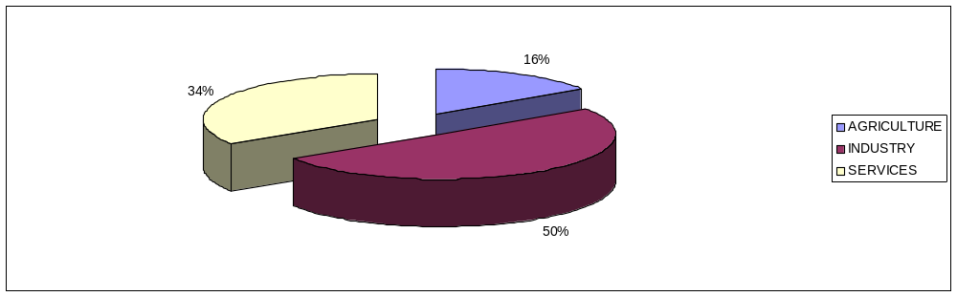

Figure 6: Output Share after Simulation of AGLIB
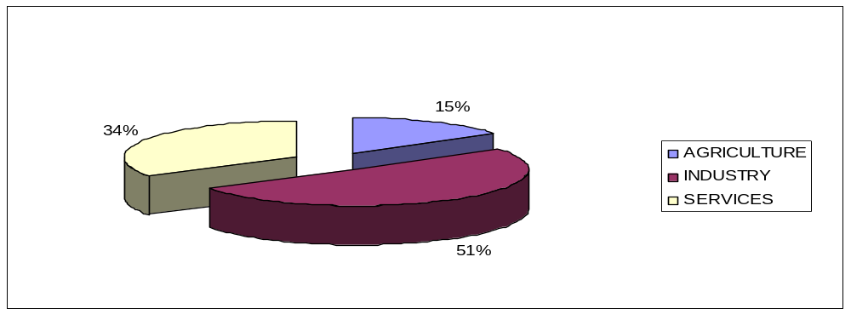

Figure 7: Change in Import Volume of AGLIB
(Percentange Change from Base)
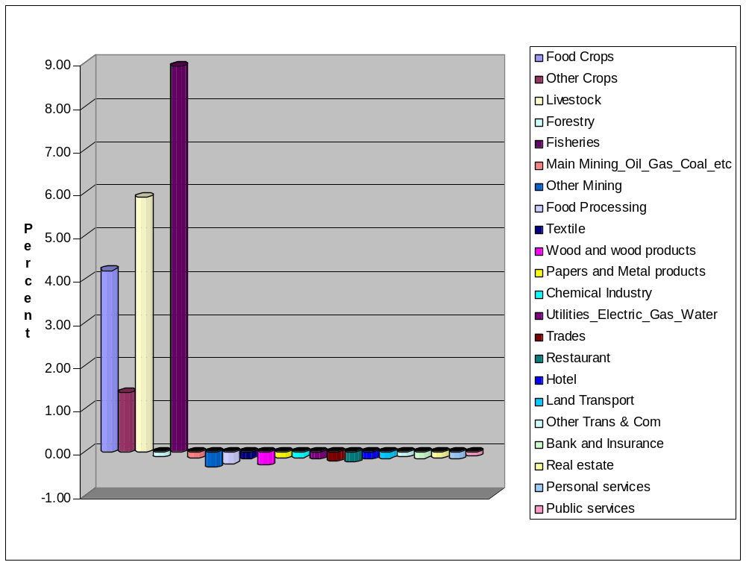
Figure 8: Change in Consumer Prices of AGLIB
(Percentange Change from Base)
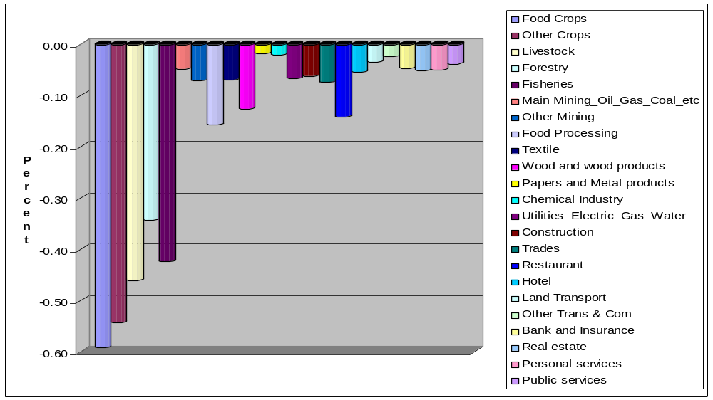

Figure 9: Change in Wage per Labor Category of AGLIB
(Percentange Change from Base)
-0.45
-0.40
-0.35
-0.30
-0.25
-0.20
-0.15
-0.10
-0.05
0.00
0.05
P
e
r
c
e
n
t

Over-all Wage
Agriculture employee (rural)
Agriculture employee (urban)
Agriculture self-employed (rural)
Agriculture self-employed (urban)
Production employee (rural)
Production employee (urban)
Production self-employed (rural)
Production self-employed (urban)
Clerical employee (rural)
Clerical employee (urban)
Clerical self-employed (rural)
Clerical self-employed (urban)
Management Professional employee
(rural)
Management Professional employee
(urban)
Management Professional self-employed
(rural)
Management Professional non- employee
(urban)

Figure 10: Change in Disposable Income of Households of AGLIB
(Percentange Change from Base)
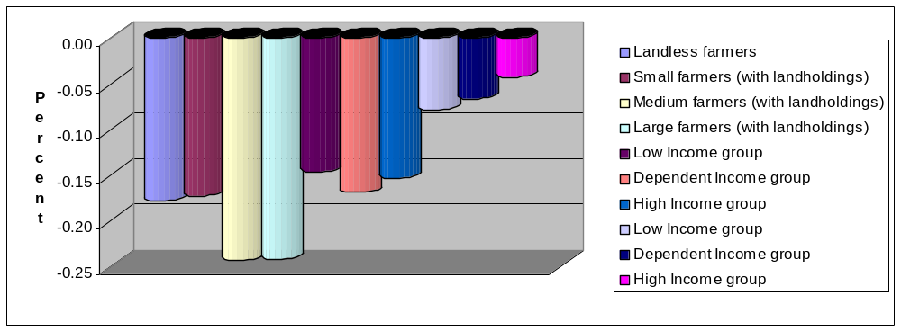

Figure 11: Change in Poverty Headcount of AGLIB
(Percentange Change from Base)
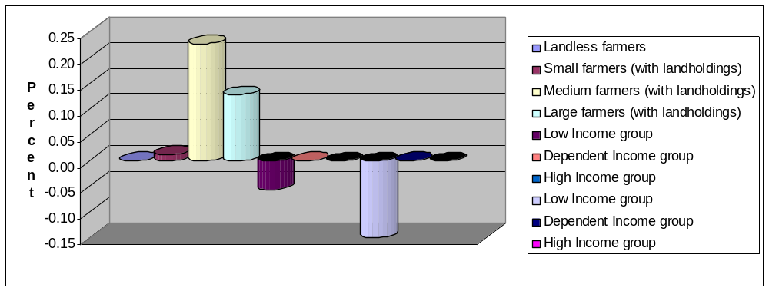

Figure 12: Change in Wage per Labor Category of AGLIBPRO
(Percentange Change from Base)
-0.30
-0.20
-0.10
0.00
0.10
0.20
0.30
0.40
0.50
0.60
P
e
r
c
e
n
t

Over-all Wage
Agriculture employee (rural)
Agriculture employee (urban)
Agriculture self-employed (rural)
Agriculture self-employed (urban)
Production employee (rural)
Production employee (urban)
Production self-employed (rural)
Production self-employed (urban)
Clerical employee (rural)
Clerical employee (urban)
Clerical self-employed (rural)
Clerical self-employed (urban)
Management Professional employee
(rural)
Management Professional employee
(urban)
Management Professional self-employed
(rural)
Management Professional non- employee
(urban)

Figure 13: Change in Disposable Income of Households of AGLIBPRO
(Percentange Change from Base)
0.00
0.05
0.10
0.15
0.20
0.25
P
e
r
c
e
n
t
Landless farmers
Small farmers (with landholdings)
Medium farmers (with landholdings)
Large farmers (with landholdings)
Low Income group
Dependent Income group
High Income group
Low Income group
Dependent Income group
High Income group

Figure 14: Change in the Cost of household Commodity Basket of AGLIBPRO
(Percentange Change from Base)
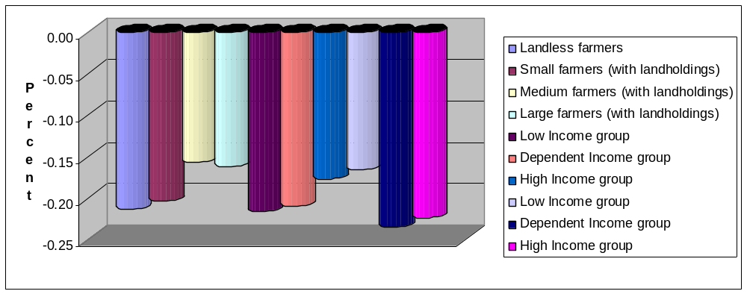

Figure 15: Change in Poverty Headcount of AGLIBPRO
(Percentange Change from Base)
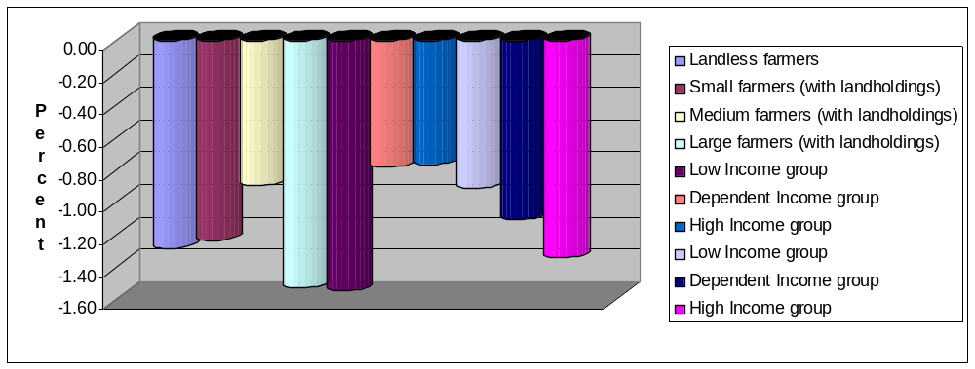

Figure 16: Change in Disposable Income of Households of TOTLIB
(Percentange Change from Base)
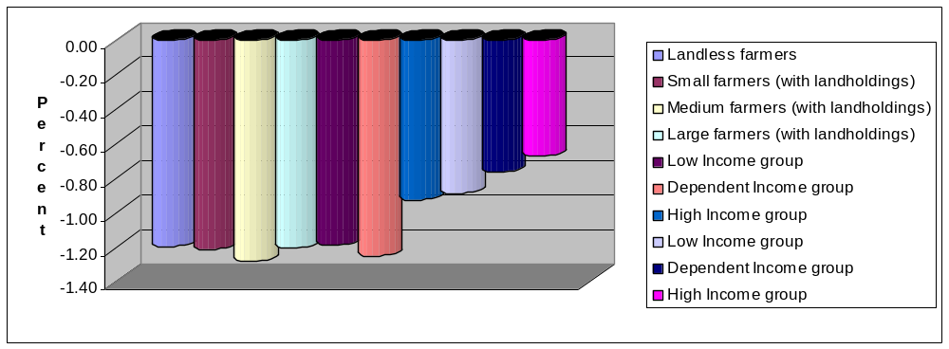

Figure 17: Change in the Cost of household Commodity Basket of TOTLIB
(Percentange Change from Base)
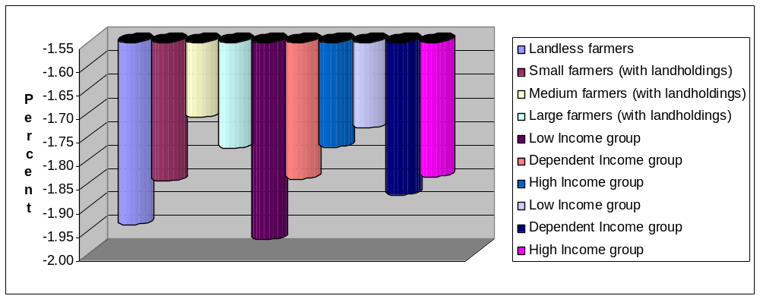

Figure 18: Change in Poverty Headcount of TOTLIB
(Percentange Change from Base)
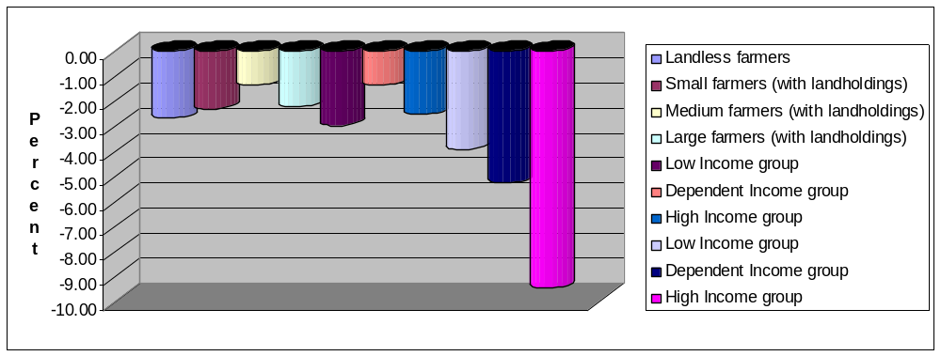

Economist/ERD/ADB, Manila. (gsugiyarto@adb.org). The views expressed in this paper are those of the author and do not necessarily reflect the views and policies of the Asian Development Bank, or of the Board of Governors or the governments they represent.
Assistant Profesor, De La Salle University-Manila, (coronge@dlsu.edu.ph)
Economist/ERD/ADB, Manila. (gsugiyarto@adb.org)
G33 was co lead by Indonesia and the Philippines during the 2001 WTO ministerial meeting.
Also referred to as CGE Micro Simulation or CGE Macro Micro model
This paragraph is taken from Brooks and Sugiyarto (2005)
The CGE model is not linked to a household survey.
The CGE model was constructed by Caesar Cororaton in 2004, and extended for poverty analysis by Erwin Corong in 2005 under the Asian Development Bank’s Poverty Reduction Integrated Simulation Model (PRISM) work, which is supervised by Guntur Sugiyarto.
See Ravallion (1992) for detailed discussion
The poverty threshold would be equal to the food plus the non-food threshold, where threshold is defined as the cost of basic food and non-food requirements.
Main mining includes oil, gas, coal
Owing from the decline in the prices of imported agricultural intermediate inputs
Also known as the cost of the household commodity basket
This will be discussed under factor remuneration. See table 15

